Middle Man
Growing up in Neillsville, Wisconsin
Richard Sprague
2023-11-13
Table of contents

Introduction
The middle child is not quite this or that. We tend to be half way, hard to pin down as we straddle that balance between the first and last sibling. My older brother and my younger sister lived with me in the same town, same school, same everything. They seemed content with our circumstances, happy to take life a step at a time, remaining close to family and whatever life’s trajectory threw their way. But as the middle child, neither here nor there, thinking I could find a better fit elsewhere, I left as soon as I could.
We grew up together in a small midwestern town, which at the time seemed wholly typical and unexceptionally American. It’s only now, most of a lifetime later, that I can see the improbable fortune we enjoyed growing up there, and the privilege of a childhood in that rapidly vanishing past of an American that is all but forgotten.
I wrote this to remember my brother, who was with me every day of those first eighteen years, but whose many under-appreciated strengths I grew to recognize over time. He understood, better than I, that most of what we learn cannot be written down.
A middle man passes stories from one person to another, and inevitably many important details are lost in transmission. I’ve tried to keep to the facts as best I remember them, but my flawed memories and many errors will no doubt be obvious to anyone who was there. For that I humbly apologize.
2023-11-12

1. Neillsville, Wisconsin
Rural America underwent its biggest changes in the first half of the twentieth century, long before I was born. From an economy that was 90% agriculture to our modern, urban one, what used to be considered the backbone of American culture has gradually faded into history.
Not for me.

Neillsville: A brief history
During the 1960s and 1970s, small farm-centered towns like Neillsville were already becoming marginalized in American culture, but the older residents – my teachers, civic leaders, and relatives – remained in a world that would have been recognizable a half-century before me.
By the time I was born in 1963, Neillsville’s main industry had long since switched to dairy farming, but that was a modern development. Settled originally in the 1840s, it was the plentiful forests and the promise of a lumber business that first brought James O’Neill here, building a sawmill on the creek that bears his name. By 1854 the community that had developed around it was important enough to be chosen as the county seat.
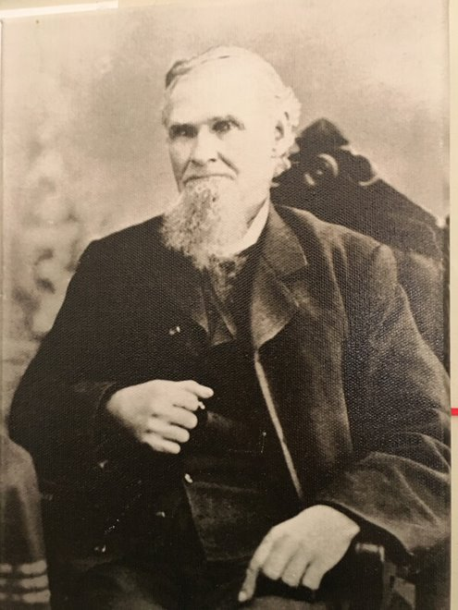
Neillsville’s founding father, James O’Neill
Lumber was an important business through the 1800s. The nearby Black River was in those days wide enough for commercial navigation, flowing through the heart of central Wisconsin all the way to the Mississippi River. As O’Neill’s Mill processed the plentiful oaks, chestnuts, elms, and birch of the forests into lumber, land was cleared for farming corn, oats, and soybeans, and hay for grazing animals, especially cows.
By the early twentieth century, much of Central Wisconsin was becoming a center for milk production, for cheese and butter-making, now exportable to the cities via the railways that crossed the state. Rolling hills and forests, punctuated by plentiful water from small streams and lakes made it ideal for dairy farming. The geography as well as the climate was familiar to north European immigrants from Germany and Scandinavia, who came in droves, attracted to the excellent farmland and not intimidated by the cold, long winters. These hearty settlers and their big families soon multiplied and integrated, so that by the time I arrived, the only memory of Europe was in the names: Shultz, Larsen, Elmhorst, Opelt, Makie, Mengle, Swensen, and dozens more names that were so common I assumed the whole United States was populated this way.
Most of these immigrants came originally by train, from the teeming drop-off places in Chicago. My grandparents spoke routinely of the importance of the trains in their childhoods, but the Neillsville train station had been long abandoned for passenger service by the time I was born. In decades past it was the only practical way out of town, for both people and freight. Central Wisconsin was littered with small towns that had once thrived but were now all-but-abandoned after the transition from rail to automobiles.
My seventh grade math teacher, Sam Ray, married to my first grade teacher, often told us stories about the Neillsville of his childhood in the 1920s and 30s, when having a car was a big deal, because it was possible to make the trek to a big city like Eau Claire in a half a day. But by now the roads were paved, cars were bigger and more reliable, and the same trip could be done in an hour.
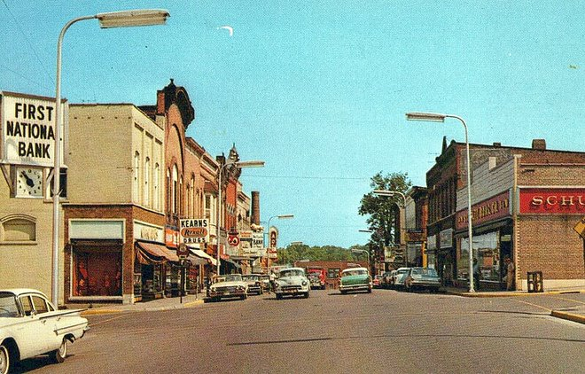
Downtown Neillsville during the 1960s, around the time my family moved there
Eau Claire was an important destination to us, and for most of my childhood it was the very definition of urban. My parents met there, at the Eau Claire State Teachers College, now the University of Wisconsin – Eau Claire Extension, so we had some familiarity with the place, but it was still considered a place to go on special occasions, no more than a few times a year. With a population of more than 60,000, it dwarfed any of the other places we could imagine visiting.
Neillsville, at 2,750 was itself the biggest city in Clark County (total population around 25,000), so we already thought of ourselves as a real city, unlike the smaller towns that dotted central Wisconsin: Greenwood, Granton, Hayward, Thorp, and many others. For shopping, you could buy most of what you needed in Neillsville. We had two grocery stores, a hardware store, car dealerships, furniture and department stores, a shoe store and more.
But still, for serious shopping, you would have to make the thirty-mile drive to Marshfield, which at 20,000 people made Neillsville seem small. Marshfield had traffic lights, fast food outlets (McDonalds! Kentucky Fried Chicken!) and even a tiny community college. Like Neillsville, Marshfield had a newspaper, but it published daily, not once per week.
Marshfield’s biggest employer, the Marshfield Clinic, was regarded as one of the better hospitals in the state, and possibly in the Midwest, attracting a small but important segment of well-educated doctors and medical practitioners, no doubt attracted by the small-town lifestyle in a natural setting.
That was our world: Neillsville, innumerable smaller nearby towns, the big city of Marshfield, and for very special occasions the huge metropolis of Eau Claire. The world beyond was, to us, mostly theoretical. There were the Really Big Cities, like Minneapolis and Chicago, and occasionally you would hear of somebody traveling there, perhaps to fly on an airplane (we didn’t know of any other way to travel by air). Our grandparents had met and married in Chicago, but left soon after that, and had nothing good to say about the place. Our uncle insisted that, if you ever find yourself needing to drive a route that takes you past Chicago, whatever you do, don’t go through the city.
That was fine advice, as far as I was concerned, though frankly a bit irrelevant. Why on earth would anyone need to visit a big city like Chicago when we had everything we needed right here?

1.1 Farmers
Neillsville since the 1960s and 70s has seen less change than many American places, if only because its rural location makes it too easy for the rest of the world to pass it by. The population when I was there, two thousand seven hundred and fifty, is about what it is today.
The 1980s were tough on rural agricultural towns like Neillsville, and many of the ways that Neillsville could be proud of itself went away. I’ve been back a few times since, but not enough to understand the subtler changes so it’s just my speculation that the general quality of the people has changed.
Dairy farming, and the agricultural life in general, was the defining pillar of the community. By the time I grew up, America had already shifted from an economy based on farmers, but that was all theoretical to us then. Today it’s hard to imagine, but my brother and I were considered “city boys” by the local standards. But even us city boys were very familiar with the smells and activity of a farm: the moist pungency of cows in a barn, the thick overhang of pollen in the hay fields, the long, hilly dirt roads out of town with red barns sprinkled lightly through forests and never-ending corn fields.
In middle school, out of emerging teenage spite, I chided one of my friends, a farmer’s son, that the world doesn’t really need farmers. “We’d find some other way to get food,” I insisted. I was imagining robotic planting and harvesting machines, maybe, or a world of genetic modifications and food grown in factory vats. Science, I thought would eventually make obsolete the old-fashioned, primitive ways of growing food. At the time, I meant this in a provocative, maybe mean-spirited and certainly immature way, but in the larger sense now I guess I was on to something.
Farmers today, even in Neillsville, are endangered. Yes, there are people who make a living from tilling the soil and raising cows, but more likely than not, they are employees of corporations, the big and efficient companies that now run agriculture like factories. Neillsville now boasts several of these multi-thousand acre enterprises, with a staff of specialists: a full-time expert for example whose only job is to determine which crops to plant in which field; a team of veterinarians to look after the herds; a foreman – maybe a group of them – looking after the dozens or hundreds of unskilled hands hired to do the menial and still labor-intensive jobs of putting up and repairing fences, driving tractors up and down fields, attaching and releasing milking equipment twice each day from row after row of cows. Those are not the farmers I remember.
My farmer friends were all families. You could say they were “family businesses” but the word “business” seems awkward somehow and not really applicable to people to whom this was a way of life. Our friends weren’t milking the cows in order to earn a living – though of course that was the net result. They were farmers because their parents were, and because that was what you had to do in order to eat. You can’t be a farmer if, to you, it’s a “job”; it’s a lifestyle. The farmers I remember got up in the morning to milk the cows, not out of any consciously expressed purpose (“it’s my job”) but because that’s just the way it is. Why do city-dwellers clean up their dishes after dinner? Why does a man in the suburbs mow his lawn? They do it because it’s something that has to be done. It would never occur to a farmer to think of his occupation as a “career”, in the sense that, oh I’ll just do this for a few years and then submit my resume to some company and switch to a different job. Farming, to a real farmer, is life itself.
On my, sadly, infrequent visits back to Neillsville since that time I find that few of my friends remained in farming. Farmers children nearly all went to college, it seems, and even those who majored in “agricultural studies”, ended up mostly in the cities, in other occupations. The few who remained behind, keeping up the family farms have migrated to organic farming, where the profit margins are higher, and where the benefits of direct attention to the farm is greater.

1.2 Tourism
Despite its central location geographically, Neillsville is about 30 miles from the nearest interstate highway, putting it almost three hours drive from the nearest big urban area of Minneapolis-St. Paul, and almost six hours from Chicago. That’s an impractical distance for day trips, so to attract visitors and their tourist money Neillsville has had to invest in various attractions, with varying levels of success.
There’s the natural beauty of course: rolling green hills in the summer, colorful leaves in the fall, white powder trails perfect for snow sports in the winter. When the Ice Age receded, it left a large moraine just outside of town, the top of which presented a beautiful view of the Wisconsin countryside. Sometime after I left in the 1980s, it was turned into a Vietnam Veterans memorial and today draws thousands of visitors a month.
On some measures, Neillsville could even beat our nearest big city of Marshfield: we had a radio station, WCCN (the call letters stand for “Clark County Neillsville”). The Clark County Jailhouse, now a museum, is listed in the US Register of Historical places.
But no other town has anything to compare to our biggest tourist attraction: the “world’s largest cheese”, housed in a special exhibit at the edge of town, a monument built for the 1964 New York World’s Fair. As if that weren’t enough to attract tourists, the occasion was further memorialized with a large outdoor statue of a cow in its honor. “Chatty Belle”, complete with a speaker and audio player will, upon deposit of a quarter, regale any visitor with a short missive about the wonders of our town.
Such was the tourism industry in Neillsville, and I guess it was reasonably successful since the “talking cow” and nearby Worlds Fair Pavilion are still there.

1.3 Daily life in the 1970s
It’s hard for my kids to understand some of the basic ways that life has changed since I was their age.

1.3.1 Telephones
My parents and grandparents could remember when their homes got their first telephones. Very few families had more than one, usually a standard black rotary dial, often in the kitchen, shared among all the family members. When that phone was in use, an outside caller trying to reach the home would get a busy signal; no calls could be received until current call ended. We had no voicemail or answering machines either; if you called somebody and there was no answer, you’d have to call again and hope they were home the next time. Worse, there was no way to tell that a call had been made, or who it was from. If you heard the phone ring but didn’t answer it in time, you’d never learn the caller’s identity unless they dialed again.
Local phone calls were free. Since this included most locations in Clark County, my mother could call my grandmother regularly without worrying about the cost, but anything more distant required a per-minute charge. The fees to places in the Midwest were fairly reasonable – maybe a few cents every ten minutes? – but more distant locations and the charges could really add up. A call to friends or relatives out of state might cost a dollar or something per hour – the equivalent of, say, $5 or $10 today. This was something you might do on a special occasion – a birthday, Christmas, or perhaps after a funeral or birth – but generally we didn’t call unless it was very important.
Fortunately – or perhaps, as a result of this – we didn’t have many friends or family that were distant enough that this would matter.
Instead we relied on the mail. Much, perhaps most, communication with people outside of Neillsville occurred through the post. I wrote many letters, and postcards, and received many more. The mailbox was my lifeline to the world.

1.3.2 Information
Our news about the world came from radio, TV, newspapers, and magazines.
Popular or common titles were available at some of the stores in Neillsville, but for more specific books you’d have to go elsewhere. There was a bookstore in the Marshfield Mall that stocked a full variety of books.
It’s hard to overstate the importance of libraries. Our public library was small and underfunded, but it was accessible to everyone. The high school library was much better, and it was a delight when I was finally old enough to be allowed admission. Later I was also able to peek at even bigger libraries, in Marshfield and then Eau Claire. The amount of information was staggering!
Even basic facts – the kind that anyone gets today from the internet – required serious research. What’s the population of Wisconsin? What year was the Civil War? How do you best treat a cold? Answers required finding and looking it up in the appropriate book.
One treasure trove of knowledge was the Encyclopedia Britannica, which my family was fortunate to have at our house. Sprawling along our bookshelves in ten or fifteen volumes, you could get a short summary of all the world’s knowledge. Of course, it was nothing like the depth of today’s Wikipedia, but it was well-written and approachable. I remember spending hours sprawled out on the floor digesting articles about everything.
For shorter, factual answers we had almanacs and other specialized reference books like dictionaries or The Guinness Book of Records. If, in the course of a discussion or homework assignment you needed to know a fact, you had to crawl across the room and open the book. If it wasn’t in the book, you had to visit the library. And if it wasn’t at the library, then your only choices were to give up the search or – and I did this occasionally – write a letter to some expert and hope for a reply weeks later.
We also had maps, bound as an atlas for a broad survey, or roadmaps that were useful for traveling. Paper maps, road signs, and spoken directions were the only way to know how to get to your destination.
Finally, there was the phone book, which was useful for more than simply finding a phone number. These books – distributed annually for free to all households – contained lists of businesses printed on yellow paper. These “yellow pages” were organized by subject and included paid advertisements for businesses. If you needed a plumber or electrician, or you wanted to know which churches are in town, your first stop was the yellow pages.

1.3.3 Photography
Cameras were widely available at prices that anyone could afford, and we took plenty of photos. But to today’s generation, raised on high-quality images and video from mobile smartphones, our photography was incredibly primitive.
The camera itself was cheap and if you couldn’t afford a commercial model it was easy to make your own. Once summer we made a “pinhole” camera out of cardboard and successfully took photos that I have to this day.
No matter what camera you had, the photos themselves required a separate purchase of photographic film. You could buy film canisters, usually in rolls of 24 or 36 images for reasonable prices – a few dollars. But, importantly, you couldn’t view the images until after they were processed – a separate step that required weeks of waiting and additional money. All told, a single photo might cost between $0.25 and $0.50 – not a trivial amount of money in a world with a $3-$5 hourly wage. Because you had to take photos in increments of 24 or more, this often meant that some events didn’t get viewed until months later.
Although it wasn’t unheard of for people to process their own photos in a home “dark room”, mostly we dropped our film at the pharmacy, or mailed it to a mail-order lab that would send the developed prints back to us within a week or two.
The significant, weeks-long lag between taking the photo and seeing the results made for special moments when at last we received the final images.
Sometime in the 1970s, Polaroid’s instant photo cameras became widely available. To us, these were revolutionary because they let everyone enjoy the images within minutes. The downside: each photo was more expensive, on the order of $1. In today’s money and relative purchasing power, that would feel like closer to $5 for a single image.
As you can imagine, at those prices each photo was precious and we tended to take them only on special occasions.

1.3.4 Food
An agricultural community contains abundant reminders of food everywhere: the big farms with their cornfields and pastureland, of course, but also in our day-to-day lives. Everyone we knew had a vegetable garden. Fishing and hunting were popular activities, and not just for sport: many families proudly supplemented their pantries with food they had caught themselves.
By today’s standards we would have been considered locavores or even organic, because most of what we ate was grown nearby. This wasn’t necessarily by choice: I don’t remember caring where the food came from. That just wasn’t important to us.
We ate plenty of non-local food: packaged goods like breakfast cereals, canned goods shipped from elsewhere, or orange juice from concentrate. During the winters we had no choice, but by mid- and late-summer, we were eating fresh local produce like lettuce and green beans.
As you’d expect from a dairy-dominated location, we drank a lot of milk. We ate cheese too, of course, but nothing like the variety you see today in an upscale supermarket. For us, cheese was always yellow-orange and came in exactly two varieties: cheddar and Colby. It was a source of some pride that Colby had been invented in the nearby town of Colby Wisconsin.
Like most adults, my parents drank coffee, usually purchased in large tin cans of ground beans from national brands like Folgers or Maxwell House. In those days, long before the founding of Starbucks and its minions of boutique imitators, coffee was coffee. Terms like “latte” and “espresso” were literally foreign to us.
For some reason, despite being surrounded by coffee drinkers, my siblings and I never picked up the habit. I assume my parents offered it to us as we got older, but it never occurred to me to try it.
Typical meals
Breakfast was some type of cereal with milk. Corn flakes and Cheerios were probably the most common and popular. My family always had those boxes on hand, served poured into a bowl with fresh full-fat milk. My mother taught us to sprinkle a bit of sugar on top as a special treat.
In our house we often ate hot cereals, usually oatmeal served with milk and perhaps brown sugar. My mother sometimes made other hot cereals, like Ralston or Cream of Wheat.
Bacon and eggs were another standard, especially when visiting grandparents. On Saturdays we often had pancakes as well, usually served with a corn syrup sweetener like Aunt Jemima or another “maple-flavored” topping. Although we had access to fresh, local maple syrup, for some reason my siblings and I thought it tasted like medicine and we refused to eat it.
We referred to our mid-day meal as “dinner” and this was often a sandwich of some kind. Cheese was common, perhaps served with sliced meats like turkey or ham or roast beef. My mother taught us to spread a leaf or two of iceberg lettuce on top, though I generally refused the mayonnaise or mustard that she suggested.
The final meal of the day we called “supper”, and in my family it was typically some type of meat – often beef, pork, or chicken – with reheated canned vegetables like peas or green beans. We ate this with store-bought sliced bread, preferably as bleached white as possible.
My mother often cooked potatoes, usually mashed and topped with generous amounts of butter. Beef roast was a common meal, cooked to perfection in her electric oven.
At my grandmother Pulokas’ house, the bread was always homemade, usually a dark rye or whole wheat bread. My grandfather preferred thick crusts, served with copious amounts of freshly churned butter.
For fruit, either as a snack or served with a meal, we ate apples (usually red delicious, but often a variety from a local tree), pears, and perhaps other fruits gathered locally, like raspberries, blueberries, or strawberries in season. The grocery stores stocked plenty of imported, cheap bananas year round. In season we could also get fresh peaches, cherries, oranges and grapefruit. Some of those fruits might be available at other times of the year, but always at exorbitant prices.
Snacks were simpler than today. My mother would regularly bake cookies, brownies, or pies, and leftovers were always available. To top off the calories required by the teenage boys of the household, we also ate boxes of packaged snacks, like Oreo Cookies, Fritos Corn Chips, and Twinkies. I don’t think the idea of “healthy snacks” would have occurred to us. Like dessert, the whole point was to have something that tasted good.
I remember the day our family bought a dishwasher. Before that, everything was washed by hand, and usually hand-dried too with a towel. Visiting Grandma Pulokas it was a treat to be assigned the drying duties, but I don’t remember doing this at home. Maybe it was a duty related to my sister and mother.
Microwave ovens were exotic and expensive, so we didn’t have one but the Gungors did. It was a treat to try putting different foods in the microwave to see what would happen.
Restaurants were not nearly as common as they are today. Although Neillsville had exactly two competing fast food places – the A&W and another ice cream shop called The Penguin – and one or two cafes that served lunches, I don’t remember anything that today would be considered a fancy “sit-down” or white tablecloth restaurant.
Central and Northern Wisconsin were known for their “supper clubs”, a sort of combination restaurant - tavern - gathering hall, often used for weddings or other receptions. These places served food similar to what most people enjoyed at home: meat roasts, fried chicken or fish, potatoes, canned vegetables. Our family strictly forbade alcohol, so we wouldn’t have visited places that served it, but I imagine it was common for supper clubs to offer local Wisconsin beer in cans or bottles.

1.4 Small town neighborhood
We lived in an old, two-story house on Oak Street, surrounded by a diverse mix of neighbors, many of them families with children my age. Our next door neighbor was a postman with two children a bit older than us, including a teenage daughter who occasionally babysat. We had a few elderly widows, including Mrs. Demert, who wrapped her tiny Chihuahua puppy into a snug hand-knit body suit before his daily walks in the cold Wisconsin winters. There was Mrs. Fry, who lived alone except during the summer months when I saw my first taste of California, a license plate on a car parked in front of her house that carried a load of grandchildren. We had the Carters, a family of Sixties-era hippies, who apparently used drugs enough that my mother used their name as a superlative: “…more X than Carters have pills.”
We knew everyone: lawyers, doctors, schoolteachers, the town barber and his kids, a fireman and his family, small business owners including the grocery store, hardware store, a furniture store, and much more. And while of course there were differences in wealth among all of us, we all lived in similar-sized houses and the children attended the same schools.
Well, most of us did. Even a small town like Neillsville had private parochial elementary schools: St. Mary’s Catholic, and St. John’s Lutheran, Bible Baptist. But any educational differences had to do only with religion, which to outsiders would have seemed tediously arcane among Christian people who agree on far more than they disagree. We didn’t know there could be secular private schools for wealthy kids, or even specialized schools for people whose parents had enough money to pay to have kids focus on, say, the arts, or to get an education surrounded by other rich kids. We just didn’t know that world existed.
Politically, as can be expected from a small Midwestern town, most people seemed sympathetic to the Republican Party, but it was by no means a shut-out, in the way that Democrats exclusively dominate urban areas or university campuses in the rest of America. You would not draw attention to yourself by having it be known publicly that were a Republican in my small town – any more than anyone would think you were extreme for being a Democrat – but you would be better off keeping your views mostly to yourself, because you couldn’t assume that the others around you would agree with you.
The US Supreme Court ruling that prohibited prayer in classrooms was only a decade or so old by the time I was in school, so although we didn’t overtly pray (I’m not sure in Neillsville the schools ever did) it certainly wouldn’t have been the kind of thing parents would have complained about. My kindergarten teacher led us to say grace before our snack time, though it’s likely that she did this because most of the kids said grace at home, and it would have been completely natural to pray at school too.
My friends included people like Roberta, the girl who seemed perpetually happy. Or Roger, the big-boned farm boy who, like many others in our class, always smelled of freshly-milked cows.
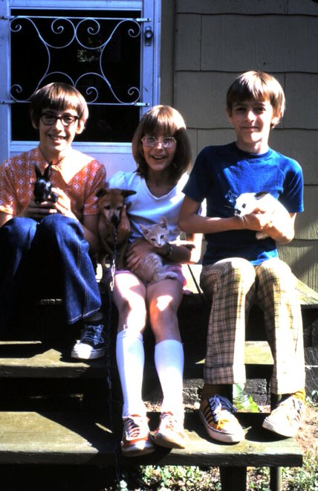
Gary, Connie, and me sitting on our back steps with our pets
I knew that my family was poorer than some families – and better-off than others – but at the time it seemed less about money than about priorities. Some of the houses boasted prettier, well-manicured lawns, but we had a bigger backyard garden. Some people had nicer furniture and carpeting, bigger TV sets or newer cars. But nothing about any of their lifestyles seemed beyond the reach of my own family. Occasionally we’d hear about somebody going on a big vacation, maybe by airplane to a faraway tropical island, and that seemed like the peak of luxury, but my family went on vacations too. Maybe we didn’t travel by airplane or stay in fancy or expensive hotels, but we could go where we wanted. Who needs money when you can stay with relatives or camped in a tent along the way, eating sandwiches and canned food.
At school, the differences in wealth or prestige didn’t matter a bit. The “rich kids”, children of lawyers and doctors, ate the same school lunch that we did. If they brought their own, it might have come in a fancier cartoon-labeled lunchbox while mine was a paper sack, but the contents were the same. A tiny handful of kids were rumored to have subsidized or free lunch. These were invariably victims of tragedy: the family whose home had been destroyed by fire, the kids whose father died in a boat accident, or the big family outside town who parents didn’t seem to be normal (maybe they were mentally handicapped?). Even then, to be on some type of public assistance was something everyone –including the recipients – viewed as disastrous, a shameful hardship for all involved and definitely just a temporary stepping stone on the way to self-sufficiency.
If there was a correlation between family status and school performance, it wasn’t a strong one. With few exceptions, everyone came from intact families – a father and mother – and the family attitude toward education probably affected school results as much as anything. When I discovered early in first grade that I tended to do well in school compared to the rest of the class, I found that my chief competitors were the children of schoolteachers or those whose parents had been to college. Even then, any link to the parents seemed tenuous, because I could always find exceptions, and of course academic performance was only one of many ways to measure the students. Some were better athletes or artists, some were more social. But we all attended the same school, and learned the same things.
The Neillsville Public Schools were located on a single tract of land on the east side of town, eventually consolidated into a single building. You entered the east doors for Kindergarten and graduated out of the west doors for high school. We had roughly 100 kids in each grade, split among four or five teachers. A small administrative staff rounded out the school with dedicated art and music teachers in elementary school, and more specialized teachers in high school. Although the place seemed huge to me at the time, the faculty – especially the longer-served ones – knew pretty much every student, if not directly then from teaching siblings.

Our religion dominated our lives so much that I don’t remember many friends from elementary school who didn’t have a connection to church, but we had neighbors, and like all kids I suppose it was only natural to find ways to play with them.
Although technically we lived in a city (the largest, the capitol city, of Clark County!), our neighborhood (like every neighborhood, come to think of it) was on the outskirts of town. An elderly philanthropist, Kurt Listeman, had donated some land to the city long ago as an arboretum, a large undeveloped forest with some trails carved into it, running along a scenic path to the nearby Black River. It wasn’t the kind of place that today I’d call a “hiking trail”, but to our pre-teen minds, it was the ideal place for play, especially on endless summer days in a world before parents thought to overschedule their children in “day camps”. Everything we did, we had to invent for ourselves.
In the large, overgrown field that separated our backyard from the arboretum, we found plenty of other neighborhood children who had come to play, and in time we invented a game we called “all day game”. If you showed up sometime in the morning, you’d find children from throughout the neighborhood, usually divided into teams of some sort, all playing an elaborate version of hide-and-seek. We imagined that the other neighbors were from a hostile foreign country, or that we were spies sent to penetrate the defenses of the enemy, or that they were invaders intent on destroying us. We rarely came face-to-face with the enemy; we usually only saw them from a distance.
Occasionally one side would spot the other at a sufficient distance to plan a surprise “attack”, creeping slowly through the underbrush just to the point of the other camp, sticks and stones in hand, ready to deliver a beating. Inevitably, the opposing side would discover the attack just in time either to flee or to counter-attack, depending on the whim of the players. The counter-attack, of course, would result in reverse behavior: once a side discovered it was about to be raided, they would themselves need to flee or counter-counter the attack, depending on the circumstances, precipitating even more fun of the chase.
These games really did last all day, and everyone in the neighborhood seemed to join. Usually it was my family—both brother and sister – plus the Gungors, the Shorts, the Frys, and many others. The kids who we didn’t know from church, we knew from school – or if they were in different classes, we at least knew of them – so it was easy to identify our “enemies” by name.
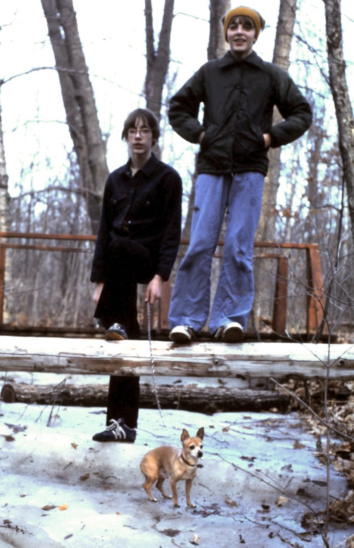
My brother and I walking our dog through Listeman Arboretum in the winter
Part of being away from home, running through the woods, all day was that obviously our parents (i.e. mothers – the mothers were all stay-at-home) wouldn’t be watching us. Nowadays such inattention would be unthinkable: what responsible parent wouldn’t know exactly where a pre-teen child is? But our mothers interpreted our absence as a sign we were happy and self-sufficient. They knew we’d be home eventually, if not for treatment of the occasional scrape or bruise, then certainly in time for dinner. My mother’s only rule, at least until we were older, was that we were not to go near the river itself. She knew too many personal examples of children who had drowned. In fact, one boy in our neighborhood did drown, and we knew of at least one other kid at school who unsuccessfully tried to rescue his younger brother who had fallen in during the springtime. So we stayed away from the river. But the rest of the woods was fair game and we took full advantage of it.
On one particular day, during an especially long forage into the woods, I remember we stumbled upon a group of much older teenagers hiding an illicit stash of beer, cigarettes, and who knows what else. At first were afraid they might try to hurt us for having discovered their evil den of sin, but the beer had apparently put them in a happy mood, so instead they just laughed at us.
Otherwise mostly what we found in the woods were trees (good for building forts and hideouts), sticks (good for make-shift weapons), and the occasional baby bird or animal (good for bringing home as an adopted pet). It was endless, nonstop adventure.
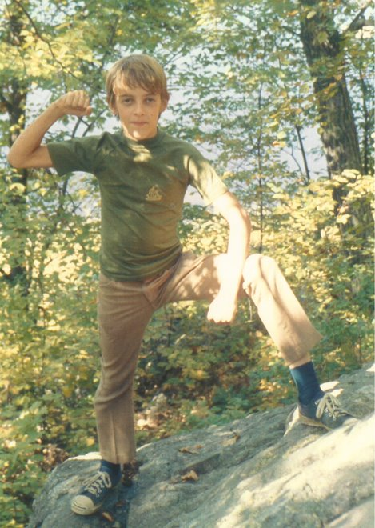
Outdoors at age 12

1.5 Neillsville People
If you’ve only lived in big cities, you might think that everyone knows each other in such a small town. That’s not quite true – even with fewer than three thousand people, nobody knows everyone. But much of the population has been there for generations, and long-time residents can find a connection with just about anyone. With fewer than 100 kids in each grade, anyone associated with the school system will know somebody with common family names. You could also identify people by their occupation (farmer, hospital worker, teacher) or by their church.

1.5.1 Our Friends
I no longer remember precisely when the Miller family arrived in Neillsville. The father, Dan Miller, was a woodcutter who raised his family in Athelstane, a small rural town on the way to Upper Michigan. The oldest was a boy, David, who towered over his four younger sisters. The parents were serious Christians who attended our church regularly, and the older kids matched ages with ours, so we naturally came to know them well.
Dave Miller and my brother loved many of the same things: cars, motorbikes, fixing things – all guy stuff. I think there was much friendly competition between them over who could their various guy hobbies, so they leapfrogged each other through high school buying and then fixing up old cars. Though Dave was deep down a serious, well-meaning boy, he had more tolerance for risk-taking than either my brother or me, and we looked at him as living right at the edge of lawlessness.
It’s funny to reflect on this now, because by any of today’s standards, Dave would be squeaky clean, but we saw him as a bold and daring ne’er-do-well. My brother enjoyed dirt-biking as much as any boy, but Dave’s ability to tolerate high speeds and dangerous situations topped anything we would have attempted. Where the rest of us (especially me) were barely willing to go up and down hills, Dave thought nothing of flying his bike right over a cliff. We joked about how crazy he could be.
His father, a straight-and-narrow pillar of the church, gave Dave little room to get into trouble at home, but school was another matter. Events reached a head one day when Dave did something so egregious (I don’t remember precisely) that, as punishment, Dave’s father decided to join Dave at school for the day. Obviously nothing could possibly be as mortifying to a young teenager, and he complained about it for years, but that I suppose was the father’s intention.
It may have been his status as an only boy in a family of sisters, but he seemed more comfortable – eager – to be around girls than we were. He was not afraid, like we were, to ask a girl out, or to take her for a long ride in his car, and later he would brag – just us guys – about what he had been able to get the girl to do.
Like most teenage stories, I doubt the reality was anywhere close to the imagined bravado when they were told, but Dave was a risk-taker in other areas so who knows.
He fell head over heels in love with a girl from another town, and he talked constantly about wanting to see her. He even changed his car license plates to “NADEEN”, which of course we thought was ridiculously short-sighted.
But then I remember one day, a Wednesday evening after church, when we normally had time to go over his most recent exploits, Dave confessed to us that he was no longer interested in misbehaving. “I don’t want to go to Hell,” he said, a point that we took more seriously coming from a boy who till then didn’t seem to consider the consequences of his risk-taking.
Dave married Nadeen a few years later and literally lived happily ever after – last I checked they’ve been together for more than 30 years.
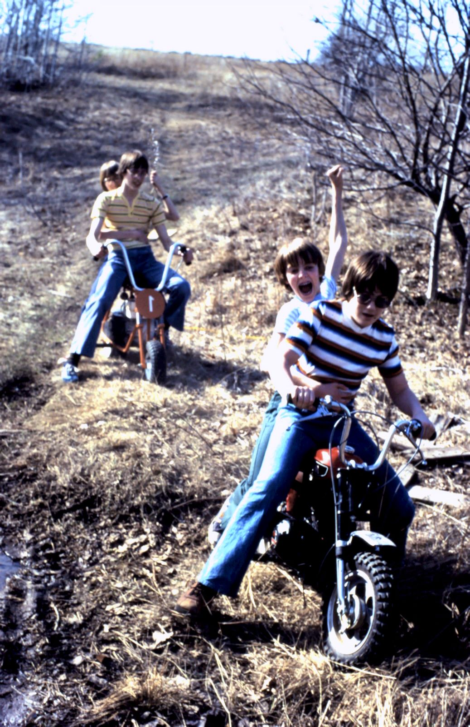
My brother motorbiking with Dave with Jimbo driving me

1.5.2 Neillsville Friends
Maria Marks was one of half a dozen, maybe more, children in a family that attended our church. She had an older sister who I know worked far away at our Christian summer camp, and a younger brother who was a year older than me. The mom was an elderly woman who, I’m sorry to recall, sticks in my memory because her body odor was so overpowering that eventually somebody had to intervene and ask her to bathe before coming to church.
Maria was a nurse, probably in her late 20s, maybe 30s by the time I knew her, and very single. She wanted badly to be married, and I don’t blame her: she would have made a wonderful mother and I’m sure she wanted a family more than anything. She was also a very devout Christian, pure and sweet and loving.
After living in Neillsville for so long, she apparently decided that she was unlikely to meet a suitable husband there and so she took a chance and moved to Alaska on a one (or two?) year missionary program that involved some church-related initiative. I didn’t hear much about how it went, but i’m sure it was quite the adventure. Nevertheless when the assignment finished, she returned to Neillsville, unmarried and a bit older.
Sometime after this, a man named Joseph began to regularly attend our church. I’m not sure how he happened to come here — maybe he was related to somebody? — but he was very taken with Maria and began to pursue her. It was clear to us outsiders that the two were not a particularly good match, notably due to his rather large girth. He was very obese, not especially attractive. I don’t know that he had any other qualities that would make him ordinarily somebody she would seek, but apparently none of this mattered relative to his charm. He did everything to make her feel like he would be a good husband. One night at church, after I guess they were a thing, he testified how much weight he had lost since meeting her — proof, he believed that God wanted them together.
Long story short, they married and last I heard are still together, though childless. A real shame, because Maria would have made such a good mother.

Mark was a boy my age, who lived about a block beyond Jimbo’s house. Mark was well-liked and intelligent, and although our paths crossed regularly, I don’t remember any particular incidents that would have made us close friends. Everyone knew everyone, so my memories of him don’t stand out for anything in particular.
He was a budding filmmaker, in the same way that I was obsessed with computers, but like me, he had to live within the constraints of the technologies of the times. Still, using what today would be unthinkably primitive techniques, he was able to make some interesting home movies, often about his favorite theme: space travel. We were all heavily influenced by Star Trek and later, Star Wars, but Mark brought his interest to the rest of us, writing short movie scripts, and then directing them using the consumer film movie cameras of the day. (Later posted to YouTube)
I don’t remember how he met Julie, his high school sweetheart, but whatever it was, the two of them are inseparable now in my memory. I think they attended the same college (Eau Claire) and then married within a few years of high school and they were still together 40 years later.
Right out of college, Mark and Julie started “Ag News Network”, a radio program with daily updates relevant to farmers. I lost track after leaving Neillsville, but it apparently didn’t last very long because the next time I heard about them, they were living in Minneapolis. I think he worked at a bank for a long time, until he took advantage of a layoff package to start his own marketing business.
Along the way, I remember that he won some kind of screenplay contest that let him pitch in front of the makers of Star Trek. I read the script at the time and thought it was very original, very well-done, although it apparently never made it to a contract. He self-published a book too.

1.5.3 Small Town Low Life
The knowledge that our parents loved us was a deeply-ingrained fact, like air, and like wind sometimes something to resist. Of course, parents should love and care for their children – no exceptions – but we also knew that not all families could take that for granted.
Neillsville was a small town, and it was possible – just – to know something about everyone. Even among those we didn’t know directly, there was a connection not far removed, and gossip was plentiful. As kids, we were well-protected from the worst of humanity, but that didn’t mean we were wholly unaware. Years later, when I could understand the bigger truths, I could see that sometimes when things aren’t quite right, there was a deeper problem.
One of the girls in eighth grade left school because she was pregnant. She had always been quiet, not a particularly good student, with few friends, so we didn’t notice too much. I remembered how, years earlier in fourth or fifth grade, while playing some kind of game of tag at school, she and another girl had tackled me. It was all just fun, so at the time I just thought it was rather odd, not malicious, that she grabbed my groin and squeezed me. This hadn’t happened to me before – touching that way was considered more gross than inappropriate – and the game was too fast to dwell on such oddities, so I attributed it to normal roughhousing. It wasn’t until years later that I learned that her pregnancy was a result of incest, an apparent rape by her father.
Then there was a boy who seemed to prefer to play with girls. Again, we didn’t see this as particularly shameful or undesirable. In kindergarten I preferred the quieter games of the girls too sometimes, and this boy didn’t exclude boys – we played with him too. He just seemed like he felt more comfortable around the girls, and he was otherwise fairly friendly and interesting so we didn’t think anything of it.
Years later, the town optometrist – an otherwise well-respected neighbor who we all knew as “normal” – committed suicide. He shot himself in his basement, having left a thoughtful note to his wife warning her not to come downstairs. It turned out that this man had regularly invited that boy alone to his house, showing him pornographic movies in his downstairs theatre.
We all know what we mean when we say “small town values”: nuclear families with a working father and stay-at-home mom, active in the community including regular church attendance, hard working, clean living, even short haircuts for men and boys and always long hair and dresses for the girls. Popular movies and sitcoms often hold these stereotypes up for ridicule as a repressive society drenched with hypocrisy: the church-going father who beats his wife and children, the gay-bashing minister with the secret homosexual affair, the abstinence club run by the school slut.
Nobody uses the word “big city values”, because the only difference, it seems between the secret alleged sins of the small town is that the city people are open about it, unashamed, even proud of their immoral ways. “At least we’re not hypocrites,” they say in smug judgment of the small-towners.
But I think the difference is not one of hypocrisy but aspiration. Nobody in a small town believes that people are always righteous and good or that sin is limited to big cities. Maybe it’s the direct experience with sin and its personal, individual affect on people that makes a small town more averse to such habits. Of course we sin, but we really wish we didn’t. If the city people want to claim that their bad behaviors are actually good, then that’s the part we don’t understand because we know from first-hand experience the wages of sin.
I learned about infidelity long after I left, because as a teenager I guess it never occurred to me that people could run into trouble later in life. We knew that husbands could cheat on their wives, of course, but it seemed like something that only happened to those who weren’t active in the church.
Our high school guidance counselor, for example, was always friendly, active in the community, a great resource for kids who didn’t know what they wanted to do after high school. His wife was the most popular teacher in fourth grade; Gary had her, and their policy of spreading siblings out among different teachers was the reason I was passed over for selection into her class, which seemed so much more full of interesting projects and great teaching than the comparatively dull class I was assigned.
A few years after I had left, we learned that this same guidance counselor and his wife had abruptly quit town, moving far away after it was discovered that he had been having an affair with one of the high school girls. Everyone knew the girl well, of course; she was popular and outgoing. If he had been a high school student himself, we would have thought the two made a great, natural couple. But clearly, something had not been right all along.
Many other examples: our high school history teacher, who abandoned his wife and teenage daughter for an affair with another teacher. The math teacher who, besides algebra and geometry, taught me by example the harsh and lonely world of an alcoholic, and that unforgettable, medicinal smell of alcohol on his breath. The town banker, pillar of the community, who after forty years of marriage ran off and then remarried a younger woman. But at his funeral, it was his original wife and their many children who mourned him most.
George Williams lived around the corner from us with his postcard family. His wife was the always-prim daughter of one of the founding families of Marshfield, and they had two children, a boy and girl who attended our church and we knew well. George was by all accounts a successful businessman, owner of the local appliance store, and lead accordionist in a popular polka band. Though he himself wasn’t an enthusiastic Christian, his wife attended our church regularly and the kids were raised just like me. Sometime after I left, his business failed and he was forced to move to Marshfield. Who knows if that was the cause or the consequence, but sometime after that we learned about an ugly affair, and his tragic divorce. Although nothing about the situation would have made sense to me at the time, I could somewhat explain it by the fact that he wasn’t, perhaps, as enthusiastic a Christian as others.
Bill Smith, on the other hand, had no such excuse. An active outdoorsman and leader in our scouting group, he was by all accounts a loving husband, father of three boys, and deeply-believing Christian. A few years after I left Neillsville, we learned that he had been involved with a woman who had been renting a trailer home from him. His wife discovered it by accident when, upon opening a Christmas card addressed to him, saw that it was signed by “your other wife”. Turns out this renter was herself an enthusiastic Christian, and the affair started over various theological conversations they’d had when he visited her to check on the property.
Then there was Steve, one of my favorite Sunday school teacher friends, a simple electrician who inspired me with his eager interest in all things intellectual, far beyond what you’d expect from a small town laborer who’d never been to college. To this day, he is proof to me that the world is full of people, in places you’d least expect, who are meant for bigger and better things but whose circumstances somehow never arrived.
His wife, Jill, is best described with the word “loud”. She seemed his opposite: the type of person who prefers to think while talking, and although she talks much, the signal to noise ratio is, well, low. But she was a kind, cheerful person and a good mother to their son.
When I last saw them in person, they were fretting over their (now adult) son’s involvement in a relationship with a much older woman. Steve, I remember, was not fooled when the son insisted that he had to stay overnight on her couch because he couldn’t get the car to start. “I wouldn’t have stayed on the couch if I had been you,” he said. But with the son out of the house and on his own, there wasn’t much else they could do, and Jill had other things on her mind anyway: she wanted to leave town and move to Mexico for a while to live with some missionaries. She wanted Steve to join her, but he was reluctant.
I learned later that in fact, Steve did ultimately come along with her, but that somehow in Mexico he became involved with a woman. Jill didn’t find out until much later, at which point they of course divorced, as things go in a small town. By then he was apparently fed up with her completely because he soon found another girlfriend, online, a mail order Asian bride back to America. Now Steve is settled with the new woman, a few houses down from Jill, crossing paths regularly with townspeople who knew him from his youth, but apparently he simply doesn’t care. The last I talked with him, he had completely renounced his faith and was reading and studying progressive politics and ideas – a complete change from when I knew him and a bit sad.

All of these episodes taught me more about human nature and about how the world really works. There was great good in Neillsville and great evil, with the good always slightly ahead of the evil.
Our community didn’t have much illegal drug use, at least as far as I knew. Sure, there were the “bad kids” who went behind the bleachers to smoke cigarettes between classes, and who knows what else they may have done, but it wasn’t something that affected me. They were a tiny minority, and the sad stories from the rest of their lives made it obvious that they were people to be friended, not emulated.
Gary and I were insulated from all this anyway. Neither of us would have tried smoking even if we’d had the opportunity. It seemed dangerous, a sin that crossed a line that couldn’t be uncrossed.
One kid, who we nicknamed Jesus because of his long hair and beard, seemed to be an important influence on the behind-the-bleachers crowd. I remember him because his first name, Richard, meant that we were sometimes compared and contrasted, and because he sat behind me in history class, where he enjoyed poking my back with his sharp pencil. I didn’t know him well, although as with most people in Neillsville we had a connection. His mother, divorced, lived on our street and showed some interest in our church. When in an attempt to be friendly I happened to mention that connection to him, he warned me sternly never to speak of it to anyone. He hated church, he said, (and his mother?) so he didn’t want any association whatsoever to come back to him.
Years later I learned that he had been killed, murdered in some uncharacteristic small town violence in which he was found cut gruesomely into pieces, supposedly caught in a drug deal gone bad.

2. Elementary School

2.1 Pre-memories
My mother was already three months pregnant with me during the Cuban Missile of October 1962. She tells me that week she stocked up on as much food as she could, hoping to stock enough to care for my older brother, who himself was only six months old.
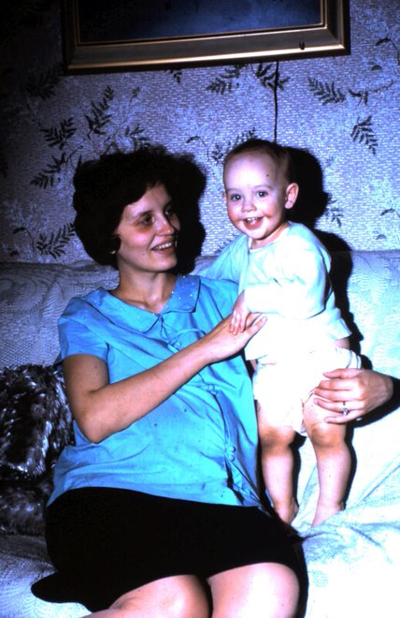
My mother holding my brother Gary while pregnant with me.
The crisis had passed by the time I was born the following April, but by then she was too overwhelmed to care. She gave birth to me at the Neillsville Memorial Hospital during a record-setting heat wave. In the days before air conditioning, she would not have been very comfortable, but she was young, a 22-year-old farm girl toughened up by cold Wisconsin winters.
She brought me home to a small apartment in the nearby town of Granton, where my father had found work as a math teacher. Having just turned 23 himself, he was only a year out of the Eau Claire State Teachers College where they had met. Most of their classmates were already married and out in the world just like they were. In those days it just seemed like the normal thing to do upon turning 18: get married, have kids, settle down.

It’s hard to tell, after more than fifty years, which of my own memories are genuine and which are “memories of memories”, the foggy chimeras inherited from long-forgotten discussions about my earliest memories. Nevertheless there are a few incidents I can recall with enough clarity, and that fit the basic facts, well enough that I think they qualify.
My brother Gary was barely ten months older than me, and my sister Connie was only a year younger, so they were in all of my memories. I vaguely remember playing with them, on a hard wooden floor – maybe at Grandma’s house? All of my early memories are happy and content.
I remember living in a house in Eau Claire, with back yard facing into a woods. It was Autumn, or perhaps Spring, because there were dead leaves on the ground, without much vegetation. There was a dog – I don’t think it was our dog – and he was running into the woods, so I followed. After a short distance, I noticed I was getting far from home so I stopped, hoping the dog would return, but he never did. That’s the memory: that’s it. The rest is an unsatisfying lack of closure, wondering what happened.
My parents tell me that we didn’t have a dog at the time, so it must have been a neighborhood pet. But what was it doing in our yard? Why did it leave such an impression on me? Who knows?
I vaguely remember the house itself: yellowish paint on the inside, a front door that opened directly into the main room, facing the tiny kitchen. A sofa to the left of the door blocked off the living room, where a child’s crib (my sister’s?) had been set up. Later my parents told me a story how, upon bringing my baby sister home from the hospital and setting her in that crib, my brother and I felt the urge to make her feel at home. We donated our favorite toys (or so the story goes), some heavy steel-made Tonka trucks, which we somehow tossed into the crib, barely missing the poor baby.
Another memory, set in the same house: I was talking with my mother, apparently about an upcoming birthday. “Your birthdays keep rolling along,” she said, and in my mind I pictured a birthday cake, spinning up the hill to our house. If that memory is accurate, based on the dates that my family was living in that house, it would have been just before my third birthday.
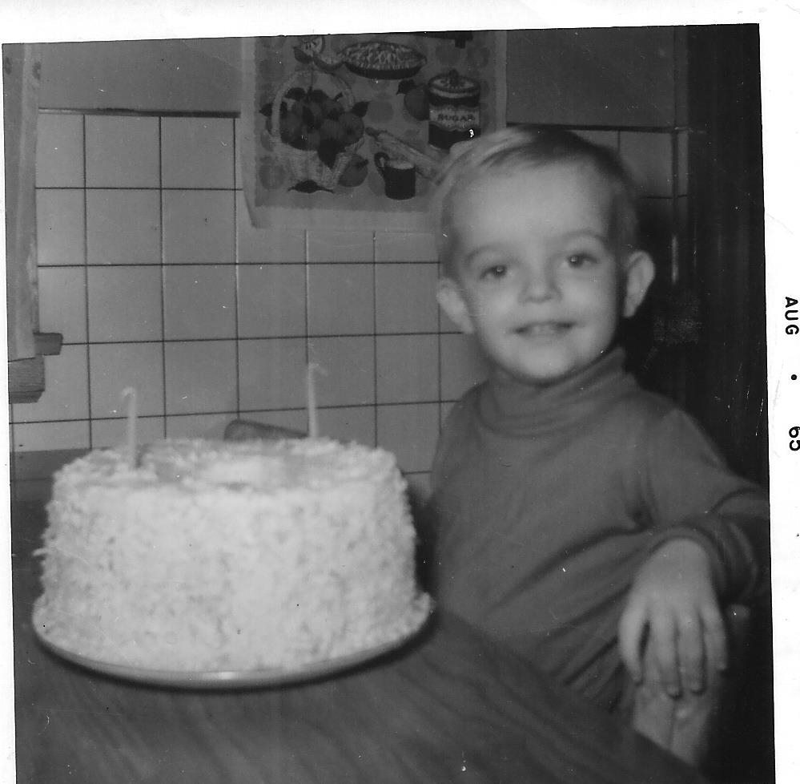
I’m two!
My left wrist bears a very light scar, nearly faded after half a century, which my mother said is the aftermath of an injury involving a toy drum set. I have no memory of this at all, but in my mind’s eye I picture a cheap, exposed metal ring protruding from a plastic covering, somehow digging into my wrist. It must have been more traumatic for my mother than for me, because if there were any long-term effects, I soon forgot them.
For years during my childhood, my mother called me by the nickname “mouse”, because she says I was so silent as I crawled through the house. If I was unusually quiet for a small boy, it may have simply reflected my overall sense of contentment. In photos, the baby me was always smiling, looking contentedly at the camera (no doubt, happy to oblige the requests of whoever was taking the picture).
We moved to Neillsville by the time I was four years old, most likely in the summer, in time for my father to take a job as a science teacher at the high school. Our first stop upon arrival was at our new church, the Neillsville Assembly of God, and there I made my first friend: Tommy Mohr, whose mother was the church secretary. His older brother Bobby became my brother’s friend. Though I remember little else about the Novak boys from those earliest days, I imagine we saw them regularly – several times a week – before and after church services, no doubt and perhaps in between. They lived in the country, so it would have been impractical to visit him at his house – my memories of our rare visits there are when he was a bit older..
That’s it. Those are my only memories of life before elementary school. I would have begun with kindergarten, after I had turned five in April of 1968, so an entire year had passed in Neillsville before my memories kick in. That seems odd, now that I think about it – a move to a new city spurs no special memories in a child of that age – but perhaps I was so content, so trusting of my parents, that the surroundings of home and neighborhood just faded into the background. I was a happy baby, living a contented early childhood with a family who loved me, and maybe that’s all I need to remember.
Happy baby

2.2 Elementary Stories
My first day of kindergarten was a disappointment. Our teacher, a white-haired woman named Mrs. Helen Smith, was by the time I joined her class in the 1960s had no doubt been teaching since before World War II, and I’m sure nothing about a group of five-year-olds was unfamiliar. When our classmate Jane, who could not bear to be parted from her mother for the few hours in the afternoon for our half-day classes, began the class with sobs and whimpers, Mrs. Smith promptly dispatched her to the art closet, ensuring the rest of us would be undisturbed by her distress. When, sometime during the year, my classmate Doug swallowed some pennies, she knew to calmly call the Principal, who drove him to the hospital.
My brother, who had his first day a year previous and who, as far as I was concerned had demonstrably achieved greatness in all things Kindergarten-related, proved to me that school was a busy, happy place, full of art projects and alphabet practice – and familiar playmates. I didn’t know the children surrounding me on that first day, but I would. Most of them would be my companions for the next twelve years, and more than half would remain known to me for the rest of my life. Of the hundred or so kindergarten kids, split into four classes – two in the morning, two in the afternoon – perhaps seventy-five or eighty would be together at high school graduation. Thirty years after that, about forty would gather for our class reunion, many of them with grandchildren already attending the very same school.
Mrs. Smith promised us that our first day would be an easy one: some play time, a song or two, a brief introduction to the fun we’d have during the year, a snack, and – if we had time, she assured us—a nap. The rest of the agenda happened as promised, but the nap never materialized and I went home with the cocky self-confidence of a five-year-old who knew already that sometimes teachers are wrong.
Never mind, soon I was caught up in the daily rituals of school. In those days, none of us entered kindergarten with any experience with the alphabet, or with numbers, so there was plenty to learn.
The best part of school was the toys: trucks, wooden bricks, and guns for the boys; a pretend kitchen complete with pots and pans and fake plastic wigs for the girls. I don’t remember recesses outside. Maybe we didn’t have any: in the cold Wisconsin winters it would have been a big project for Mrs. Smith to dress up all those kids, send them outside, and reverse the process when they came back in. No matter: I wasn’t much of an outdoors type, and playing with balls or other sports wouldn’t have appealed to me. I preferred to play in that pretend kitchen, with the girls, though eventually Mrs. Smith corrected me and made clear that I needed to be with the boys. Oh well, that was okay too.
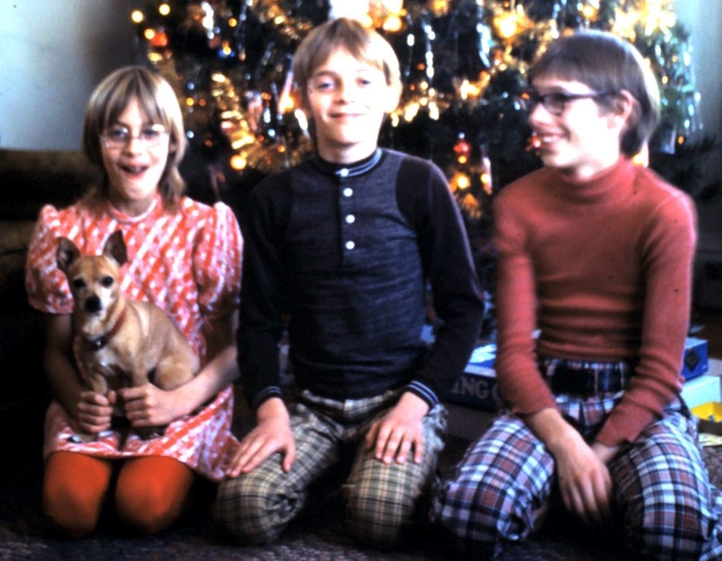
Christmas with my brother and sister, with our pet dog, Charlie Brown

2.3 Charlie Brown
I remember little about the circumstances that led our parents to drive us to a farm outside Neillsville where we were greeted with our new puppy, who for some reason we promptly named Charlie Brown.
“Chucky”, as we often called him, was a part-chihuahua, part-terrier mixed breed descendent of some indoor farm dogs. More important than the breed, though, was the purpose of the dog. In rural communities like ours, dogs were divided into two categories: farm dogs – which lived outside – and indoor dogs, where were kept strictly as pets.
Farm dogs were large and given free roam to mingle and travel however they liked. Good farm dogs helped round up the cows or other stray animals, scared off any deer or other intruders that attempted to graze on a vegetable garden, and generally provided overall security services. It didn’t matter the farm – if you for some reason attempted to sneak into a neighbor’s yard at any hour of the day or night, you were guaranteed to be greeted by the loud bark of a farm dog.
Farm dogs lived outdoors year round, sheltered in a small dog house built for them. On the coldest of winter nights they might be given access to the barn, but generally the breeds that thrived in Central Wisconsin were the type that if anything preferred the cooler weather of the winter. Huskies, Collies, Danes – large animals with hearty appetites and friendly, curious personalities that kept watch over the farmstead.
By contrast, an indoor dog like Charlie Brown was suitable mostly as a pet, like a loving sibling whose only responsibility was to provide affection to the other family members. Ostensibly tasked with home security services like their outdoor cousins, most of these pets were pretty worthless. Charlie Brown was happy to bark at intruders when circumstances were obviously peaceful, but he wouldn’t hesitate to hide under the bed if he thought there was any real danger.
We once tried to breed him – we lent him for a weekend to a family whose female dog was in heat – but Charlie showed no interest. He could be a little touchy around other dogs, and occasionally would nip at a stranger if provoked. He slept a lot.
Still, he was our dog and we treated him like family. He ate when we ate (including table scraps), and often accompanied us when we were outside playing. I don’t remember having any specific duty to take him on daily walks – I assume my mother did that, or perhaps the only “duty” was to open the door and let him come back when he was finished.
I don’t remember ever asking neighbors or others to watch him when we were out of town. Charlie came with us everywhere. After all, he was part of the family.
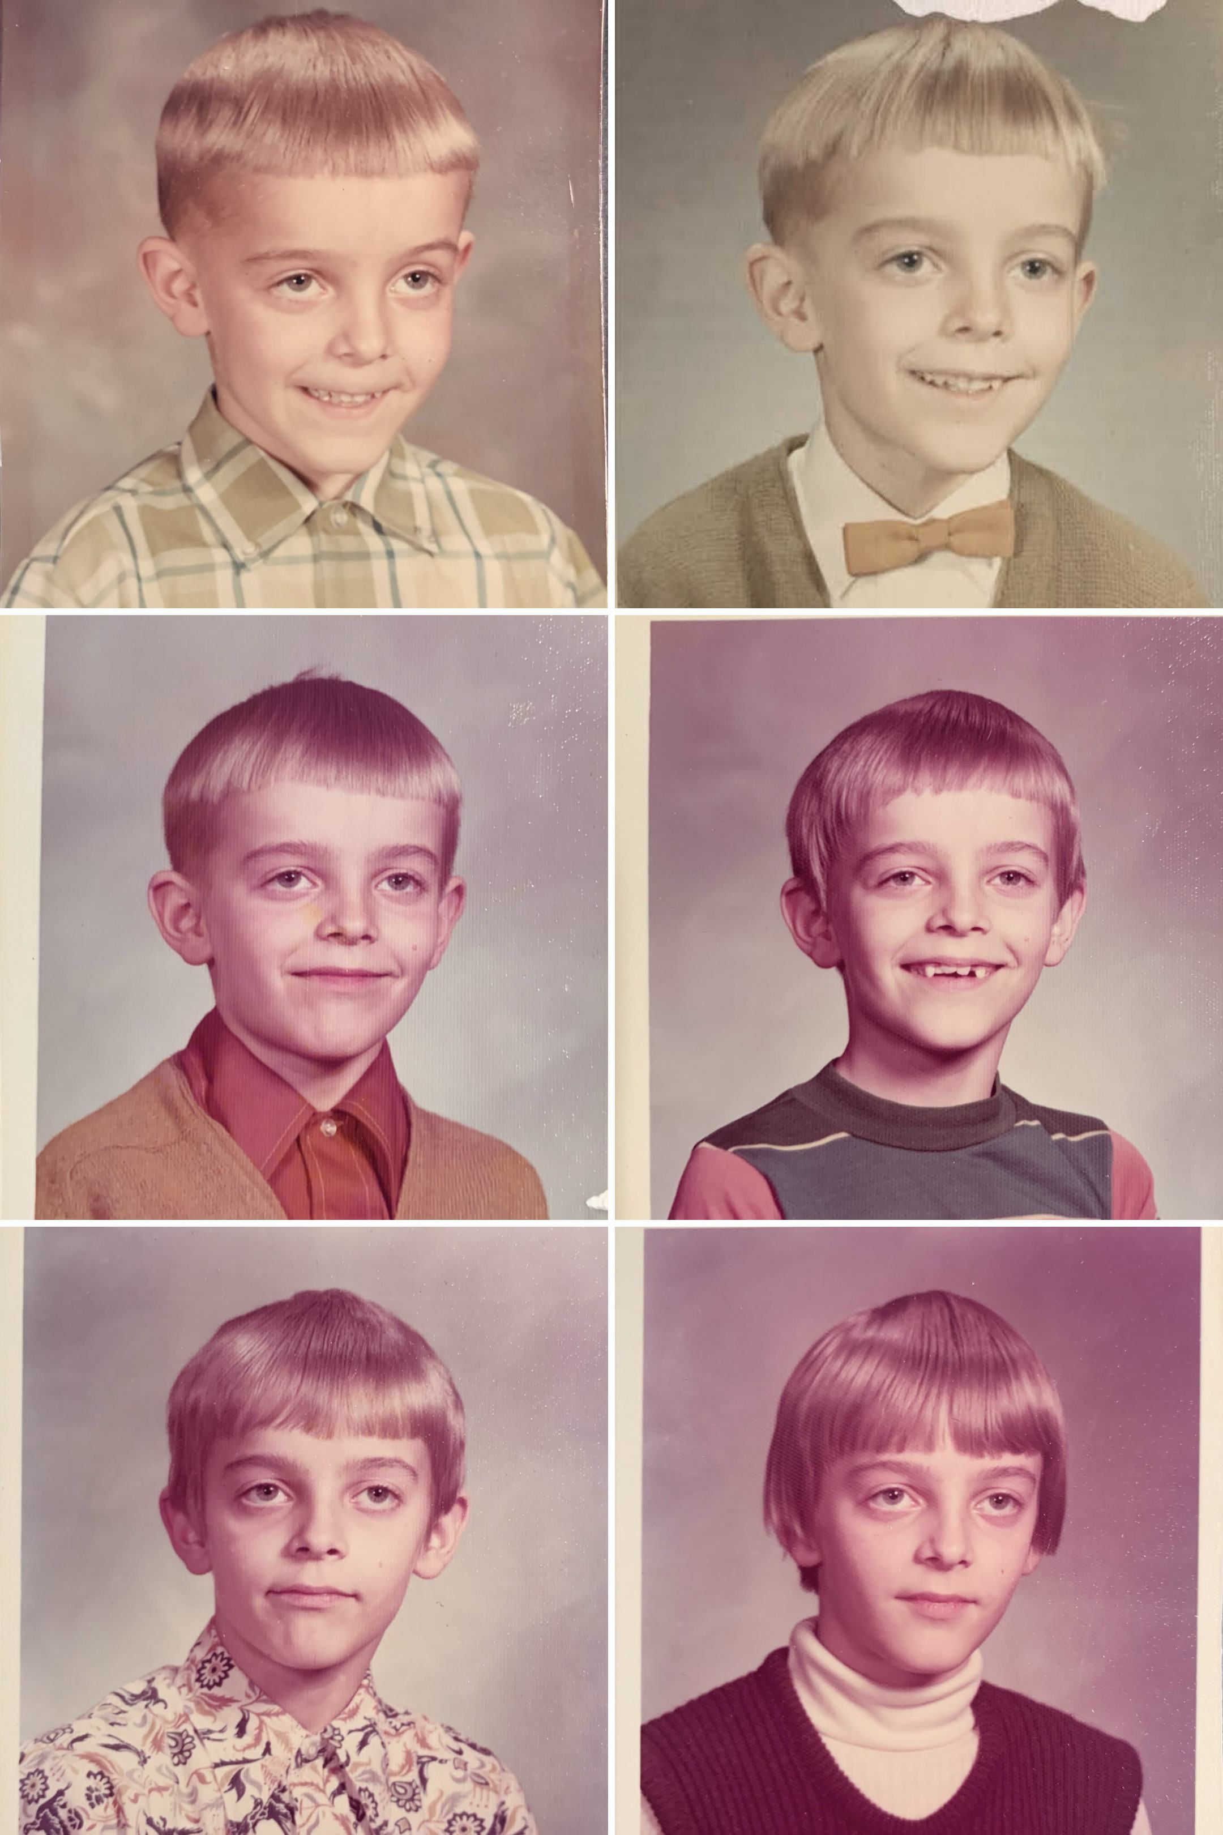
You can’t tell from this series of elementary school portraits that I was very sick part of the time

2.4 Hospital
A few months after Kindergarten, my teacher called my mother to pick me up early. I’d been experiencing such a severe stomach ache that even a hardened teacher like Mrs. Smith knew it was hopeless to expect me to finish the half-day class. At first my parents assumed that it was something I ate, or that I’d eaten too much, but when the pain continued the next morning, they thought maybe I’d caught a virus of some sort and kept me home from school. I was feverish and couldn’t hold down food, and after a few more days they became concerned.
My family didn’t have a lot of income, but in those days it wasn’t unusual to be like us without health insurance of any kind. Doctor visits were cheap, especially for routine things like childhood vaccinations, so most people just paid for their medical bills in cash. But even the few dollars it would cost to visit the Neillsville Clinic was a tradeoff for my parents – it was money that couldn’t be spent on other things – so I was kept home in my mother’s care until finally they decided that my condition wasn’t a normal illness. They needed professional help.
I don’t remember much about my first visit to the hospital. My mother knew Dr. Thompson, the doctor who had delivered me five years previously, but this time I was assigned to Dr. Ozturk, one of two Turkish-born doctors of the four or five doctors at the Neillsville Community Hospital. He spoke with a friendly accent, his face smiling and eyes squinting when he examined me.
He was a surgeon. The small staff at the hospital had determined that I had a bowel obstruction – my intestines were wrapped around themselves in a tight knot that prevented passage – and having waited so long for treatment, I was in a dangerous situation.
Bowel obstructions are very rare in small children. Years later I learned that, as a baby, I was born with a hernia, a not uncommon condition caused when the navel doesn’t completely close over after the umbilical cord is cut. In nearly all cases, the belly button closes over naturally in a few weeks or months, but in my case it took longer – years – and apparently a piece of my bowels had become entangled as a result, leaving me obstructed.
The standard treatment is to wait it out, inserting a tube through the nose into the stomach to release pressure on the intestines. An intravenous (IV) drip was placed into my tiny five-year-old arm to give me some badly-needed hydration and food. But I had already waited too long, and my condition remained serious. This would not resolve itself on it’s own, Dr. Ozturk concluded, and arranged for surgery.
Operating on a five-year-old is a big deal to any parent or relative, but I don’t remember much. In later hospitalizations I would revel in the attention, but perhaps my condition was so serious that I was simply too weak to notice anything.
They operated, and along the way Dr. Ozturk decided to remove my appendix. I’m unsure why. Appendicitis is very unusual – perhaps unheard of – at that age, and it would have been a straightforward procedure to adjust the bowels to end the obstruction. Maybe my condition was worse than expected, and inflammation had spread to the appendix? More likely, I now think, he removed the appendix because to a 1960s doctor, it was a vestigial organ whose only effect on health would be negative, if later inflamed, and he thought that as long as he was in there anyway, he might as well get rid of it and save any potential later trouble.
Anyway, the surgery was a complete success and I made a full recovery. I was back in kindergarten, back playing with my friends, back with my family, just a normal five-year-old boy. The only change was that now I had a story, something that made me special. I was the kid in the family who’d been in the hospital.

2.5 More Hospital
After kindergarten, after my appendix had been removed, I seemed to have fully recovered, yet I continued to have stomach pains, which my mother treated with Pepto Bismol. The raw pink taste of the gallons I drank still hasn’t faded after all these years, but at the time my situation didn’t seem particularly disturbing. After all, I was a small boy who’d just had major surgery. Otherwise I continued to develop normally and all seemed fine.
But sometime in third grade, my situation became much worse. The doctors wrote the following notes on August 14, 1971:
The child had been sick for about a year and probably more. He would chronic abdominal pain and off and on his breathing was not regular. There was something wrong going on in his abdomen and the parents did not have any insurance, his father is a minister and does not have much money and he did not bring the child for exam. On admission he was chronically ill and he was in a mal-nutritive state. He was slightly toxic and his growth was a little below the average. For the past three or four months the child would not eat because he stated to his parents that his abdomen gets tight when he eats and at times while he is eating he would stop eating because of the same pain. This has been going on chronically for the past three or four months and prior to admission his symptoms became worse and the day of admission increased in intensity and he became acutely ill.
Unlike kindergarten, where I distinctly remember the day I went home early from school due to illness, I have no memory of how or why I ended up in the hospital this time. Looking back at the doctor’s notes now, after all these years, I see that my situation was far more serious than my younger self could comprehend. The small town doctors in Neillsville gave up on me. Unable to help further, they loaded me into an ambulance and transported me to the much bigger hospital thirty miles away in Marshfield.
I was assigned to a Japanese-American doctor named Dr. Toyama. Years later, as an adult who had spent years living in Japan, I went back to Marshfield and found him again. I learned he was an issei—his parents had come to the US before he was born, and he grew up here (I don’t remember where exactly). Somehow he ended up living in the middle of Wisconsin and had spent his entire career there. He didn’t remember me very well – he claims he did, but with so many thousands of patients over the years it’s hard to tell exactly – but when I was a suffering eight year old, he was the center of my existence.
Upon arrival at Marshfield, Dr. Toyoma wrote in his notes about me:
He was doubled up in fetal position…the abdomen was flat, colostomy on the left side which was not yet matured…bowel sounds were absent…The child did appear exhausted.
Due to the pain, Dr. Toyama didn’t do long tube intubation and went straight to surgery, where
he was found to have a tight adhesive obstruction in several areas with collapsed bowel distal to the obstruction. The obstruction was in the mid small bowel. There was purulent non-foul fluid in the peritoneal cavity at the time of exploration, however, no perforation was noted. The colon appeared normal…cultures of the peritoneal fluid grew out pure culture of E-coli.
After conferring with the Neillsville doctors and my parents, Dr. Toyama decided that my original surgery hadn’t addressed the real problem, which was a sigmoid volvulus, an intestine that was predisposed to become wrapped around itself and become blocked. I had been sick for quite a while and there was a significant danger I had already sustained permanent damage, he feared, so I would require a series of surgeries to uncover the underlying problem and find a permanent solution.
Meanwhile, my current situation was extremely serious, he warned. I was so weak that there was already a good chance I wouldn’t survive. My brother and sister were called to the hospital – normally young children weren’t allowed inside the patient area – and were told, gently, that this might be the last time they see me.
I knew I was not well, but at the same time I also knew that I was very special: a constant stream of friends, relatives, and neighbors came to my bedside bringing all manner of presents. I was the center of attention! If anyone told me there was a chance I’d never leave the hospital, I don’t remember it, because I certainly didn’t feel like my life might soon be ending.
In fact, among other memories of that time, I remember thinking how wonderful it would be to fly in an airplane, maybe even become an airline pilot. I don’t think I was particularly worried one way or another about the future.
Marshfield was a great, modern hospital, with its own pediatric ward, full of other children, extra-friendly nurses and even special activities and visitors. Famous visitors who passed through town would often stop to see the hospital, and of course the pediatric ward was a must-see for them. One day the famous basketball performance team, Harlem Globetrotters, came in to my bedside and signed autographs for me. Lying in bed with an IV, tubes coming out of my nose, and with my weak, skinny arms, I must have been a pathetic sight, but I never remember any sense of concern around me. To me, it was all a place of wonder and nonstop attention.
There was one exception to my sense of calm. Since Neillsville was about thirty miles away, my parents – usually my mother – had to drive quite a distance to see me. Since she was responsible for my siblings as well, who were in school but still needed to be fed and cared for, she could be with me only during the day. The evenings after she left, and especially the mornings before she arrived were difficult and lonely.
My religion was a big influence on everything I did, so naturally I saw my hospitalization in the context of God and His purpose for my still short life. I had been taught that only a tiny few people had a true understanding of God’s plan for humanity, and that even among those of us who believed, we still fell short of what God wanted. And a sin is a sin; even one tiny, seemingly insignificant breach of God’s rules could keep you out of heaven just as certainly as the most dastardly bank robbery or murder. I knew that I sinned too – sometimes the worst sins of all are those that you do subconsciously, non-deliberately, in a moment of forgetfulness, and I had plenty of those.
Some sins are passive – what I would later learn to call “sins of omission”—when we know that we should do something but we don’t. These are among the most annoying sins because they result from laziness, or lack of willpower, and sometimes from simple shyness. For example, I knew that my fellow hospital patients were mostly unbelievers, and that I owed it to them to share my knowledge of the saving grace of Jesus Christ. By not sharing – by keeping silent when I knew that they could benefit from this message – wasn’t I falling into a terrible trap of the Devil? Wasn’t that a sin?
I knew the importance of keeping up my faith with regular prayer and Bible reading. Sometimes I forgot, or was too lazy or distracted. Wasn’t that too a breach of God’s will – a sin?
Although you’d think that an eight-year-old, weak with sickness, tired and injected with medications, would not have cause to think much of these things, in fact it was at the center of my mind. I knew that God loved me, and that it was only through prayer and diligently following His will that I had survived this sickness at all, but I also knew he was testing me for some greater purpose. Would I pass the test?
One morning, after a particularly difficult night of anxiety over this, I woke up thinking I knew the answer: clearly I had failed the test. I was convinced that this meant I would not be going to heaven at all, and with the imminent Rapture an ever-present possibility, I suddenly had a strong premonition that last night had been the moment when Christ returned to earth, and I was left behind.
I began to cry. A nurse soon noticed this and immediately tried to comfort me.
“What’s wrong?” she asked, holding my hand with a voice of sincere concern.
“I’m afraid,” I said, hesitating. Should I tell her my real fear – that the Rapture had happened last night and that I had missed it? If this were true, then it meant my nurse had missed it as well. Was this really the news that I wanted to break to her at this moment? First I’d need to explain all those other details of the Gospel, and she’d want to ask questions, perhaps challenge me with doubts. This whole explanation could take a long time, and at this moment I was just feeling sad that I wouldn’t see my mother again.
I decided to skip the long explanation and just cut to the point.
“I’m afraid,” I said, continuing, “that my mother won’t be coming back.”
As an adult looking back on this, I can imagine the reaction this produced in the nurse, who no doubt wondered what sort of family life could cause a little boy to doubt that his mother would visit him in the hospital. She was calm about it, though, listening to me and offering her reassurances that my mother would be there the same time she always was.
She was right: my mother walked into the room, to my immediate relief. The nurse explained that I had been especially anxious that morning, worried that my mother wouldn’t return, that this was a normal type of separation anxiety, not to be concerned, etc. That was it.
But I wonder if this had happened today, maybe she would have been required to note my behavior somewhere, perhaps a side report to a doctor or a social worker to be on the lookout for signs of family abuse or some other tragedy.

The burden of caring for me was so time-consuming that around this time my brother and sister were often dropped at the farm of our Pulokas Grandparents. I was too sick to know much about the time they spent there, but I know they enjoyed it. Partly of course it was because their grandmother spoiled them – delicious food and plenty of toys. Life on a farm can be especially fun for little kids. Gary enjoyed looking at the farm equipment – Grandpa even let him drive the tractor. They played in the hay mow of the barn, rearranging stacks of hay to make pretend forts. And of course there were animals: dogs, cats, rabbits and cows. Gary was old enough that occasionally Grandma would let him try milking, though despite Grandma’s patience he showed too little interest to be of much help.
There would be plenty of other visits to Grandma’s house when I came out of the hospital, but I know Gary and Connie kept special memories of that summer’s lengthy visit, when the two of them developed their first tastes of independence away from parents.

2.6 Gungors
The Neillsville of my first memories may have been rural, but it was not completely removed from “The Sixties” of the rest of America. One of my first glimpses came in art class, when the teacher let the girls bring record albums to play while we worked: popular songs of the day, like Leaving on a Jet Plane, or Do You Know the Way to San Jose, repeated over and over.
My school held bomb drills, last vestiges I guess of the 50s and 60s fear of nuclear war, where once or twice a school year we learned to duck under our desks for protection.
We had hippies, Hells Angels, and draft evaders just like the big cities. One day, while browsing a copy of US News and World Report, I came upon some photos of the Black Panthers, and my mother warned me to immediately report to her if I ever saw anyone like that in real life.

One sunny morning I woke up to find one of our downstairs windows shattered. Dad had run outside to catch the two teenage boys responsible. He apprehended them and was arranging to settle the matter with their parents, a doctor and his wife. Although they lived only a block away, that was the first time I heard their name: Gungor.
Dad had been working at the high school as a substitute teacher, and the two were in his class. Somehow the teenagers learned that Dad’s real occupation was a small-town preacher, and this was apparently funny enough to them that they decided to vandalize our house. I don’t know the full story, but if their intent was to intimidate my father somehow, their plans backfired.
This was not my father’s only close call. While setting up the church, he reached out to many people and groups on the margins: alcoholics, deadbeat dads, single moms and their unruly children. He even spoke to members of the nearby Winnebago Indian tribe, including one very large and mean-looking man named Rudy, who arrived at our doorstep once very late at night insisting that he needed to talk about God, alone, in a place far away.
Dad greeted all of these rough people with the same missionary zeal that led him to Neillsville in the first place, but his farm-raised instincts kept him well-grounded in the ways that people could be evil, so if Rudy started with any ill intents, they evaporated by the time Dad finished talking with him and Rudy became a regular church goer.
So it was with the Gungor boys, who quickly became enthusiastic members of our church, forming our local version of the “Jesus People”, a Hippie-inspired movement that spread with the Sixties, substituting Christianity for drugs but keeping the same dress code (long hair, blue jeans, bandanas) and focus on love and peace. The two boys, Ed and Mark, were also musically inclined and they formed a Christian rock band, drawing even more young people to our church.
One of them was their little brother, who was introduced to me in the basement of our church one Sunday as Jimbo, the precocious doctor’s son, who soon became my best friend.
Jimbo was a year younger than I was, but had skipped first grade and was a third grader like me. He was the pride of his mother, Lily, who knew he was destined for greatness and spared no expense to ensure he had the finest of everything. It was a treat to visit his house, which seemed overflowing with the latest toys of course, but also with books and innumerable puzzles and games. We soon discovered a mutual interest in Chess, Stratego, and many other board games of strategy that kept us busy every weekend.
Jimbo had a younger sister, Lisa, who was Connie’s age, and they became such close friends that they nicknamed each other “sissy”. Gary joined us too, and there probably wasn’t a Saturday where we all didn’t play together. In the winter, we could go to the Gungor’s large basement with its musty shag carpeting and endless games of the board game Life.
The Gungors had one important possession we didn’t have: a TV, a full-size color model that seemed to be always turned on. To us Spragues, this was both a treat and a mystery: we had no television at our house, so anything we saw was new. But in those days before home recording and cable TV, the viewing options were limited on weekend afternoons, so we watched less than you might think. Still, Jimbo watched enough that he was able to introduce us to TV-inspired real-life games, where we would imitate the premise of a show, taking on the roles of one of the characters, pretending to live in that world. Our favorite was Star Trek, which I had only been able to watch in brief glimpses, but with Jimbo we played incessantly. He liked to be Captain Kirk, Gary was Scottie – the resourceful fix-it man, and I of course was Spock, the unwaveringly logical, science-oriented, and endowed with special powers that let me do mind melds and Vulcan death grips.
It was also at the Gungor house that occasionally I was allowed a peek into his father’s study: a small room that was positively crammed with books and magazines. Dr. Gungor was a Bulgarian-born Turk who had lived under the Nazi occupation as a boy, became a medical doctor, and immigrated to the U.S. in the 1950s. It was while practicing in New York City that he met Lily, a lively Puerto Rican woman who became his wife. The rumor was that Lily had been a single mother with three young boys and she met Dr. Gungor while bringing them to his clinic.
I have no idea how such an unlikely family ended up in Neillsville. When I met them, the three oldest boys were followed by an oldest sister, Leyla, then Jimbo, and the youngest girl Lisa. It was a big family in the middle of Wisconsin farming country. A doctor’s income in Neillsville made them among the wealthiest families, and Lily’s gregarious personality meant they were among the most social families too, seemingly connected to everyone.
The Gungors, besides being close friends, also became for me an aspiration, of another world that could be realized through education and money. And their world was highly approachable: through my friendship with Jimbo I realized that money had great usefulness but it didn’t determine happiness or success.

2.7 The Pack
Though it’s true that people in a small town are naturally open and friendly to one another, that does nothing to diminish the human instinct to separate into smug cliques and, beginning in middle school, this segregation began in earnest.
There were early hints even in elementary school, like the time walking home with my brother in second grade, when the Larsen boys appeared out of nowhere and threw our art projects into O’Neill Creek. The projects weren’t that important, we told ourselves, and those kids were way bigger than we were, so we chose to simply ignore that act of meanness.
By middle school, though, the Larsen boys – especially Mike Larsen, the oldest – were completely out of hand. Between classes, Mike was always surrounded by the biggest, toughest boys, all of whom seemed permanently on the lookout for weakness. It was as if they fed on it, like vampires in a never-ending search for blood.
They found their first blood in David O’Grady, a friendly, slightly portly boy who otherwise was normal in every way. He was in the same grade as my brother, who was a friend and regular lunchtime and recess companion. But David had one conspicuous weakness that was quickly and mercilessly exploited by the unforgiving mean boys.
David had arachnophobia, a fear of spiders that was impossible to ignore among boys looking for a target to prove their own strength, because as every boy knows, nothing is a better proof of strength than the weakness of another.
The rumor was that David had, as a very young boy, been attacked by spiders in an outhouse while using the facilities, and the experience had traumatized him so much that he was barely able to think about spiders without getting chilly reminders of the incident. His fear was total, completely irrational, enough that the mere mention – the mere threat of a mention – would send him into a clear defensive stance, his eyes widening, his lips pursed, his stance ready to flee. The other boys, seeing his, could not resist the easy kill, and soon David was surrounded by taunts.
During the Fall and Spring, when live spiders were abundant and easily snared by the farm boys, David was in especially big trouble, but even Winter brought little relief. Nothing gave greater pleasure to the meanest boys than to draw a picture of a spider on David’s notebook – watch him squirm! – or to threaten that one had been discovered and was now – here – in my hand waiting to be tossed right in his face.
David, sadly, was unable to hide his fear. The mere mention of the word, the slightest hint that the very concept of spider was about to be brought into the room, send him shivering with chills. There was no refuge. When he tried to hide in the library, the boys brought him magazines and books with pictures of spiders. It got to be so bad that he couldn’t go near the “S” section of the library, for fear that a heartless bully might be lying in wait ready to pounce with a book of gruesome photos.
My brother, being an erstwhile friend of David’s, soon became a target as well. Gary was not himself afraid of spiders, but there was guilt by association, and the meanest boys began to search for his weaknesses, as if it was their solemn duty, like inquisitors, to find every soft spot in the school body.
Being younger, though only by a year, threatened to push me into the negative association as well, and I began to see constant reminders of how close I was to becoming the class punching bag. The mean boys showed no mercy on David O’Grady, and now the boys in my own grade, seeing the fun, couldn’t help but notice the advantages to their own status by being able to prove that somebody else was weaker. It seemed to be just a matter of time before they came after me too.
Jimbo was worried. A city boy through and through, he was unable and uninterested in the physical activities that the bullies respected. The meanest boys always traveled together, “like a pack”, he said, and soon that’s the label we assigned them.
The Pack. They congregated during free moments at school, like wolves hunting for prey at breaks between classes, at lunch time, and after school. If you saw them together, you knew it was trouble, and I soon learned to avoid certain areas of the school, or – when that was impossible – to make sure to pass only when other, weaker boys could be sacrificed to ensure my safety.
Gary and I were obvious weaklings. Both of us, tall and skinny, Gary with his awkward glasses, our pants always too short. Today’s school administrators, ever-vigilant against bullying, would have intervened to protect us. But we had no such help. There were no anti-bullying signs posted in the hallways, no hall monitors to watch for signs of the weak being exploited by the strong. We were on our own.

2.8 Religious School
The Neillsville public schools had for a generation been consolidated into a single building at the top of a hill on the eastern edge of town. I entered kindergarten on one side of that building and graduated high school on the other side. In between was a middle school that, in the mid 1970s needed major construction, a years-long project that required all sixth graders to bus daily to an old one-room schoolhouse outside of town, the only place large enough to hold the classes. My brother attended there for his sixth grade, and I would have gone there too, but about that time a new school opened in town: the pastor of the Bible Baptist Church began accepting students for a religious-oriented school for kids from kindergarten to high school somehow it was decided that I would attend too, for a year. Jimbo’s parents decided to send him as well, so the two of us joined about 20 or 30 kids each day in the pastor’s house, where small divided desks had been set up for our school.
The curriculum was from a national organization called Accelerated Christian Education that produced a series of go-at-your-own-pace workbooks on all subjects relevant to a primary school education. The process was simple: you take a short test to determine your initial classroom level, and you work your way through various assignments and quizzes in a workbook until you could prove through passing another test that you know the material. For me, it was a natural and easy way to learn and I breezed through much more than one year’s worth of material in the time I was there.
The curriculum’s initials, ACE, also stood for a series of “privileges” you could earn weekly for various academic-related tasks. The “A” privilege was easiest to achieve, and it allowed you to have regular recesses in exchange for completing a certain amount of work on time each week. “C” gave you additional recess time and it was flexible: you didn’t have to take your breaks with everyone else. In return, you were expected to do all the work required for “A”, plus extra, and there were some other tasks, like completing a book report. But I worked hard to achieve the hardest, “E” privilege, which gave unlimited recess time. You earn it with all the “C” requirements plus a class presentation and some Bible memorization. Although I started the year striving for “C” privileges, matching Jimbo, I soon realized that “E” wasn’t that much harder, and soon I was achieving “E” every week, greatly increasing my free time.
Attending the school allowed me to became good friends with many of the students, most of whom were hard-core Bible Baptists. One peculiar characteristic of religion is that often the biggest animosities are reserved for those who are more similar in doctrine than those who disbelieve altogether. So it is that Southern Baptists disagree more vehemently with Bible Baptists – often to the point of veering into personal attacks – than they do with, say, Catholics, Mormons, or even atheists. To a Bible Baptist, an atheist can be excused perhaps for simply misunderstanding the message of Christianity; but a Southern Baptist has no excuse. When the two denominations disagree – as they often do – about the meaning of a single word in a Bible verse, neither side is guilty of a misunderstanding. The only way such a disagreement could happen is through willful, perhaps even malevolent blindness.
To fundamentalist Christians, there is no greater apostasy than to break with the True Faith on the matters of theological urgency that separated our churches, and the year I spent with the Baptists was for me marked with great memories of theological debates, both with other students and with the pastor.
David Webster fit all the stereotypes of a thundering Christian fundamentalist: crew cut hair, always dressed in white shirt and tie, deeply and sincerely committed to his faith. I found him stern, but fair, and nobody could ever accuse him of hypocrisy: I know he sincerely believed in everything he taught, and he lived his life according to the principles he expected from us.
A fierce anti-communist and sincere follower of the John Birch society, he saw the hand of Satan in everything, and believed America was great only because of its Judeo-Christian principles, a bedrock that had greatly and perhaps irreversibly eroded by the time he met us. Rock ’n roll music, everyone in Hollywood, the international banking system, much of the scientific establishment, and many more powerful institutions were in open conspiracy against us, and we would prevail only by holding our Christianity tightly.
Our discussions at recess and lunch grew into deep theological, philosophical, and often scientific debates, and I thrived. He tried to convince me that my father’s church was victim of a terrible Satan-inspired lie that hinged on some subtle Biblical wording. Similarly, he taught me how science was polluted with demonic lies about the nature of God’s creation; Evolution of course was the worst offender of all, insidious because from a purely scientific standpoint it made a mockery of the scientific method. How could anyone be fooled by such obvious falsehood?
I learned so much from him that year, and from my fellow students, as we debated these great issues. For the first time I was forced to confront how my father’s religious beliefs were distinct from other Christians, but I was able to do it in a friendly environment of people who treated the Scriptures as sincerely as he did – the only difference being that they had found an alternative interpretation. Although I didn’t get to debate Evolution in the same way – we were on the same side on that issue – I learned to respect the skill of delving into facts, always looking for holes in my arguments, to be prepared for a debate with eternal and life-or-death consequences.

3. Hopes and Dreams

3.1 Hobbies
My own children grew up in a world with screens everywhere, and it’s hard for them to understand a place without the TV or internet. What was there to do?
Plenty! Our lives were a rush of school and church activities, a big woods nearby that needed exploring, and an unlimited number of hobbies. Surrounded by the natural world, we collected rocks for polishing, and I remember keeping small potted plants – a tiny cactus. Gary had an Erector Set and I had Tinker Toys. Like all girls her age, Connie had her Barbies.
Stamp collecting came naturally in a preacher’s family that occasionally received letters from missionaries in other countries. Paper letters were natural and abundant in those days, and so was were the stamps affixed to them. Competition was natural for two boys so close in age, and my brother generally avoided direct matches with me, so I think he wasn’t particularly serious about his stamp collection, and appeared unconcerned that mine seemed to be always bigger and better.
Then one day, out of nowhere, a package arrived for him containing a treasure of philatelic supplies: genuine stamps from around the world, a book describing how to excel at the hobby, and a magnifying glass. He was elated! Somewhat enviously, I agreed to look more closely at his new haul, when I noticed the fine print on the cover letter, explaining that this package was being sent on a trial basis by generous people who just knew that he would want to purchase it, but that in the very unlikely chance that it didn’t meet all his desires, he was welcome to return it without charge.
Naturally he was devastated. Now I know that such unsolicited mailings are illegal and that he would have been entirely within his rights to keep the whole package, but at the time it was nothing but a letdown and his interest in stamp-collecting disappeared.
That’s okay, because we had plenty of other ways to keep busy. We played with model rocketry and model airplanes, loved by my brother, who was always more of a builder than I was. And of course there was music.

3.2 Music
We didn’t think of ourselves as an especially musical family, though by most standards today I guess we were.
My mother had a good singing voice, but had never learned to read music or play an instrument, so most of the musical activity in our family came from our father, who learned from his grandmother. We had a piano in our home, I think as a gift from Dad’s family, and he would often in a moment of boredom play a few pieces from memory, like the hymn “When I think of the goodness of Jesus”. He whistled too, and it was not unusual to hear him humming a song or two. I think he secretly wished our family was much more more musical. He sometimes referred enviously to families that would sing together on long car rides (though sadly, to even mention this out loud to my siblings would have brought groans), and we owned a stereo phonograph, a luxury for a family with little spare cash.
From an early age, then, all three of us kids were expected to learn music.
Any potential talent on my part was apparently not visible when I was in kindergarten. My teacher was disappointed in my singing voice enough that she singled me out among my classmates for special training by a special education teacher. Once a week I was led away from the class to meetings with a woman who gave me singing exercises. At the time I thought it was silly and pointless: she asked me to tap along with a time signature for example, or sing simple “do-ray-mi” scales. I must have done okay, though, because I was rewarded after each session with a piece of candy which, ironically, I didn’t like and promptly passed along to a classmate.
My brother and I began piano lessons early, at first taught by Dad, but soon taught by an elderly lady down the street. She gave each of us a practice card in which we were expected to record the number of minutes each day that we practiced. If the totals were not at least 20 minutes per day, we knew we’d suffer from her stern looks and reprimand at our next lesson.
I don’t remember being especially diligent one way or another, but I do remember being surprised at my brother’s struggles. Concepts that seemed easy or obvious to me seemed to take him extra time to master. Since until then I had always assumed that my brother, being older, was naturally better than me at everything, this was the first time it occurred to me that maybe I could outcompete him at something.
In third or fourth grade, our elementary school began to introduce interested students to instruments and my brother and I were encouraged to think of which we’d like to play. He chose the alto saxophone, for a reason I no longer remember, and soon our house was full of the struggling sounds of a beginning saxophone player. He seemed to enjoy it, and I couldn’t wait my turn to learn an instrument as well.
Somehow I was intrigued by the fife and drum photos I saw in paintings of the American Revolution: I chose drums.
Our music teacher, Mr. Rasmussen, explained that the percussion section was the most difficult in the orchestra and that only those students who performed highest on the music test would be admitted. My friend Todd Makie made the cut, but I did not. The rejection disappointed me, though I assume my mother was secretly relieved that our house would not be filled with the noises of an aspiring drummer. And thus I became a flute player.
A year later, it was Connie’s turn to choose an instrument and somehow she chose the trumpet. If you had passed by our house that year, on any given day your ears would have been confronted with the off-tune sounds of three kids, dutifully practicing our mandatory minimum of twenty minutes a day. And for many years of Sunday mornings after that, any visitor to our church would have heard our orchestra in the front: the three Sprague children plus the Gungors and a few others playing in the song service.
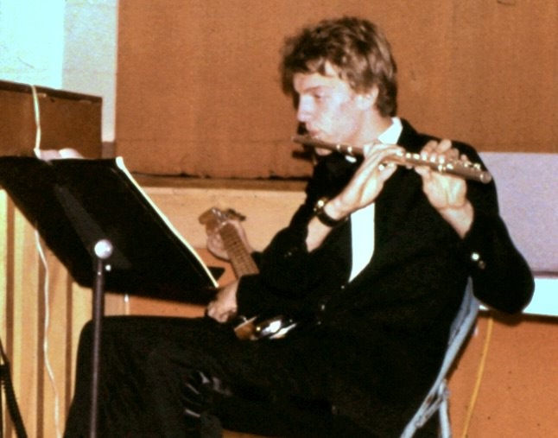
Me playing flute at a school event
I didn’t know at the time that the flute was a “girl’s” instrument and it was several years before I noticed that I was the only boy flautist in the band. Despite the normal awkwardness of any teenager pressured to conform, I don’t remember ever regretting my choice. In fact, I appreciated the many advantages of a flute compared to other instruments: its size makes it much easier to carry and cheaper too. Unlike reed instruments like my brother’s saxophone, there are no consumables. I also liked the smooth, simple sounds and the range. The result was that I found the flute enjoyable to play, and I practiced enough to become the best in the school.
In our regular competitions, I always placed first, advancing to regionals and finally to win at the state contests too.
Well, that’s not quite true. I wasn’t always first. Each year, our high school band held auditions to determine the seating arrangement for each instrument section. We were each given a set piece to play into a tape recorder, which would then be blindly evaluated later by the teacher for ranking. Somehow I came under the impression that the point of the audition was to see who could play the piece fastest. I practiced and practiced until I got my time under some unbelievably quick number of seconds.
Thinking there was no way my rapid performance couldn’t have been best, imagine my disappointment when the final seating chart showed I was among the last – sixth out of eight. Upon discovering my error, I asked the teacher if I could try my audition again. The rules were fixed, he said, so I would be stuck in my seat … unless, he added, I went through a process of challenging my superior seat-holder.
A “challenge” meant that I would formally invite a higher seat holder to undergo another recorded audition, where each of us would play a piece to be evaluated blindly by the teacher. Whoever wins that competition would take the higher seat.
And thus I systematically challenged my way from sixth place to first, in a process that must have taken weeks. But I never lost my first place again.

Gary too did well at these contests and he continued to play regularly through high school, when he joined our jazz band. As the lead alto saxophonist, he played weekly at sports games throughout the year, developing a reputation as a solid, reliable performer. Like me and Connie, he practiced regularly throughout the year to avoid disappointing Mr. Rasmussen in our regular music lessons.
We didn’t think of music as anything special – it was just something our family did.
Much later, upon entering college I auditioned for a place in the Stanford orchestra. The judge asked me the name of my teacher. Mr. Rasmussen was hardly famous enough for that, and I wondered why they bothered to ask. “You play remarkably well for never having had a teacher”, he said.

3.3 Our New House
For most of my childhood we lived in an old two-story house on Oak Street, a few blocks from church. This was the neighborhood near the Gungors and many other kids our age, with whom we enjoyed countless hours of play after school and in the summers.
Our house was owned and paid for by the church, a perk that partially substituted for the low income my father earned as a pastor. But as his family grew older, Dad began to think about his long-term future, including eventual retirement. Where would he live when, inevitably, he became too old to work?
The church board came up with a solution that resulted in a purchase of new property on the other side of town, and the construction of a brand new house that we would now own. One result of this delightful opportunity is that we were able to design the entire place from scratch. We were given catalogs of standardized floor plans, which we devoured as we speculated about the layout of rooms and hallways.
We contracted with a builder from church who, I’m sure, did the construction for close to his costs. He was also a skillful and flexible builder who knew how to build the house exactly how we wanted, regardless of whatever blueprints we found in the catalog.
During the more than a dozen years I shared a room with my brother, I don’t remember any particular conflicts. It annoyed me that he got to keep the top bunk, no matter how much I pleaded with him (and our parents) to swap places now and then. The lack of privacy, I’m sure, became more noticeable as we grew older, but to us at the time it was just normal. Neither of us could conceive of a different living situation.
That changed when we moved to the new house. For the first time, we could keep different hours. If either of us left something on the desk or floor, the other wouldn’t be inconvenienced. Instead of keeping my personal items in a box in a shared closet, I’d have a closet of my own.
There were many other changes. In our old house, the family shared a single bathroom on the upper floor. Now we would have two. We were no longer limited to baths; we could take showers. Instead of oil-powered heating, Dad arranged for us to have a wood-burning furnace, augmented with natural gas and electric. And of course, the kitchen appliances and bathroom fixtures would all be brand new.
This transition happened at precisely the right time, just before the inevitable changes in adolescence and high school threatened escalating conflicts with my brother. Now, for the first time, we would each have our own space.

3.4 Earning money
Although I never felt poor, money was always something my family needed to watch carefully. Later I would hear about truly poor families, those who had to go light on food at the end of the month, and I couldn’t relate because it never seemed that food, of all things, would be something to be rationed. In the middle of farm country, there was never a shortage of fresh food; people gave us stuff, not because they thought we needed it, but because there was so much extra that it made sense to share.
Still, money was not the type of thing to be given to children without a specific purpose – school lunch money, for example – so if there was a purchase we wanted, we needed to find our own money. Christmas and birthdays were one source, but for real freedom we knew we had to earn it ourselves. Fortunately, this was easy to anyone willing to work for it.
My brother was the first to find his own income. Mr. Swenson, an older man in our neighborhood, ran the newspaper delivery services for Neillsville and Gary became the delivery boy for a paper route. It paid by the delivery – on the order of a few cents per newspaper per day – but once you accumulated a few dozen customers, as he did, and were willing to work six or seven days a week, the income easily surpassed whatever any of us could expect from gifts.
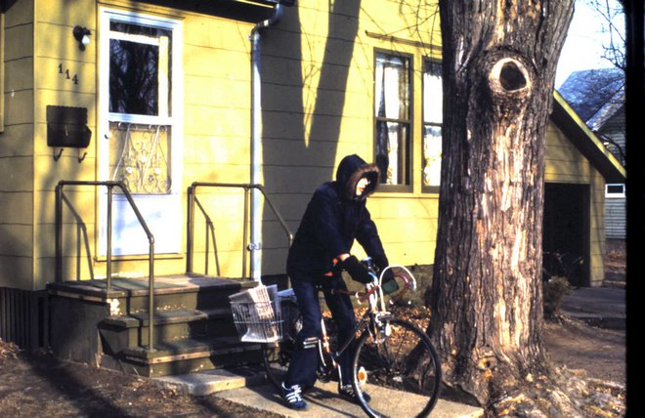
Gary setting out on his newspaper delivery route.
As soon as another route opened in our neighborhood, I grabbed the chance too. My route wasn’t as many customers as my brother’s, but it was still good pay as far as I was concerned. Over time, between us we accumulated additional customers as other neighborhood paper boys grew older and dropped out, leaving the routes to us. Later an even bigger opportunity came, to deliver a weekly free classifieds paper (“The Shopper”). We had to deliver to every house, and this time we were paid by the insert as well, which came as a separate pile of papers and needed to be added to each paper before delivery. It was boring, manual labor but I learned to see every one of those papers, not as a tedious chore, but as income: a tiny downpayment on bigger and better things.
A paper route requires getting up early in the morning, every single day, good weather and bad. We had to be responsible, not only for delivering the papers in good condition to each household, but for collecting and tracking the money from subscribers. If we wanted more money, we could also walk the neighborhood door-to-door and find more subscribers, a sales job that I hated, but was absolutely part of the business.
Besides carrying newspapers, as we became older we found other jobs in the neighborhood: raking leaves, shoveling snow, mowing lawns, and occasionally a more substantial offer for another labor-intensive job cleaning a field or something. None of these jobs was particularly well-paying, certainly not by today’s standards, but it was real money and I learned to pay attention to every penny.
Although there were minimum wage and other laws, such legal technicalities were irrelevant to our job-by-job work. Our payments came in cash, without deductions for taxes or fees. We didn’t report anything to the IRS – we didn’t even know how – and if anything the idea of submitting a tax form would have filled us with pride, something to prove our adulthood.
We learned about earning income this way from my father, who also worked odd jobs. His meager pastor’s salary, less than $1,000 per month in 1970s money, was barely enough to live on, so he supplemented it with whatever extra money he could find. When I was younger, he roofed houses – a hot, backbreaking, and often dangerous job that he rarely did without a partner. Later, and more regularly he would paint houses, and sometimes I would go to the site with him, mostly to watch (apparently my mother believed the job was too dangerous for a young boy).
Our father earned his main side income in the woods. Rural Wisconsin, with its abundant forests, has long been a land of loggers. Paper mills were always ready to buy cut timber, and the men of my family had several generations’ experience cutting trees. I think my father was born with a chainsaw in his hands, and throughout his life few things gave him more pleasure than the sight of large trees ready to be harvested.
Throughout our childhood, he teamed up with another pastor, his best friend, who lived in a nearby small town. They found work subcontracting for a local logger who had the big tree-moving equipment, a “skidder”, and contracts with paper mills to deliver the logs, each of which had to be carefully cut into eight-foot segments, called “sticks”, with the bark removed. Removing bark (“peeling”) was a tough job, but it wasn’t especially dangerous for kids, so my brother and I were quickly enlisted. I worked in the woods with my father most of the summers of my childhood, right up to the final year before I left for college.
Dad cut the trees and then paid us by the “stick”, a six-foot measurement. When we were too young to peel, he recruited us to measure out the logs as he sliced the fallen tree trunk. As we grew older, we were given our own hand-sized crowbars to peel the bark and pile the logs for later skidding.
Each stick was worth five cents, and a reasonably strong and ambitious kid could do several dozen per hour, perhaps ending an eight-hour workday with several hundred sticks, or ten or twenty dollars, perhaps up to one hundred dollars per week. Older kids, once they mastered a chainsaw for themselves, could earn much more. For small town kids, without job possibilities at fast food or other service establishments, this was great money.
The work was very unpleasant. Getting to the worksite often required a significant hike through the woods – usually through thick brush, along clearings from previously-harvested trees. Mosquitoes and big, evil horse flies were a constant menace, made even more annoying while sweating in the hot sun. But the worst insect of all was the wood tick, a small creature that liked to burrow into clothing, then skin and could be difficult to remove. You wouldn’t find them until arriving home, by which time they had already begun sucking blood, leaving large itchy welts that persisted for days afterwards.
We cut the trees with gas-powered chainsaws so noisy that Dad issued each of us earmuffs to protect our hearing. The gasoline that had to be hauled into the woods as well, in large cans, and cans of oil too for lubricant. I was too young to touch the saws, but I’m sure Dad brought repair equipment as well. He carried two saws, and probably extra chains, to prepare for inevitable breakdowns.
Tree-cutting was itself as much of an art as a science, a skill my father developed with long experience judging wind conditions and the location of nearby trees. In a thick woods, there was a trick to deciding which trees to cut first: make sure they fall in the right direction and leave holes in the forest to make it easier to fell succeeding trees. A botched job of cutting one tree could increase the danger in cutting the next, because a tree that fell into another would now require a second tree to be cut, and possibly others after that, like dominos, each hanging dangerously high in the forest, potentially all collapsing at once on the helpless loggers below.
That my father did this successfully year and year out, was as much due to luck as to his long experience and apparent enjoyment in the work. When we pleaded him to slow down, or to take a few days off, he told us that his own father – my grandfather – had been an even harder worker.
The dangerous work produced its share of minor injuries: usually welts from branches that slapped into us unexpectedly, or cuts from peeling bark in places that were difficult to reach. Once, when I was in third or fourth grade, Dad had a serious accident: a deep chainsaw cut into his knee that required a doctor’s attention and long weeks of recuperation.
It was hard work, but monotonous, so to pass the time I began to amuse myself with a game that I played in my imagination. A “stick”, I imagined, was a year of my life – more precisely, the life of a fictional hero of mine. At age one – the first stick – perhaps something happened with his parents. At age two or three – the following sticks – came the first signs of precociousness, an inchoate musical ability breaking forth. Soon, as the sticks piled on, he was my age and quickly proceeding through school, skipping grades far faster than his peers, until by twenty he was out of college, on to a PhD, and further, farther in his career.
I don’t remember the details of my game, but besides driving away the monotony, I learned to look forward to these daily imaginations of the future. My hero would get older, wiser, richer, marry and have children, make fantastic accomplishments, each day better than the previous one. I was not nearly as fast or efficient a worker as, say, my brother who would routinely rack up a few hundred sticks a day. To me, reaching a hundred was a big milestone, rarely met by the end of the long day, which was just as well, since it kept me from needing to confront the mortality of my imagined hero figure, but just leave him comfortably into an old age while I thought about the money I’d collected that day and looked forward to even more the next.

The Neillsville Foundry
Our house was located at the outskirts of town, the very last house, separated by a field from a small steel foundry that provided good employment for hundreds of low-skilled workers in the area. One Spring day, my brother was asked if he’d like a job there too, for the summer. Since he already had a good position at the grocery store, he passed the information along to me and I eagerly accepted. So began my first major experience with the world of blue collar labor.
The foundry produced small metal objects, but to be honest, I don’t really know exactly. Perhaps it made parts for the other blue collar employer in Neillsville, the Nelson Muffler plant on the other side of town. Or maybe the objects were simply finished manufactured products useful for their own sake. Who knows. I only remember seeing the large steel smelting facility inside, and lots of metal molds in large sand pits.
I was hired to help dig out some of those sand pits, which apparently needed some attention after years of usage. There were other odd jobs around the factory too, like a field that was overrun with junk, and ancient supply rooms that needed clearing and sorting. Somebody in the factory had decided these tasks were perfect for some summer employees, and I – plus a half dozen other workers – became one of them.
I say half-a-dozen, because I vaguely remember there being several of us, but the only two I remember well were the person assigned to us as a “foreman” and a fellow classmate named Mark Dayton.
The foreman was the son of the town dentist, the older brother of a fellow student of mine. He himself was a student at UW Eau Claire, intending to be a dentist himself someday. This job was, to him, simply a way to earn some cash for college and expenses. This alone made him different from most of the other older workers, nearly all of whom thought of this factory as a career.
Mark Dayton was one of these. He got the job thanks to his older brother, who had been working at the factory for a number of years after leaving the army. Mark had no plans for college, and no real plans for what to do after high school, which was itself something he thought of as a parking place for himself until he left home and got a “real job”. He wasn’t a particularly good student, so I don’t think he would have minded dropping out of school entirely, if he had a permanent job offer from a place like this factory.
Mark and I became good friends. The work was lousy, lots of digging, lots of lifting; but there were breaks and frequent opportunities to talk, and it was natural for the two of us to spend our time that way.
One day Mark came to work with an announcement for me.
“I started something yesterday,” he said, proudly. The night before, in discussion with his parents, he had decided to pick up smoking. He showed me a new pack of cigarettes.
“Mom wants me to smoke the same brand as the rest of the family,” he said, “but I’m going to smoke Marlboros for a while instead. If I’m going to smoke, I want to taste something.” He said this in a matter-of-fact way, like somebody discussing the reasons for buying a specific brand of toothpaste or choosing a candy bar.
He wondered why I didn’t smoke – at least a few puffs now and then – and I tried to explain that I was concerned about lung cancer or other ailments. Of course, working as we were inside a filthy, smoke-filled factory, one where the management felt compelled to offer us face masks – it was hard to argue from a purely medical standpoint that cigarette smoking was a particularly bad habit.
He and many others at the factory offered me cigarettes, but when I refused, they never asked me again. I believed smoking was sinful, a violation of the Biblical commandment to treat the body as the “temple of the Lord”, a place never to be deliberately defaced. I realized even at the time that this commandment was subject to interpretation: we drank coffee and tea – hardly examples of healthy beverages – and for that matter, what about chocolate cake? Both of my grandfathers used tobacco – my paternal grandfather’s car perennially smelled of cigarettes, and my maternal grandfather enjoyed snuff—so I don’t think we were against smoking for any serious Biblical reasons as much as the simple fact that it seemed an expensive, wasteful, and generally unhygienic habit.
Even without cigarettes, I’m pretty sure that summer caused some strain on my lungs. We were issued face masks on the particularly dirty days, but even then, it seemed by the end of the day that every pore in my body was filthy. The pits we had to clean out were full of a fine sandy substance. Some of the pits seemed to have a different type of sand than the others; one in particular had a foul odor that I still remember. Even when I had been away from the factory for several days, I’d still find bits of this sandy powder coming out of my ears, or emerging from my nose. It was awful.
As awful as the labor was, on the other hand, the weekly paychecks were wonderful. Even after the various deductions (what is FICA anyway?), the total was more than months of delivering papers or mowing lawns. It felt like real money, too, earned through an official “job”, like a grownup. In those days, the odd jobs or the money earned from helping my father cut wood, didn’t feel as “real” for some reason. To be a serious job, you needed an hourly wage at a significant business, and for all its faults, the factory was definitely significant.
I had a goal in mind for the money I was earning: I wanted an Apple II personal computer. I had already carefully studied the prices and specifications, and the model I wanted was going to cost a bit over $1,000 including the color TV needed for a display. The purchase was well within my summer’s budget from my factory salary, and every day at the factory brought me a bit closer to my dream.
But just as suddenly as the offer had arrived at the beginning of the summer, the foreman one day made another announcement: our positions were being eliminated. I was laid off.
Suddenly, my dreams of saving money for the summer were shattered.

Odd Jobs
During the summer before my senior year, my father suggested we take advantage of the large empty field next to our house and grow a cash crop. Word at the time was that cucumbers were the way to go, so when Spring came, Dad found somebody with a tractor who tilled the field and made it ready for planting. We bought seeds and dutifully planted half an acre of cucumbers.
Agriculture is not an easy occupation, but somehow I ignored my father’s warnings about the importance of regular weed control and irrigation. The plants took longer to grow than expected, and by the end of the summer had produced far less than it would take to break even on our investment.
Cucumbers are sold to a distributor in town, who paid based on the size of the vegetables. Our field produced maybe one or two large sacks of cucumbers, but most of them were tiny and worth little. I remember bringing them to the distributor’s place and one-by-one inserting our crop into specially-measured holes, after which our results would be weighed. I no longer remember how much cash he gave us – perhaps $50 – but it wasn’t nearly enough to make up for all the trouble it took that summer.
Technically I was supposed to repay my father for the upfront costs of seed, fertilizer and the cost of tilling the field, but he had pity on me and let me keep the entire pitiful amount.
It takes a few years of growing before your crop starts to be profitable, he explained, a potential future that didn’t matter to me. I intended to leave town long before the next crop anyway.

Real Jobs
Despite our family’s history with family farming and the fundamentally entrepreneurial outlook that brings, I grew up thinking that “real” money came from a job with an employer and a steady paycheck. In Neillsville, as it is today for many teenagers, those jobs were in retail.
The ideal place to work was at the one fast food restaurant in town, the A&W root beer stand. The older, prettiest girls in high school seemed to get hired there, along with the best-looking guys who followed them. Although I supposed we Spragues might have liked to work there, it seemed like too much of a reach, so we never bothered to consider that as an option.
The town gas station was a more likely option. Before the oil crises of the 1970s precipitated the regulatory changes that allowed self-serve gasoline, boys were needed to pump gas. I knew an older boy who had worked there, but I was too shy to ask him about the process for finding a job there.
My brother was bolder. When, around age 16, he got serious about finding a part-time job, he approached all the places that seemed likely to hire. The gas station had no open spots, but Gary found more luck at our grocery store.
Neillsville had always had several small grocery stores, the largest of and oldest of which was a supermarket called the Neillsville IGA. Sometime when I was in elementary school, the IGA came under the ownership of Bob Solberg, who had begun his career operating a tiny competing dry goods store down the street from our house. We knew him partly through his daughters, Lisa (my grade) and Kim (Gary’s grade). Bob had a reputation as a hard-working, honest, and no-nonsense business man. Gary was a perfect fit.
He started as a stock boy, patiently moving boxes from delivery trucks on to the store shelves. He did other miscellaneous chores, from setting up new counters to cleaning floors and bathrooms. Eventually he worked his way up to the ultimate job: cashier. It wasn’t long till he developed a reputation as a reliable, hard-working employee who could be counted on to do anything, including the less fun jobs that other temporary workers avoided.
Years later, when Bob looked back on the hundreds of employees he’d hired, he remembered Gary as the best of all. Always on time, reliable, focused on completing the necessary tasks rather than simply punching the clock.
The job paid well by Neillsville standards, and for a high school kid raised by frugal parents, Gary was soon saving lots of money and before long he had his own car, a boat, and eventually even had moved into an apartment of his own. By Neillsville standards – in fact, by any standards – he was doing quite well for himself.
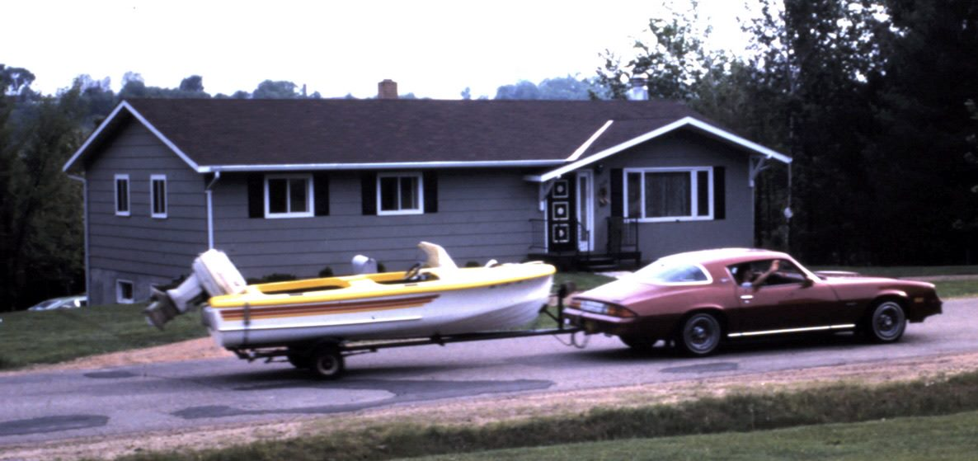
Gary was proud of his boat and car, paid for entirely through his own earnings

3.5 What I want to be when I grow up
I was in about third grade, and my mother was talking about me to some adults. “Ricky likes jokes. I think he’s going to be a comedian when he grows up.”
“No, I’m not,” I said, apparently offended that I might be categorized in such lowly terms. “I like history.”
I’m not sure if I understood what it takes to be an historian, or even if such a thing existed, but it was a clue that I saw myself as a thinker, one who makes a living from his brain rather than his muscle.
The earliest record of what I would be was a note my mother put into one of those fill-in-the-blank scrapbook albums for babies. Alongside the yearly height and weight, and favorite foods, there was the question: “When I grow up I want to be…” and a helpful multiple choice set of answers. Instead of “fireman”, my mother circled the choice for “astronaut”. Of course, in those moon race days of the 1960s, such a dream would have been common for every kid, and I suppose I was probably similar, to the degree I bothered to think about it. But like most kids, I needed several more years before I could think about it for myself.
My multiple bouts of hospitalization, and experience of seeing Dr. Gungor’s position first hand, made me interested in becoming a doctor. That seemed like a good fit, and it matched my eagerness to learn about science, but it never became a passion. I just felt that, yeah, I could do it; it was good money and prestige, so why not.

Missionaries and Languages
Sometime in elementary school, maybe after fourth grade, after a world cultures reading when I learned about Saudi Arabia, I learned while in the midst of a fervent prayer session, that God wanted me to become a missionary. Saudi Arabia seemed like an especially challenging place, and that’s where I wanted to be. I didn’t know anything about what it would take to be a Christian missionary in a Muslim nation, but who was I to question God’s call? It just seemed obvious that this was why I was put on the earth, and for many years that was what I understood would be my life’s work.
Perhaps it was too obvious, too inevitable for me, so I didn’t pay much attention to the mechanics of what it really meant to be a missionary. Of course I needed to learn more about God, through prayer and Bible reading, but I was doing that anyway. The social studies classes at school, where we learned about other cultures, kept me interested in the idea of foreign lands, but I don’t remember taking it to a deeper level.
But around the same time, my schoolteacher showed us a documentary about linguistics that absolutely fascinated me. Although if somehow I were ever able to find that film and watch it again, I’m sure I would be disappointed – it has built up quite a monumental reputation in my recollections—but it instilled in me the idea of how interesting the mind is. Like the short story I read in third grade that exposed me to computers for the first time, I suddenly saw how language was another way to become smarter. I realized that I really wanted to learn another language.
Real missionaries visited our church from time to time, and when they did they usually stayed at our house for a few days. I remember missionaries who talked to us, over dinner, about places like Thailand, South America, the Philippines, South Africa. It gave me a sense that foreign countries were real places, with real people who were just like me only from a different culture. What was it like to speak another language, to think from a different culture, I wondered.
Like many Americans, another exposure to the rest of the world came from the friends and relatives who had served in the military. One such family, the sister of a regular church-goer and good friend, had just returned from living in Okinawa Japan, and had even brought a missionary back who presented at our church. The missionary visited us with his family, and I met for the first time somebody who had lived in Japan and – what really impressed me – had learned to speak some Japanese. I no longer remember the words they tried to teach me – I’m sure it was simple greetings or perhaps numbers – but the very sound of the words impressed me. How does language work, I wondered? How can you possibly express the same ideas, using completely different sounds and symbols?
I had other hints about how fascinating it would be to know another language. It was in the evening, at a church Bible study held at the home of one of our church members, and as was the custom each person was asked to read a verse from the Bible, one at a time, around the room. There was an older woman there, from the Chippewa Indian reservation, who apologized that, although she had brought her Bible, it was written in her native language so she would be giving an on-the-fly translation that might be slightly different wording. My father, delighted by this, asked her instead to read in her native language, and she did. At this point, the hosts of the Bible Study, who were immigrants from Germany, admitted that they too normally read the Bible in their own language. It struck me as absolutely amazing that, not only were there different words that meant the same thing, but that you could have a key idea from the Bible represented in a code that was perfectly intelligible only to those who understood the language.
All of this made me eager to learn a second language. Our school taught basic Spanish starting in middle school, and I tried as best as I could with the couple hours per week minimal exposure. But obviously I was not going to get very far and I lost interest. Spanish wasn’t my idea of a “great” language. Meanwhile, I noticed in my father’s collection of books a five-language dictionary: translations to/from English, Spanish, French, German, and Yiddish. It was great fun to look up words in one language and see how they sounded in another. Of course, since most of the words were indo-european, it wasn’t hard to notice the similarities, and this gave me more confidence in my ability to master these languages.
In Jimbo’s house, I found another interesting set of books, a course on memory from Dr. Bruno Furst. My father had the same book, a home correspondence course with tips for how to develop a perfect memory. I devoured the series of lessons, driven by the desire to reach one of the later ones “Learn a foreign language on the plane ride to the country”. When, at last, after surviving chapters about memorizing long phone numbers and people’s faces, I arrived at the one about languages, I learned again how similar the European languages were, and once again developed additional self-confidence that I too could someday be bilingual.
But why Spanish? I thought. Here my mother intervened in my life in one of the critical ways that made me what I am today. We needed to choose which classes to take among a set of electives that included two that I really wanted to try, home economics, and industrial arts, plus Spanish. I decided that because I already knew the basics of Spanish, I could skip it. But my mother wouldn’t let me. I was angry and disappointed at the time, but she insisted that I needed it for college. Ultimately I was able to take the other electives anyway, but her insistence that I take Spanish the whole way kept me focused on learning the language – any language – in a way that I couldn’t have had the self-discipline to do on my own.
Still, Spanish was never enough of a “cool” language for me to want to seriously devote myself to it. My teenage arrogance let me think I already knew the basics well enough – after all, hadn’t I studied the 5-language dictionary, didn’t I already know much of the simple vocabulary, wasn’t I learning the basics of the grammar?
Travel to Mexico, fortunately, forced me to confront my linguistic limitations. True fluency, I realized, would take more than a Dr. Furst course. But the American-born missionaries I met convinced me that it was achievable. Maybe I would try a different language, but I definitely wanted to know what fluency felt like.

3.6 Computers
I first became aware of computers through a reading assignment in third grade and I was hooked. The short reading, which described the fast math calculations possible on a 60’s-era minicomputer, made me excited about the possibilities of how much smarter I could be if I had one of these things.
Around that time, my father took a part-time job working for the county surveying office, and they issued him a pocket calculator. Although I’m sure these devices had been existence by then for a few years, it was an early (and expensive) model that we otherwise wouldn’t have been able to afford, and I was fascinated. Today we take calculators for granted – they’re so cheap and ubiquitous – but in those days it seemed like a work of genius. Not only could it give instant answers to any arithmetic operation – including division, which to my elementary school mind seemed impossibly complex – but it gave answers to eight digits of precision. This calculator was a simple four-function model, so it had no fancy scientific operations, but that made it all the more approachable to me and I remember spending hours playing with it, and imagining all the fun I could have if something like this was available to me all the time.
By middle school, calculators were becoming common enough and cheap enough for normal families to afford, and it soon was on the list of items I’d like to save up for and own for myself. My paper route money, accumulating slowly, was already enough to afford the cheapest models and in time I might be able to afford one of the real fancy ones.
My decision was made for me, or so I thought, when John came home with a new calculator. Oddly I no longer remember the details of what made is special: maybe it was solar-powered, or maybe it had some additional functions like square root, but I do remember explaining one day to my mother that this is the one I needed to buy.
“You can’t have it,” she said. “You’re just buying it because John has it.”
Mom understood that this was money that I had earned myself, and she must have wondered if it was better to simply let me squander it rather than assert her power to prevent me from a purchase with my own money. But she was also right: I didn’t need that particular, more expensive model. She was teaching me that in order to justify my purchase I needed a better explanation than simple peer pressure.
Ultimately I bought a slightly different model, a bit cheaper but just as good. Prices on electronics always go down, so my delay was to my advantage and I ended up with a pretty good model. I also learned a lesson about the importance of thinking for myself and making my own judgments. It helped that money always seemed tight, like something you had to measure and count carefully, never to be wasted. It was a good preview for the way the rest of my computer life unfolded.
Somehow during this time period, John had become interested in electronics. He found a mail-order company that sold kits, a bundle of parts and instructions that let you assemble your own device. He was good at it, and he began to make electronic equipment, first some simple ones, but was close to taking the biggest plunge and building a full-blown color TV set. Although it was well beyond my budget, I followed his activities closely and soon found myself in competition to understand more, not only about electronics generally but about new and interesting devices I could assemble for myself.
This led me to the discovery one day at the school library, of a magazine called Popular Electronics, and a rival and more technical one called Radio Electronics which in the mid-1970s began publishing more and more articles about digital electronics, including how to build primitive computers. To call it a “computer” these days would be considered an exaggeration: it did nothing more than simple computations – there was no keyboard or display. The key part was a CPU, which at about $18 was a lot of money to me, but not an impossibly-large sum. The trick was how to get ahold of the part.
Since the chip was made by RCA, I started with a local TV repair shop in Neillsville, asking the owner if he was able to order parts from RCA and to my delight he said yes, and that the particular CPU I wanted was something he could get for me. The final price tag, including charges for special ordering it, was just too much for me to take the plunge on just yet, so I passed, but it got me thinking a lot more about computers – and I began to scour every issue of Popular Electronics as soon as it arrived at the library each month.
Our library also had older issues of these magazines and in my hunger for anything to learn about electronics, I discovered the January 1975 seminal cover story about the MITS Altair computer, now regarded as the first PC. I was absolutely floored that such a thing was possible, and I immediately wrote to the company for details and a price list. I still have the letter they sent in response, including a poster-sized description of their products which I hung on the wall of my room.
But getting my hands on a micro-computer would be expensive, far more than I was able to pay especially for something with so little practical use. Fortunately, around this time our high school library signed on to a new timeshare computer service from the University of Wisconsin River Falls, and I became hooked.
In today’s world, where computers are absolutely everywhere, a timeshare computer – literally, you “share” time with others on a single computer – seems crazy slow, and it was. The computer terminal, installed in the high school library, was a simple typewriter-style printer, connected to a central “mini-computer” a hundred miles away at state university extension. The connection, through a phone line, could send and receive characters at the rate of 100 bits per second, or roughly five or six characters per second each way. The terminal in our library wasn’t a computer—it was just a printer with a keyboard, and each keypress had to go through the phone lines to the computer, where it was carefully shared with the keystrokes of dozens of other users in a way that made it feel like a personal computer. Each keystroke was sent back through the phone line and printed on a long, continuous roll of paper, at which point you could type another key and the process would continue. A series of characters typed this way would constitute a command to tell the computer to do something, at which point it would then send back a stream of characters representing its answer.
Even such simple functionality, at the time, was probably outrageously expensive, but our high school justified the cost because it came with online information about careers and colleges. This database, plus a few other equally simple applications were enough to excite the staff of Neillsville High School, but John was excited about something else: the innocuous-looking programming manual that came with the terminal.
The computer could be programmed in BASIC, a simple coding language that was deceptively easy, even on such a slow terminal. John started by writing some very simple programs, and after he showed me how, I was hooked. Soon I had memorized the manual and was carefully crafting new programs in every spare moment I had.
The process was painfully frustrating: I would write my program at home, without a computer, and then enter them later at school. Only then would I know if my program worked or not, and if not, I had to return home and carefully analyze my code, plus whatever the output was, fix it and then repeat the process the next time I was in front of the computer.
To make it even more frustrating, the terminal was a popular place and there was a long line of other students who wanted to use it as well. The librarian instituted a signup sheet, giving priority to those who wanted to use the career database. John and I convinced her that programming was an equally valid reason to use the computer, so we were next in line, but this still meant we had to show up first thing on the morning that the signup sheet was posted, gaining access to rationed time on an even more rationed and slow computer.
Still, such restricted access had one big benefit: it made us very careful programmers, knowing that a simple error that was prevented at home could save days of computer access later. Most of the time, by the time we entered the programs, they were already so carefully and thoughtfully constructed that they worked the first time, requiring only minor modifications.
The biggest problem was finding out more information about the programming language. The manual in the computer room was too brief to show more than the simplest commands, which we soon outgrew. I thirsted for anything at all that I could do better than John, and soon was scouring every possible source for more information.
One day, hidden in another room at the library I discovered a very thick manual – the real programming manual that had come with the computer but had apparently been forgotten no doubt due to its size and apparent irrelevance. But it wasn’t irrelevant to me. I brought the book home and poured through every page carefully, learning everything I could about seemingly arcane features of the programming language.
Much of my interest was fueled by my rivalry with John, and at first I hid the book from him, only revealing the new commands I uncovered when absolutely necessary to demonstrate some cool new feature. My interest in showing off, of course, soon forced me to reveal the secret manual, which I now shared with John. This proved even better because he soon found more things that I hadn’t seen, and we both became part of a virtuous cycle, getting better and better at programming, at 100 bits per second.

Summer programming
Although summer vacation was of course something all students look forward to, for me especially the end of classes in June meant the end of access to the school’s computer. I think John was less worried about this than I was. Writing computer programs came naturally to him, and although he was as competitive as the next male teenager when it came to trying to outdo me, he had other interests – and skills – besides computers. Summer meant more time for his electronics hobbies, for example, and his father – as owner of a car dealership – had plenty of paid work for him to do as well.
But I was too hooked on this computer to simply go without for the summer. I begged the librarian, a kind and supportive woman named Della Thompson, to let me visit the school during the summer.
Della was the mother of Tracy, a neighbor boy close to Jimbo’s house, a boy we had played with for years. I’d been to his house innumerable times, including once with Jimbo in order to film our own “movie”, a Star Trek wanna-be involving special effects and, of course, interaction with technology and computers. I knew Tracy’s mom from those times at his house, and she knew me as well, so when I finally worked up the nerve to ask for permission to drop by the school, she gladly agreed – at least for the days when she herself was at the school.
To have more access, I needed to speak with Mr. Hoesley, who today would have a title like “IT director”, but in those days was simply an assistant principal, responsible for some of the more mundane tasks that the principal didn’t have time for, like ordering and installing pieces of educational equipment, including the computer in the library.
Mr. Hoesley, fortunately, was happy to have me use the computer in the summer, at least on whatever days the school was open – which was most weekdays, since he himself worked through the summer. Nowadays, somebody like him would be actively involved in the computer education, perhaps writing programs side-by-side with me and John, but he was more than happy to let us do all the computing.
For much of the summer, my daily pattern was similar: ride my bike to the school in time to meet Mr. Hoesley when he arrived and let me in to the library. I’d work there until the day was finished, mostly entering and then debugging computer programs I’d written the night before. If it worked, great! If not, I’d debug as long as I could, and then spend my evening pouring over the printouts to see what had gone wrong, adding and subtracting lines of code until I had a plan for the next day.
I’d also spend evenings pouring through the compute manuals to learn more and more arcane commands, expanding my knowledge of what was possible and learning there was no apparent limit on how cool this technology could be.

TRS-80
It wasn’t until I was in college that some people started to use the term “personal computer” (after the first popular one, the IBM PC). Until then, we called them “home computers” or “microcomputers”. In fact, the “micro” in Microsoft dates from those days, when Bill Gates wanted people to understand that he was making microcomputer software.
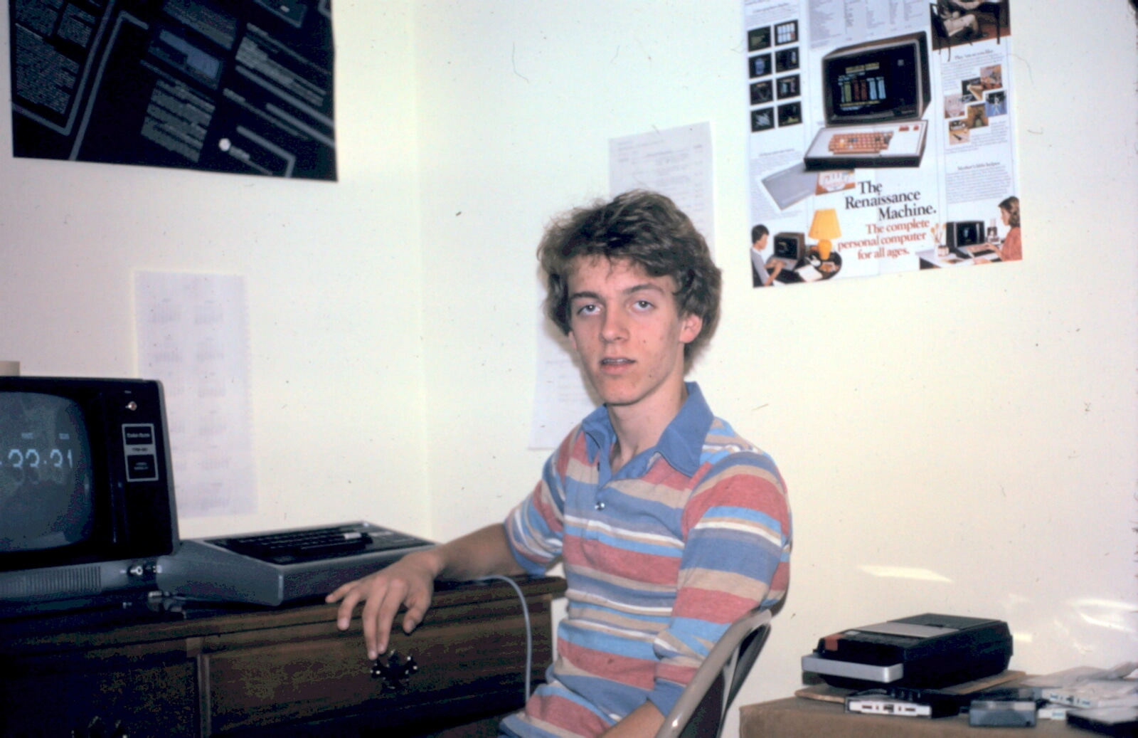
My first computer: a Radio Shack TRS-80
These computers were outrageously simple by today’s standards, but that also made them an excellent learning environment because it was possible – just – to understand everything about the entire system, from the chips to software. This made the subject, to me, all the more approachable, and even today I still think about computers in terms that I first understood back then on my first one, the TRS-80.
The TRS-80 came with just one microprocessor, called the Z80. It could execute only a single 8-bit instruction at a time, at the speed of 4.7 kilohertz – just under 5,000 operations per second. By comparison, the PC I use to type this document has eight separate microprocessors, each running about one million times faster and with instructions that are 64-bits. A true comparison isn’t possible, but roughly speaking that’s tens of millions times faster — and my current computer contains many more parts, some of them far more complicated and faster even that that.
My first TRS-80 had a 4K memory RAM memory in which everything had to run, including all graphics on the 64 x 24 line screen. Memory was so tight that the computer didn’t even support lower-case letters; there was a hack to let you display in lower-case, but it required soldering a separate memory chip onto the motherboard, and although I was tempted, I didn’t want to risk ruining the entire computer with a single mistake.
I devoured the manual for the computer, especially the programming guide where I learned about Microsoft BASIC, a simple tiny programing language written by Bill Gates himself and that was actually fairly sophisticated. One of my first add-on purchases was an upgrade to the built-in BASIC, letting me run “Level II” BASIC, a more sophisticated version that ran in 16K. A friend later gave me an even more sophisticated “Level III” version that contained more sophisticated commands and was, at the time, awe-inspiring in its power.
The TRS-80 had a simple architecture, with a single memory space for everything, including graphics and all peripherals. Pressing a key on the keyboard flipped a bit at a fixed place in memory, which you could read in order to tell what was pressed. A major problem, in fact, with the first TRS-80s was that pressing a key prevented the computer from recognizing any other keys until the first was depressed, meaning you had to type very carefully and slowly to avoid missing a character.
It was possible to program the TRS-80 directly in the Z80 machine language, which not only ran much faster, but also gave you more direct control over some of the computer operations. I soon learned how, for example, to write a graphics operation that seemed blindingly fast compared to the built-in BASIC way of doing it. It was also possible to control the output ports and simulate some simple musical tones. Nothing, it seemed, was impossible if you thought cleverly about it.
I learned how to disassemble the built-in BASIC programming language, and I spent hours pouring over the source code, both to learn more how the whole thing operated, but also to teach myself assembly programming. For my sixteenth birthday, I received a Z80 programming manual that soon became among my favorite books; I read every page.
The computer, including monitor, keyboard, and a simple cassette recorder for storing data, cost about $700 (about $2,200 today if you adjust for inflation). That was about half a summer’s earnings for me back then, working at minimum wage.
Although I had played with programming on the timeshare computer at school, nothing compared to the time when I saved up enough money to buy one of my own. I horded magazines to learn more about them, first from our high school library, then from purchases I made during a summer visit to a store in Tulsa, Oklahoma.
The key lessons I learned, though, were not so much about programming a computer, but about how approachable the computer could be. Nobody taught me; I just picked up whatever I could from wherever I could, and I learned by trying things.
There is nothing to compare to learning new software ideas by inventing them yourself. That’s how I learned linked lists, for example, or the basics of parsing. When I later learned the “real” algorithms for some of the things I invented myself, it was a huge thrill to see that I already knew this stuff. It was as if I had discovered, independently, a world that was magical and new.
It was this sense, that I could do something that even adults had a hard time with, and that I could master a new domain without a teacher – that sense became deeply ingrained, and was something I never forgot. Years later, when I struggled to learn many other things on my own (the Japanese language, countless other computer programming languages, even new subjects in math or science or biology), I had a special confidence developed long ago in my room in Neillsville, when I learned that passionate focus could turn even a daunting ignorance into mastery.

3.7 Colleges
My parents had attended college – they met at the Eau Claire Teacher’s College, later renamed University of Wisconsin Eau Claire, in the late 1950s – and growing up I heard enough stories that somehow I just assumed I’d be going to college too. It wasn’t a topic of conversation, though. My parents never gave the slightest hint that college was either mandatory or desirable. Ultimately less than half my high school class graduated from college. It wasn’t a big deal one way or another.
School had no appeal to Gary, and he was happy to call his education complete with high school. There were various technical schools that tried to recruit him – welding, electrician, plumber – and I remember one day an army recruiter visiting our house to talk seriously about a career in the military. But he was already making good money at his part-time, now full-time job at the grocery store. The owner (who himself hadn’t attended college) talked seriously about teaching Gary how to run his store someday. Why bother with something as abstract and unnecessary as a college degree when you can live a perfectly good life without the time and expense?
At a church youth group meeting one evening, the subject of discussion was about “who do you admire?”. Whereas I mentioned a famous engineer (Jack Kilby, inventor of the microchip), Gary was more down-to-earth and practical. “Norm Foster”, he replied, speaking of the owner of Neillsville’s hardware store. Mr. Foster was an active member of our church, head of the Neillsville Chamber of Commerce, father of two well-behaved children a few years younger than us. Norm had a college degree – he had been a school teacher in Minneapolis before moving to Neillsville – but it wasn’t obvious that the degree did anything more than cost him tuition money and the time it took away from starting a real business.
Another role model, a church acquaintance who built homes for a living, boasted of the profit he earned – and his goal to become a millionaire by age 30. This seemed far more interesting and doable to my brother than wasting time to get a degree … in what? Gary had no idea what he’d like to study other than some amorphous subject like “business”.
But I liked school, and in sharp contrast with my brother, the small town occupations of store keeper or home builder offered no appeal to me.
My earliest memories of me thinking of adulthood had me at North Central Bible College in Minneapolis, the most respectable school we knew, and rich with first-hand accounts from recent graduates. In those early days when I thought I’d be a missionary, it just seemed natural that I’d be at NCBC.
But later, on a family vacation in Colorado, we stopped at the Air Force Academy in Colorado Springs, which made a big impression on me. Hearing about the intense competition required for admission, I began to understand that there were standards out there far higher than the way I’d calibrated my life to that point. Imagine being in a school where every student was the top of his high school class! I had been interested in airplanes since my hospitalization days, so learning to be an Air Force pilot on the side, at school, seemed like icing on the cake. It was then that I also first heard about the importance of preparation. You don’t just apply to these schools after high school. To stand a chance at admission, I would need a well-rounded academic resume – one that would start in my sophomore year or earlier. Suddenly, high school graduation no longer seemed so distant.
The Air Force Academy tour guide explained how my Freshman and Sophomore years would have a big effect on my application. The others who were applying – my competitors – would have a lengthy list of high school accomplishments, like proven leadership in school clubs. I would need sports credentials too – something in which until then I had no ability, much less interest. Simply showing up wasn’t good enough: I’d need differentiators like maybe a significant statewide first place accomplishment. To top it off, I’d need a Senator’s recommendation, which implied having some experience that would get me some attention.
None of these qualifications would be automatic. My family wouldn’t provide them for me, and nobody at school would tell me what to do. If I wanted to go to the Air Force Academy, I knew, I’d have to figure out all these details on my own. The standardized tests that were required? Nobody had told me what an SAT was – my parents hadn’t heard of it – but that was the least of my worries. I was confident, based on my results on other standardized tests from school, that I’d do pretty well. I needed to know more practical issues, like where the test was offered and how I’d submit my results.
Nothing was urgent, and for that I’m glad that my family made that trip because it started me thinking. Without our visit, I may not have known about highly-selective colleges until much later, when it was no longer possible for me to join the football team or do other activities I wouldn’t have done had I not believed it would help my resume.
It was long after this, in a letter exchange with my friend John Svetlik, that I first heard of Stanford.

3.8 California
Deep in our cold Wisconsin winters, it was easy to dream about life in a place with temperatures that never went below freezing, where it was summertime all year long. But good weather was only one of the many things that appealed to me about California. From my earliest memories of the 60s and their hippies and free-living lifestyle, California was to me always associated with the new, a culture that was slightly ahead of the rest of us.
As for warm climates, most of us had more experience with Florida, which for many people was a winter vacation spot, a place where grandmothers went when they retired, the home of NASA and Disney World. The Gungor family did a roadtrip there one year, bringing back scale models of the Saturn rockets, a physical proof of an exotic but tangible world outside Neillsville. Florida seemed real to me, like Wisconsin only warmer.
California was out of the world, a land beyond, the stuff of legend and myth to me. It also held risks, a place of earthquakes, smog, and of course druggies and sin. My great-grandfather Howard had lived there for a while, and we had relatives still there, though not much direct contact. But overall, there was an over-the-rainbow quality to me of a magic and sometimes scary land that could be explored with a well-prepared adventurous spirit. It was even more special because it seemed like a place for the strong and bold. Anyone could go to Florida, but only a pioneer made it to California.
Sometime in my sophomore or junior year, my parents received a letter from a family in California, announcing that they were considering a move away from the “rat race”, wanting to raise their kids more wholesomely, in farm country far from the city. Central to their choice of location was the existence of a good church, and it seemed we fit the bill.
The Nichols family that arrived was a merger of two families, previously rocked by divorce but now with a happily-married mother and father, with three children from previous marriages: two girls from the mother’s side and a boy from the father’s. The kids were roughly our ages and had apparently been together for so many years that they acted like they’d been family forever. They were all out-going, with sunny personalities that seemed to reflect their homeland, and we immediately became good friends.
The oldest girl was about Gary’s age, and the son was a few years younger, but very easy-going and friendly, and quick to become integrated with all our church activities. The youngest girl was probably about ten or eleven, when I fifteen or sixteen, but she was an excellent flirt around me and I quickly found myself looking forward to every chance we had to meet.
In talking to the Nichols, California suddenly seemed very real to me. It wasn’t a place of mythology, it was a place where people actually lived and grew up. It was also full of the future, of fast highways in exotic Spanish-named cities, with fresh food and a laid-back attitude that made me feel I had found my future home. When they spoke of the shock of the cold Wisconsin winters, I felt a camaraderie.
Soon I acquired a map of the Golden State, which I affixed to the wall of my room and began to memorize the names of the cities, the counties, the rivers. The Nichols were from the small town of Hollister, near Gilroy, famous for its garlic. I looked in wonder at the map, noting how easy it was for them to drive north just a few hours, to magical places like San Jose (just like the song, I remembered, “Do you know the way”).
There was the Central Valley and Salinas, setting of the Steinbeck novels — which of course I eagerly read, absorbing more clues about that magical place.
I saw Highway One winding up the coastline, the famous scenic drive that stretched all the way from South to North, through fresh, coastal beaches and tiny, laid-back surfing towns. As a child of Wisconsin, it would not be until I was eighteen that I first saw an ocean, so the thought of being close to the Pacific brought me a giddy feeling of anticipation, a place I knew I would have to live someday.
It never occurred to me that the Nichols family, despite being long-time California residents exposed to all that Heaven, had for some reason deliberately chose to leave, and to move to – of all places – our small town of Neillsville. If California was so perfect, why on earth would they move?
Mr. Nichols offered an unsatisfying answer. California was too stressful, he said. It was “life in the fast lane”, a place where people drive so fast they can’t look around and enjoy their surroundings. He spoke of freeways full of impatient motorists, scowling when the others move too slowly, raising their fists at each other for no reason other than the constant pressure of living in a land where everything, all the time, had to be new, where the old was tedious and boring, irrelevant.
When he talked about California as a land of high pressure and stress, he might as well have been speaking another language, because to me those words sounded like an invitation to a great, intense, and wonderful game, a place with high stakes and high rewards, of an environment where everyone, all the time, was seeking the future, moving as fast as they could to break out of old molds and old ways of thinking. If that was a little stressful for some people, so be it, I thought. Great things happen to those who work hard. No pain no gain. I knew that I wanted to be part of it.

4. High School

4.1 High School Activities
City people are more specialized, and without doubt my (city-raised) children were far better-trained than I was at any activity that they focused on. But the number of hours in childhood hasn’t changed, so the flipside of focus is that they were exposed to less variety than we were.
My brother, who didn’t especially enjoy the academic side of high school, was involved in the activities he enjoyed. He played saxophone and marched in the high school band as well as a separate school jazz band that played at basketball games throughout the winter.
He ran on the cross country team for a few seasons. His long legs made him among the best runners, and he won numerous awards.
Classes and books were a chore for him because he couldn’t see the connection to practical life. Fine, learn a few basics in history class but once you know about the Revolutionary War, the Civil War, and whatever else – who cares?
But if something had a practical bent, nobody was more focused than Gary. He loved industrial arts (we called it “shop” class) for the hands-on metal and woodworking.
His big chance came during senior year, when he was accepted to one of our high school’s “capstone” classes involving real-world projects. His project was to build a house, from scratch. Somehow the school had made arrangements with a building contractor and a developer to build a new home. They began the year by designing and digging the foundation. Then they framed it, installed the plumbing and electrical, added insulation and drywall, painted the interior and exterior, and completed the other tasks including roofing and landscaping.
The entire project exactly fit his strengths and personality and he excelled. At the time, I didn’t appreciate the significance of his achievement, but he certainly did and was justifiably proud of his accomplishment.
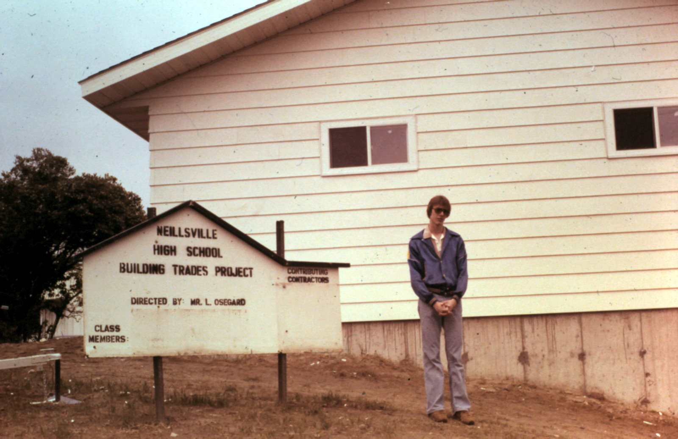
Gary and his fellow students built this house in a capstone class his senior year
Generally speaking, he excelled at everything outside of school. His regular job at the grocery store gave him enough spending money to buy the necessities required of all good boys from our rural farming community
First was a car, of course. Although a new model, or even a reasonably well-running used car was outside of his budget, that was no barrier. He somehow found a beat-up, used Camaro that he could afford. Then he bought all the appropriate fixtures: new paint, interior, even a car stereo system – everything fixed and installed on his own.
The many rivers and lakes of central Wisconsin made boating an important form of recreation, so naturally Gary had to get his own boat. Somehow he found a used one within his budget and spent a winter fixing it into something we could use on the lake.
He later became interested in scuba diving, acquiring all the equipment and gaining a certification to do deep-water diving. He once joined a group that traveled to Lake Superior to look at underwater shipwrecks. On one of those dives, he was something like 100 feet underwater when his breathing apparatus failed. Fortunately, his fellow divers took the “buddy system” seriously, so he immediately was able to share oxygen with another diver and together they safely made the long rise to the surface. He commented later at how much he was shaken by the idea he was so close to death. But Gary being Gary, he immediately jumped back in the water and continued the dive safely along with the rest of the crew. He wasn’t the type to give up easily.

None of Gary’s activities appealed to me at the time, and that was fine with him. Instead I focused on various school programs. Importantly, neither of us felt pressured to do what we did – everything was entirely our own choice.
Like Gary, I was involved in the school band, and after he graduated I even borrowed his saxophone so I could follow him in his jazz band.
I liked writing, so of course I joined the school newspaper and soon became editor. The school yearbook was another chance at writing and I enjoyed working with the team there too.
Our school had a debate team, and both Jimbo and I were active participants, regularly traveling throughout central Wisconsin to debate other high schools.
Neillsville High School didn’t have a dedicated drama department, but we did have class plays. I was a co-star in both the senior and junior class.
On the side, in addition to all of the above, by age fourteen I had developed a passion around computers that gave me a focus to my activities and interests. I devoured every scrap of information I could, and this hobby served as a powerful motivator that had me begging my parents to drop me off at university libraries, out-of-town big city bookstores, exposing me to even more of the bigger world.
I suppose it’s natural, and common, for teenagers to feel different and left out. But I don’t remember anyone in my family feeling lonely. These activities kept us in constant interaction with others – a rich variety of people from all the town’s income levels and occupations. We may not have had swarms of people crowding around us at lunch time, but there were enough other awkward kids around that we never sat alone.
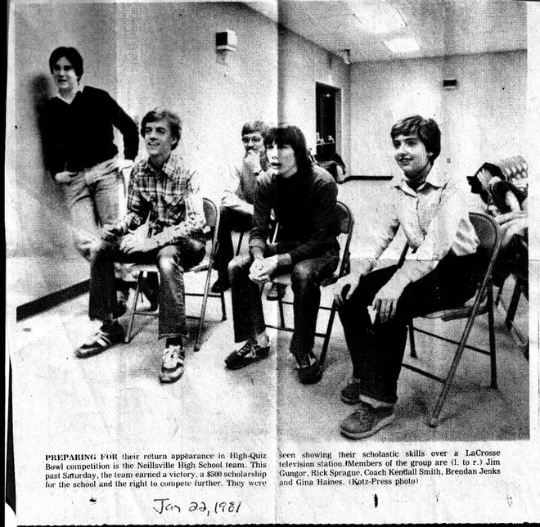
Fellow contestants on High Quiz Bowl: Jimbo, me, Brendan Jenks, and Gina Haines. Our instructor, Mr. Smith, is in the back

The Warrior Post
Our high school newspaper was an optional club that was organized by Mrs. Bratz, an amiable if somewhat breezy older woman who taught the typing class and a few other so-called “business” classes. Mostly this curriculum was oriented toward students who intended to become office workers, which in Neillsville was assumed to be secretarial work. Mrs. Bratz ran the FBLA club too (Future Business Leaders of America), which I think was intended to help students develop a knowledge of how businesses are run, but since nearly all the members were girls – as were the other classes Mrs. Bratz taught, like accounting – I assume there wasn’t much that was taught in an MBA curriculum.
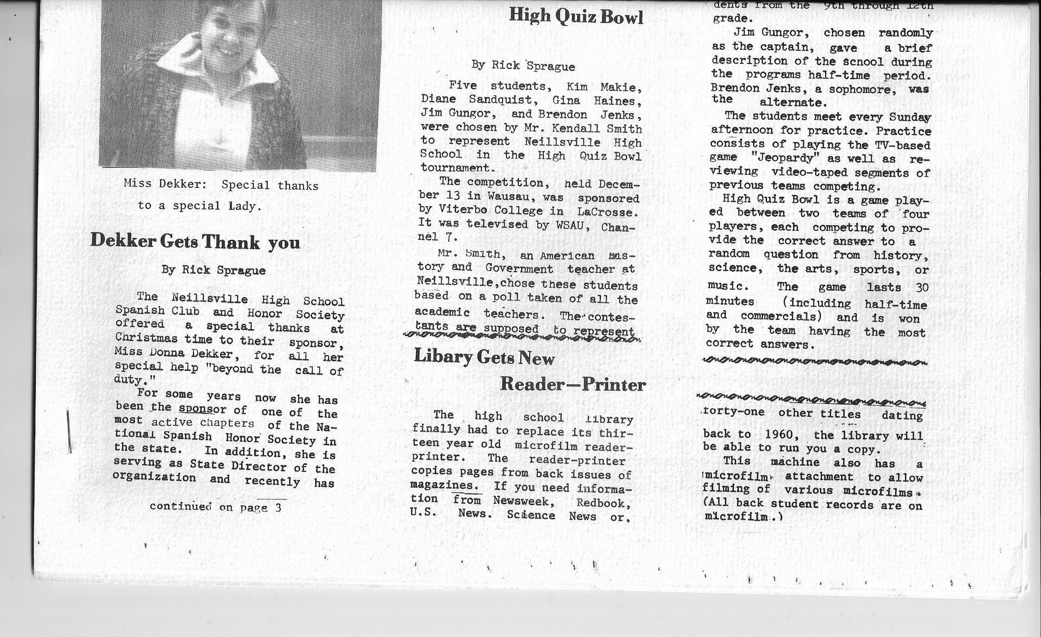
A typical page in the Warrior Post, our high school newspaper.
Besides being the only boy in Mrs. Bratz’ business circle, I found myself to be reasonably good at the job. Since early childhood, books and newspapers had always interested me, and now was my chance to do something that seemed more real: what I wrote would actually end up being read by hundreds of students!
In those days, before computers and word processors, writing a student newspaper involved a great deal of tedious and manual labor with typewriters. An article would be submitted in long-hand, then carefully transcribed on one of the school’s IBM Selectric typewriters, using a technique that today would seem outrageously primitive. To print the paper in columns, each article had to be typed, by hand, in a way that inserted spaces at appropriate places within the text so that the column would be “justified” left and right. That’s a simple setting on any modern word processor, but in those days it was entirely manual. Often that would be the most laborious part of the newspaper production, and as an underclassman that’s where I started on the paper.
Mrs. Bratz was an easy-going teacher who was open to whatever suggestions the students had, so soon I was proposing and then writing my own articles: news stories, human interest, and editorials. I turned out to be one of the more prolific authors – I enjoyed writing – and in some issues my byline was on so many articles that you might as well have just put my name on the masthead.
As a high school junior, I was technically under the supervision of an editor, who was a senior, but she wasn’t terribly organized and was if anything happy to let me do most of the work. Soon I was the de-facto editor, and by senior year I was the official editor, responsible for organizing the paper, choosing the stories, and finding writers to fill in the issue.
It was then that I learned something about management as well. Although I prided myself on being reasonably good at all the newspaper tasks, it was soon clear that I simply didn’t have the time to do everything. Even with the time, I wasn’t the best at some of the other important tasks, like selling or making advertisements, and at doing the art work. At first, I tried to micromanage everything, telling the artists specifically what to draw and where it should go, but soon I learned that this wasn’t very interesting to the artists, that they much preferred to express their own creativity. So soon I was delegating bigger tasks, and everyone was enjoying the paper writing.

4.2 Church Activities
And then there was always church, the center of all our activities. My siblings and I matter-of-factly participated in all the activities, including:
Singing: we didn’t have a formal choir, but we would have been in it if there had been one. As young children, we were regularly asked to sing at special events organized for the town elder care facilities, for example).
Our church participated in a statewide competition called Bible Quiz. The format was similar to a TV game show, where contestants competed to answer questions about the Bible. Two teams, each with four or five members, sat on a long table equipped with hand-held buzzers. The moderator asked a question that would be answered by the first person to hit the buzzer. The team with the most correct answers won.
We were issued workbooks of sample questions to prepare, but the emphasis each year was on a specific book of the Bible. In our first year, we did the book of Luke. Later we did 1st and 2nd Corinthians. Although most questions were simple facts pulled from the King James Version (e.g. “What was the name of Jesus’ mother?”), to do well required careful study of the entire book.
Our church team included me and my brother, plus Jimbo and a few girls. We had a good coach who pushed us to perform well, but nobody took the competition more seriously than me. Besides the statewide team rankings, there was a separate ranking of individual players. When the scores were announced a few weeks into the competition, we learned that our Neillsville team was among the best in the state – and I was ranking number one among hundreds of participants. This only drove me to prepare harder, and by the end of the year, I had essentially memorized all the books.
Scouting: we had an alternative to Boy Scouts that amounted to much the same thing, and we participated in innumerable campouts and service projects.
I’m not sure why our church felt the need to organize its own alternative to Boy Scouts, since back then the Boy Scouts of America was itself quite religious by today’s standards. Ours was called “Royal Rangers” and we had our own uniforms, scouting manual, and achievement badges. I suppose the Boy Scouts, which had to appeal to multiple religious denominations, wouldn’t have been able to go as deep into Bible instruction as we did. It really was a different age.

4.3 Sports
I’m grateful to my father for an important decision he apparently made in college. His own father had been a fan of organized, professional sports: baseball, football. But Dad thought that was a complete waste of time. “If you’re going to play,” he said, “Play. But don’t watch others play.”
Thanks to his leadership, we felt free to ignore sports, despite the interest shown by my friends, like Jimbo, who through elementary school was an active participant in little league, and who afterwards followed football and baseball closely as a fan. Even John Svetlik, who like me never pretended to be athletic, lived in a family that watched sports on TV, something we never experienced.
As far as formal sports participation goes, my brother was the most athletic: during his freshman year he joined the school cross country running team. He must have done reasonably well – I vaguely remember some award ribbons lying around the house someplace.
I was even less interested. Nevertheless, our summer visit to the Air Force Academy convinced me that for a successful college application I would need to show some interest in sports. During middle school, I had been on a swim team, but there wasn’t one for high school. Maybe I could join track and field, like my brother, but that seemed like a lot of work for nothing. So which sport would I put on my resume?
The most important sport in a small town school is, of course, football. Blessed with tough farm boys eager to prove themselves, the team was quite competitive. A few years before I entered high school, Neillsville had even won the state championship. The annual football Homecoming Parade was the biggest event of the school year, drawing participation from the entire community. If I really wanted to prove myself, football was the place to be.
Of course, the one detail is that I was woefully unqualified to play football. A scrawny kid who dreamed of someday weighing more than 100 pounds, I was already a target from tough kids who wanted somebody to pick on; you can imagine what would have happened if I found myself on a field opposing a team that really wanted to beat me.
Sometime after my freshman year, I discovered that the football team needed helpers, people to help track and carry the equipment, organize the trips to out-of-town games, and ensure there were other supplies, like snacks and water. The politically incorrect term is “water boy”, but on my college application forms I proudly wrote “manager”, which was the term used by the coach to recruit kids to this often thankless task.
As the water boy, er, manager, I attended every practice and game, home and away. I knew all the players and worked daily with the coaches. I didn’t mind the pejorative aspects of being called the water boy, because for me this was just a necessary line in a resume that would get me into a good college. That was the motivation that drove me.
One bonus was that I was issued a team jersey, like the players, and I was therefore allowed to wear it on game Fridays, when it was a point of pride for the boys on the team. I felt like I belonged!
The job also demanded a certain level of responsibility, something that ordinarily I could be trusted to handle. But I was young, and weak, and eager to please everyone, and this is when I got into trouble.
One of the boys on the team, a kid who was not an especially good player, decided that he liked some of the equipment, especially the team jerseys and he determined to steal some if necessary. Since I was in charge of the supplies, he knew he would have to get through me, so he began to befriend me in a half-threatening, non-transparent way. He mixed the carrot and stick: on the one hand he liked me because I was such a cool guy; but on the other hand, if I disappointed him by not letting him steal the equipment, then it was clear that I wasn’t a good friend and might even deserve to be treated like an enemy.
I ignored his entreaties as best I could, never stating clearly that I wouldn’t help him, while never fully agreeing with his plan either. Eventually this produced what I learned was the worst of both situations: by egging him on, I prolonged his attention, but by not producing results I made him more frustrated. Eventually it came to a head and he cornered me in the locker room to demand that I get him the supplies right then.
I don’t remember exactly what I did or didn’t do. I doubt that I would have simply handed him the equipment, or even that I would have looked the other way while he pillaged the storage room I was supposed to protect. I don’t think I would have been that obvious in my sin. More likely, I simply wasn’t as vigilant as I should have been, and he found an opportunity sometime where he could sneak in without my knowledge. There was a lot of equipment to track and it wouldn’t have been unusual to lose a piece or two. I probably convinced myself that he didn’t really steal it and that it would turn up eventually.
Fortunately the football coach wasn’t so easily fooled. Somehow he knew that this kid was a troublemaker, and when equipment turned up missing he immediately charge the obvious suspect. “If I ever catch you wearing that shirt, I’m going to rip it off you right in front of everyone,” he said. I never heard more about it.
Looking back on the incident, I wish I had been more forceful from the beginning, more straightforwardly obvious that I was not the type who would allow a crime like this to happen. It was a good lesson, though, and I’m glad I learned it in high school rather than suffering through it later in life, when it would have caused more damage.

4.4 Mexico
Later in high school, my grandmother’s death left our family with some extra money that my mother thought would be well-spent on forcing me to do even more with Spanish. She enrolled me in a missionary trip to Mexico during the summer after my sophomore year, and this trip opened my eyes to the world of languages and foreign countries in ways that were as impossible for me to appreciate at the time as I now recognize it was important for my future.
The trip was organized by some missionaries who were associated with a church in Madison Wisconsin. It was to be a whole collection of firsts for me. My first jet airplane ride, my first view of the ocean (of the Gulf of Mexico, which I saw through the window), and of course my first visit to a country where people didn’t speak English.
I turned out to be one of the few trip attendees with a basic knowledge of Spanish. Other than the missionary himself, who had lived there for many years, most of the team didn’t know any Spanish at all, so it was fun for me even with my limited ability to count or enunciate a few basic thoughts.
One of the adults, a middle-aged man with an impressive handlebar mustache, was one of the first people I’d ever met who had a PhD. Somehow perhaps he was taken with me because I remember him giving me some side advice: remember that you can go to a good school and come out without losing your religion. At that moment he became somewhat of an influence on me, both because he left me with some curiosity about his warning (why on earth would you think I might lose my religion?) and some assurance that it was possible to turn out fine, like him.
After arriving in Mexico, we did some sightseeing in Mexico City and I saw for the first time a truly, terribly polluted city. Back in the 1970s, there wasn’t as much air pollution as today, but even then we thought it was horrible. We travelled on the subway, visited markets and shopped for trinkets.
Later we took a series of minibuses up into the countryside, through some mountains, down some rugged roads to the town of San Luis Potosi, and I loved it. Everything was foreign and new to me. Until then, the biggest city I’d ever visited was Minneapolis, and really that was just the suburbs. I’d never travelled on a subway (or for that matter, any kind of mass transit including a bus). All of this was for the first time.
Until this trip, I had exactly two experiences with “Mexican” food. The first was at a church-related function at a friend’s house long ago, when the hostess made “tacos”: ground beef served in a home-made wrapper that resembled a pancake more than a tortilla. My second experience was at an Eau Claire fast food restaurant called Taco John’s, an early imitation of the Taco Bell chain that was just becoming established in other parts of the country. So when, at our hotel, I had freshly-made tortillas for breakfast, and later we were served pork-filled “flautas” and more for our meals – the fresh flavors were heavenly.
We were surrounded of course by the Spanish language, and to my surprise I found myself able to get around even with my basic vocabulary. All those words I’d learned in class were suddenly useful! But I also drank a large dose of humility upon realizing how different this was from the classroom. No matter how great I thought I had been as a student, I was nearly unable to understand the important things around me, and expressing myself was even harder. So although it didn’t seem as easy as I had naively believed before coming, I was able to see that through some effort, learning a foreign language was something that would be doable and enjoyable.
Part of our experience was going door-to-door, visiting every home as missionaries. Divided into teams of three, we were issued tape recorders with a short Spanish-language message, and I was assigned the role of memorizing a Spanish phrase that meant “Would you like to listen to an important message on this tape recorder?”
The villagers were generally pretty friendly, and we were often invited into people’s homes, though I realize now that this was probably more their curiosity of seeing American teenagers than it was out of a particular interest in our message. Still, the experience brought us into contact with the real lives of ordinary Mexicans, as we were welcomed into the tiny kitchens and one-room homes of the villagers. In one house, I held my tongue as a small rat rushed past, right behind the girl in my team, a city girl who if she had known what was happening would no doubt have begun screaming right there.
We were traveling in a part of Mexico in the mountains far from the coast, but it was hurricane season and during part of the trip it began to rain heavily, with ferocious winds. A piece of patio furniture in our hotel was thrown so hard across the patio that it shattered the window of one of our rooms.
The streets became flooded, waist deep in ways I’d never seen before, and we wondered why that would be: how could a Mexican town have streets filled with so much water that the sewage system couldn’t handle the load? This was something that never happened in even the smallest, most seemingly disorganized town in Wisconsin. Clearly the answer had to do with the terrible poverty of these people who were living in ramshackle huts, moving about often without cars or trucks, riding draft animals or occasionally bicycles. But the question for us was whether poverty caused the poor response to flooding, or was the regular flooding in a place like this one of the reasons for the poverty?
Traveling with missionaries – the same, fundamentalist evangelicals I was familiar with at home – kept a thread of the familiar throughout my experience in Mexico, so although I was shocked to witness, for the first time, so much that was different from my life at home, nothing I saw presented a significant challenge to the beliefs that I had already formed about the world. I was surrounded too by serious Christians who, like me, insisted on regular prayer multiple times per day with close reading of the scriptures. Our every move carried with it the ever-present background sense of a personal God watching and directing us.
If I ever became lost or uncertain about something in Mexico, I knew that God – through the Holy Spirit – would direct me back to where I needed to be. So although, especially in the cities there seemed natural cause to be wary of danger like criminals or spoiled food, we passed through unscathed and unshaken, believing that our lives were in God’s hands, who would keep us safe.
And of course that’s what happened. We returned safely home a few weeks later, but with a bit more understanding of the world beyond me. I also had made several friends in Mexico, and we exchanged letters for another year or two after that. I was now firmly and permanently interested in foreign cultures.

4.5 Vacations
I remember the first time I stayed in a hotel, or more precisely, the moment I first became aware that hotels existed. I was very young, probably less than five years old, and we were somewhere in the Blue Hills of northern Wisconsin, the place where my parents had spent their honeymoon. I don’t remember why we were there, but it must have had something to do with my father’s family, because his parents (my grandparents) were there and they were staying in what to me seemed like a luxurious cabin, with a front porch and many conveniences. My family, on the other hand, was loaded into bunk beds on a concrete floor. I don’t know why I remember this, but it was an early memory of thinking how poor we were relative to my rich grandparents.
Hotels and motels remained a luxury to my family throughout my childhood. We stayed in one again at my uncle’s wedding, held in far-off Madison Wisconsin. Later I was told that, due to a terrible sickness of one of my siblings, the time in that hotel was no happy memory for my mother, but for me it represented something exciting and new, helped considerably no doubt by the TV set in the room and the appearance of the cartoon show Underdog, which we enjoyed immensely.
Mostly when we traveled far from home, we stayed with relatives. On the rare occasions we traveled through areas without people we knew, we camped in a big family-size tent.
We knew tent camping well. During the summers, we usually attended a weeklong family Bible camp, held at Spencer Lake, near the small town of Waupaca, a few hours drive East of Neillsville. Our tent was surrounded by other families in tents and RVs, our days spent enjoying swimming at the beach, grilling food on our Coleman stove, and attending religious meetings late into the evening.
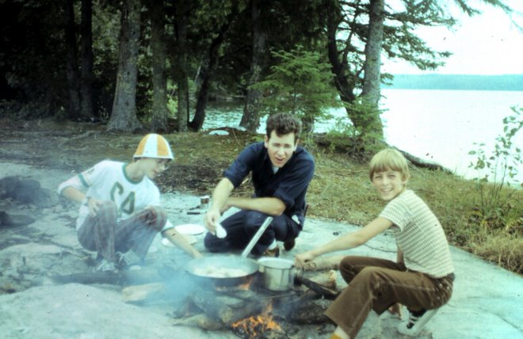
Gary, our scout leader Wayne, and me on a weeklong camping trip in Canada

4.5.1 Going West
But our first big vacation happened when I was seven or eight and my father decided to take the family to a religious meeting in the Shiloh Valley of Montana. The drive would take twenty or more hours, which we split into three or four days along a route that took us first through the familiar geography of Minnesota, then along to North Dakota and the plains, ultimately rising to the mountains and “big sky country” of Montana.
To seven-year-old eyes, the wide open spaces of the American West seemed like a magical, foreign land. Traveling in a station wagon, the iconic family vehicle of the 1970s, everything seemed spacious and free. With a “top” on the car roof that contained our tent and a week’s supply of provisions, we stayed each night at (cheap) family campgrounds along the way. My mother prepared sandwiches for lunch, and heated canned soup and vegetables for dinner. The better campgrounds boasted hot water for showers and occasionally a swimming pool for recreation. What more, I wondered, could life offer?!
At Shiloh itself was another campground pierced by a cold, mountain stream and fishing, which my father enjoyed and which produced more food for dinner. I don’t know what sort of budget my parents planned for this trip, but in today’s money I’m sure it would seem trivial. As a child, it never occurred to me that, instead of the homemade sandwiches, we might have eaten at fast food restaurants or stayed at cheap motels – those were luxuries beyond contemplation. Stopping in the beautiful natural places along the way – Mount Rushmore, the Badlands, the Rocky Mountains – it’s not clear to me now that we would have known more fun at the far more exotic places like Disneyland that many other children associate with vacations.
Our trip to Montana was the first of many summers we spent traversing the West. My father seemed unaware of other compass points, because whenever we thought about family vacations, it was always to the Great Plains and beyond, to the Rocky Mountains. Sometimes we started on a southerly route, to Iowa so we could stay with my parents’ lifelong friends, Arnie and Joyce Cox and their children. In sleeping bags on the floor of their living room, it never occurred to us – in fact, it would have seemed cold and almost rude – to stay anywhere else. Obviously if we come all this way to see somebody, we’re going to stay at their house; otherwise what’s the point?
One year we travelled to Colorado, at first to Denver where we saw the childhood friend of my mother, who now lived there as a suburban housewife. We weren’t invited to stay with them, and in fact the whole visit seemed more stiff and formal than I was used to, not nearly as fun and interesting as the visits to our relatives when we stayed overnight.
After Denver, we traversed the state to spend several days in Grand Junction to visit my great-grandmother and father. They lived with my father’s aunt Avenel and her husband Howard, who was a real estate developer. He bought large tracts of land outside the city, which he divided into subdivisions traversed with roads and single family homes. Along one of those roads, at the end of a cul de sac, he built a large compound for himself and his sons, who followed him in his business, and an adjoining house where my great-grandparents lived.
Vacations to me were always like this: a destination, visiting people along the way, learning new things about family and friends as we went. The stories I heard from my great-grandfather cemented my interest in this kind of travel and in maintaining an eternal optimism, a lust for the wonders that await every new adventure away from home.

4.5.2 Canada
Growing up in rural Wisconsin, it was only natural to spend summers outdoors. Although my family wasn’t nearly as hard-core about it as others, who lived for hunting and fishing, we did our share of camping.
To us, an ambitious camping trip involved a lengthy drive north into Ontario Canada, known for its plentiful and under-fished lakes. On at least two summers, my grandparents brought Gary and me along with them.
We stayed for about a week in a backwoods location, carrying all of our food and supplies, including a canoe strapped to the top of Grandpa’s car. Rowing out onto the endless lake, we eventually docked at a small island where we set up camp for several nights. Although we carried plenty of backup food, our intent was to live on the fish we caught.
I remember being disappointed at the poor catch and mostly eating the ham and turkey slices in our cooler.

4.6 Girls
I had a mother and a sister, grandmothers, as did most of my friends. There were women and girls everywhere, so if to understand women requires first-hand experience, then I have no excuse. I failed.
By the time I entered my early teens, my friendship with Jimbo began to fade as we developed different interests. I still saw him regularly at church, of course, though this was becoming mostly a Sunday morning thing, as his other activities kept him busy the rest of the week.
One of his biggest activities was girls. One summer in high school, his parents sent him to a camp at Illinois Wesleyan, a college in Bloomington Illinois, coincidentally the same town where my cousins lived. In a psychology class he took, he was diagnosed as being exceptionally interested in girls. I guess his hormones were raging.
His stories were interesting to me partly because they seemed to tell of an unknown world, one full of adventures I couldn’t understand because they were so unfamiliar. Partly this was due to his natural assertiveness and ability to talk freely to anyone. Many girls may also find attraction in self-confidence, which he had in large measure: he carried himself in a way that implied dashing and charm, a sharp enough contrast with my nerdy personality that perhaps he needed to dial down his relationship with me.
Still, I was interested in trying. Summer Bible camp was the ideal place to experiment. Jimbo and I were there for a week together, and although the rules naturally kept respectable distances between the boys and girls, there was plenty of time to mingle during mealtimes and at camp activities.
Jimbo took full advantage of the opportunities and within the first day had already selected a target or two, and was well on his way to pairing off.
I realize that to modern ears, this story may seem hilariously quaint, but in those days of Camp the thing to do was to get a girl to sit next to you in the evening church services. There wouldn’t be much opportunity to talk in the service itself, but afterwards there was plenty of time to walk her back before curfew to the border that separated the girls and boys’ sides of camp.
Since Jimbo was generally lucky enough to have a companion within the first day or two of the week, I was left to fend for myself, sitting alone for the service unless I took matters into my own hands and found the nerve somehow to ask a girl for myself.
So it was, with herculean effort on my part, that I chose a target and by Thursday was ready to ask her to join me at the nightly service, and to my surprise she agreed – provided she could bring one of her friends. No problem I though, and in fact it worked out great because now Jimbo was happy to be seen with me, now that I had a girlfriend too, so we all sat together.
I thought everything went well. I was very polite, of course, and after the service walked the girls back to their side of the campground without incident and being very gentlemanly the whole time. Relieved that I had conquered my shyness enough to have an actual girlfriend, I was looking forward to the Friday night (and final) service when I’d get to repeat our encounter.
Sadly, it was not to be. The girl informed me, via her friend, that she was not ready to be seen with me again for the Friday night service.
“She has a hard time concentrated on God when you’re around,” her friend confided to me. That was the last I ever saw her.

Perhaps expecting (hoping?) that my siblings and I would have more success in the dating game, my father decided sometime when I was in middle school that our family should set specific rules for boy-girl interaction. By clarifying these rules upfront, he hoped to head off any conflicts that might arise later. He wanted to specify the ages at which we would be permitted to date.
That I no longer remember the rules tells you that Dad’s concerns were unwarranted. If anything, we probably could have benefited from tips on how to be more aggressive in finding girlfriends.
With so much of our social lives consumed with church-related activities, our choices were already pretty limited, mostly to the opposite sex siblings of our friends. Yes we occasionally attended events with other churches where we might meet new people, but opportunities for interaction were brief.
I wanted a girlfriend, but it wasn’t until much later that I learned how unlikely I was to get my wish. It’s not because I was undesirable; I’m pretty sure there were girls out there who secretly thought about me. But despite having a sister, a mother, and being surrounded by girls at school and church, I lacked the confidence that is a basic requirement for a boy who wishes to get a girl’s attention.
As always, my experiences contrasted sharply with Jimbo, who always seemed to have a girlfriend. It was not until years later that I learned how many girls he had been seeing. He had access to his parents’ car, which certainly helped, and I remember once riding with him all the way to Minneapolis to meet a girl at the airport, someone he had met over the summer. Meeting her at her airplane gate, he kissed her, on the lips, in front of me and everyone else! Looking back, I assume I was there as a chaperone, a parental requirement intended keep him in line. We met her, drove her to her destination (I assume it was a relative nearby) and then we went back to Neillsville. That was it.
In the 1970s it was still possible, even common, for a public figure to be ostracized for what in those days we would have called sexual immorality. In today’s world, where I don’t think those two words can go together (is there a such thing as immoral sex?), the assumptions under which I was raised are described as “traditional”, a word that carries tinge of oppression, like a background pall in the air that suppresses us from living full, free lives. But I didn’t feel oppressed, or restricted, and I don’t think my friends and family felt that way either.
“Oh, well you were a white boy, so of course you had it made!” is the standard view today, but I think that’s a simplistic, naive way to describe a society where everyone, including white boys, had both freedom and responsibilities, expectations that, when fulfilled made all of society better off, but brought swift trouble when unmet.
In our simple, farmer-based perspective, the needs and desires of boys and girls were treated not much differently than the way the community treated the needs of cows and bulls. The innate differences between the two sexes was so obvious as to be unworthy of debate.
Of all the immoral sins, sex outside marriage was among the worst. Today it’s hard to watch even the most “family-oriented” movie without seeing teen sex as a normal, healthy part of growing up, but in my memories the very idea was shocking, and I internalized that attitude. It was unthinkable to me.
That said, of my graduating class of a hundred kids, at least half a dozen girls were married or pregnant.

At least through high school, my brother had no better luck than I did. But he had money, and a car, so girls were definitely interested in him. Like me, he simply lacked the self-confidence to put his charms to use.
Everything revolved around our church. The youth group was split equally between boys and girls, and I’m sure the girls were as interested in us as we were in them.
One highlight of our church youth activities came at regular outings to the big city of Marshfield and its roller skating rink.
My brother and I were both tall and lanky, he more than me, and being relatively unathletic we were somewhat at a disadvantage on roller skates. But it’s also not an especially difficult activity, so we learned and we were okay.
But once or twice during the evening, the rink operators would turn down the lights and play a 70s love song. Boys were encouraged to invite the girl of their choice to join them on the rink and even – gasp – hold hands. Awkward as this was to a shy boy like my brother, somehow he always managed to find a partner. They would skate around a few times during the song, hand in hand, and then it would be over.
Sorry, but that’s pretty much it for the gossip.

4.7 Svetlik
I developed a competitive spirit for school early, from second grade when the teacher used a scoreboard to track which kids were doing best, to fourth grade and the contest for who could read most books, to fifth grade when I competed against the smartest girl to see who was best at class assignments. And always, there were the regular chess matches with Jimbo. In each case, I was inspired to try harder as I discovered how I could always win, with enough effort.
It wasn’t until seventh grade, when a new boy moved to town, that I met the first person I felt was truly smarter than me in every way. Our initial rivalry quickly gave way to a deep friendship that ultimately influenced me more than any other.
I first heard rumors about John Svetlik near the beginning of the year when other students, by now accustomed to my role as best in the class, told me about another boy who was also always first in his class. He was so good at math, they claimed, that our teacher Mrs. Reidel exempted him from normal classwork to give him a different textbook and assignments.
He came to Neillsville from a town in New Jersey with an unpronounceable name but which we assumed was the Big City compared to Neillsville. Although he was new to us, his grandfather had been here decades, operating the Ford dealership in town, which his father would now be running. He had a little sister named “Sam”, short for Samantha, and they lived in a new house on the other side of town to us but near the school.
John’s family were good Catholics, which meant that our non-school free time never overlapped. My evenings and weekends were full of my own church activities, but school was another matter. As the class overachievers, we shared the common fate of nerds everywhere of being ostracized at lunchtime and it was natural for us to begin meeting every day at school. Our middle school had begun to divide into the “popular” kids versus the rest of us, and in particular there was a small but dangerous group of athletically-minded bullies who were known to gang up on those of us without enough social skills to avoid their oppression. As one of the new kids, and nerdly to boot, John came under the same scrutiny that we did and we soon were forced together for common defense.
He knew so many more things than I did, so he introduced me to many wonderful new subjects I hadn’t imagined before. Science fiction! He had me reading Asimov and Heinlein, and we shared stories about new scientific discoveries and the whole wonderful world of technology. He knew about electronics, and was good at it, showing me and then teaching me how he made circuit boards, how he modified his home clock radio to brighten the display automatically in the light, and much more.
Our friendship always had a slight edge of fun competition, but through it all I remembered my previous place as the smartest kid in class. It was an important part of my identity, to be the best in class. If I couldn’t be as athletic as others, or as popular, I wanted to be different and better at something and that something was academics. But John was so much better, I learned, just so innately smarter and more capable, that I discovered my only option was to admit defeat and find some other way to differentiate myself.
It didn’t matter. John exposed me to such amazing new worlds of ideas and I was honored – humbled – to be his friend. Along the way I learned that wonderful feeling of discovering something interesting that appealed to him too, things he hadn’t already seen. I devoured new magazines and books, always looking for something I could show to John. If I couldn’t be better than him, I could at least be first.
I also discovered that, despite an intelligence that compared to mine seemed superhuman, he was still capable of mistakes. The effortlessness with which he beat me at academics, I noticed, left him prone to be a bit lazy, and that was where I had my edge. If I applied myself – really focused on a math problem or a feat of memorization – and if along the way he grew bored or distracted by something else, I learned I could win. It was a lesson that became one of my most important lifetime observations: the truth of the turtle and the hare. Focus and determination, I learned, can beat innate ability.
Like me, John was often treated like an outcast, a nerdy boy distinguished by not being particularly athletic or popular with the other students. One day in eighth grade, Billy Roberts used John’s lack of social skills as an opportunity to put him in his place, and without provocation began to make fun of him between classes.
John immediately began swinging, hitting Billy Roberts as hard as he could with his fists shoving him to the floor, beating and kicking him. There was no particular damage, but of course John was called to the Principal’s office.
The Principal called me in too, and as I sat in front of him at his desk I began to cry. I hadn’t done anything wrong, I insisted.
“It’s okay,” said the principal, “You’re not in trouble. We just wanted to talk with you because you’re friends with John and we want to hear more about what happened.”
I didn’t know much, so after a few questions I was let go.
John wasn’t at school the next day, a Friday, expelled for a day of punishment. On Saturday I went to John’s house to see more of what had happened.
John’s Dad met me at the door. “We’re so proud of John, for sticking up for himself. Yesterday we let him do whatever he wanted at home.”
John was beaming too. This one incident took away all possibility that other kids – those who were much meaner than Billy Roberts – might treat him as a pushover. It still didn’t classify John as one of the tough kids – he would always be a nerd – but to anyone considering a little fun at the expense of a weaker kid, there were much easier targets. John was securely out of range of the class bullies.
Ironically, John’s biggest influence came when, sadly, his family moved away from Neillsville the summer before tenth grade. At fifteen, I was just beginning the most rocky years of teenagerdom, and my friendly competition with John was expanding beyond schoolwork and hobbies, to the broader worlds of socialization, of popularity, of girls. As the two indisputable representatives of the Neillsville High School geek elite, I needed him as an ally and as proof that I wasn’t alone in my interests in computers and the future. His leaving suddenly turned me into a loner.
Jimbo was still a friend, of course, but becoming increasingly distracted by girls, and by his friend Tracy, the only child of divorce we knew, a boy whose father lived far away and whose mother was proud of her independence and free-thinking ways, who gave Tracy his own phone and a subscription to Playboy to complement his education. Tracy was a neighbor, and we were friendly too, of course, but he was really a better match for Jimbo. Both boys were sports-watchers, for example, intensely interested in baseball. I couldn’t keep up, and until John left, it didn’t matter.
Now suddenly, with nobody else to share my competitive love of computers and technology, I felt very alone. It was around this time that I began to write, first for myself, and then letters to John, who to my delight wrote back promptly and at length. Thus we began a long, fruitful correspondence whose impact I feel today.
Our first letters were less noteworthy to him than to me. He was adjusting to a new, much bigger city (Mesa, just outside Phoenix) and a new school (a private, Catholic school) and his descriptions of his new, urban world were to me a wonderful window to a vast, unexplored territory that I wanted to see too. With every letter, I learned more about how different it was outside Neillsville, and nearly all of it to me was exciting and worthy of envy. He told me about the computer store near his house, the big shopping centers, the bookstores, and even the university campus. I was both envious at his great urban experiences and emboldened at the thought that someday I too would be able to enjoy that type of life if I chose. He opened a completely new world for me.
Since we were already good friends, we were comfortable discussing more personal thoughts. As it became clear that the distance between us ensured that neither of us was in a position to leak secrets, our letters took on a more intimate tone, spilling thoughts and dreams that might have been more difficult if we were living in the same place.
He told me about high school crushes, beginning with innocent teenage unrequited relationships, situations I could relate to. But over time, as he became more emboldened, both in his actual life and in his willingness to express himself in letters, he divulged more details about experiences that were beyond my social abilities at the time and I learned far more than I would have if he had been living near by.
Some of his stories shocked me, both as a small town boy and as a deeply religious one. John knew of students who used drugs, fooled around sexually, drank alcohol, a teacher who talked openly about a gay lifestyle. These weren’t themes that I encountered in Neillsville other than as theoretical concepts that proved Satan was out there in the “world”, trying to deceive us, threatening chaos and all that would be wrong if we slip from our religion.
Coming from John, though, these stories took on a reality that, though at first disturbing, helped introduce me slowly to a bigger, more diverse world, and prepared me in a way I don’t think could have happened without such a faithful, long-distance correspondent.
Writing helped, too, because I was forced to put into words, to express on paper my thoughts, and having John as a confidant was a reassuring way to know that, in the difficult transition to adulthood that we all make, I had a friend who was truly listening.

4.8 Senior Year
Today I would be considered a nerdy boy, socially-awkward.
Although I certainly wouldn’t have won any awards for “most social”, I think it would be hard to peg me as shy or reserved during my final year in Neillsville.
I had friends. I was active in school activities. Nobody would have voted me “most popular”, but in a class of fewer than 100 kids, I knew everyone, and everyone knew me.

College Applications
During the fall of my senior year, I was busy with college applications. Today’s kids use terms like “safety school” or “reach”, and they confer with guidance counselors and college consultants to pick the right combination of prestige, selectiveness, geography, and personal fit.
Among my high school and church friends, college seemed very optional. Only a few of our parents had attended college. My father, like our school teachers of course, had a bachelor’s degree. But among the farmers and small businessmen who made up our community, college was at best an optional luxury and for many it seemed like a waste of time. Unless you’re planning to become a doctor, or some professional that requires the degree, what’s the point?
This general attitude meant that there was little or no pressure to apply to colleges. Everyone was supportive to any student who wanted to go to college, but our parents and community were supportive of other choices too. Trade school was a common option: a year or two of study could qualify you as a plumber, an electrician, a welder, a secretary – perfectly acceptable ways to earn a living. If you had a family or relative already in one of those businesses, you could skip the school completely and simply learn on the job.
But I wanted to go to college (Section 3.7). I liked school, I was good at it, and thought nothing would be more fun than to learn more in-depth about so many of the exciting ideas, especially about the computers and technology that I was already learning on my own. I can’t underestimate how important it was that, meanwhile, my close penpal relationship with John Svetlik was shaping my choices. When John told me about how he’d like to attend one of the major schools, like Stanford, I took him seriously. I wrote to the colleges myself to ask about the application process. I borrowed books from our guidance school library that explained the SAT testing process. Books that included rankings appealed to my competitive spirit, and it was natural for me to ask why not go for the best.
I applied to exactly three schools:
- Stanford University
- MIT
- University of Wisconsin - Madison
Each application was completely different from the other. Long before the introduction of today’s “Common App” and other standardized processes, the written applications required different letters of recommendation and different essays. Except for my MIT essay, which I wrote on a typewriter, all of my applications were handwritten in ink.
Madison was my “safety”. As an in-state resident with good grades, my admission was all but guaranteed and I didn’t even consider the possibility that it might not happen. If anything, I assumed this was the most likely scenario, and I even had friends who discussed informally the possibility of possibly living together while there. My father had attended for a year, and of course we had visited the city a few times so it felt very doable and real.
Looking back, I’m not sure I understand how I came to apply to the other schools. Our high school library had one of those books that ranked colleges by their selectivity, including test scores. I didn’t have SAT results when I began the application process, but I assumed I was well within their acceptance range. I knew from my competition with John Svetlik that I wasn’t the top of the top, but there’s always a chance, right?
So I wrote letters to Stanford, and then MIT, asking them to mail me the application materials. I absorbed every page they sent me. Even today I remember the sepia colors of that Stanford booklet, with its pictures of palm trees and happy-looking students. The MIT catalog, with its focus on technology and hard-core science: I loved it even if, unlike Stanford, it was accompanied by wintry photos of a campus covered in snow.
MIT required an in-person interview, an hour’s drive to the bigger city of Wausau. My long-suffering parents took me there at the appointed time and I met an elderly man who engaged me in an informal chat in which I think I did reasonably well. But he ended the interview with a nonchalant question about which other schools I was targeting and which was my top choice. “Stanford,” I replied innocently.
So perhaps it was no surprise that in March I received my first rejection letter.
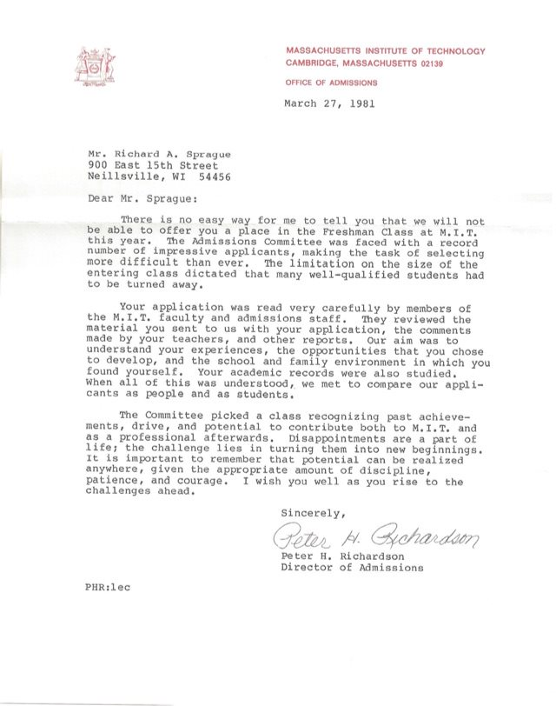
MIT rejection letter
The letter arrived on a particularly dark day, along with news of the assassination attempt on President Reagan. The hopes and dreams I had established for myself seemed to be colliding with reality.
Exactly one week later, mother picked me up from school and on the ride home she mentioned that I had received a letter from Stanford. I had already braced myself for the inevitable rejection, but then she added another detail that hadn’t occurred to me: “It’s a very thick envelope,” she said.

Graduation
By the end of my senior year, I finally felt adapted to the Neillsville social environment. In a small school, everyone knew me, but through my accomplishments and my involvement in their lives, I discovered that I had more personal relationships than previously I had thought.
I had never been particularly stressed about grades. I could get A’s just by paying attention in class. People, including teachers, thought of me as the class brain, so on the one hand I guess I had something to prove, but on the other hand, I was often left alone. The bottom line is that Neillsville wasn’t an especially challenging place academically, so there was little or no pressure to go above and beyond the minimal requirements. I didn’t pay too much attention at the time, but I suppose probably the bottom half of the class was pretty poor academically, so it may not have been all that hard to shine in a place where the bar wasn’t particularly high.
You’d think that in that environment, achieving valedictorian status would be a slam dunk, but no: that honor went to Gina. The number two salutatorian spot went to another girl, whose name I barely remember. The GPA calculations that determined class rank included the grades from physical education classes, in which I had never scored an A, and more often than not was a B. My final GPA was something like 3.85.
Anyway, by graduation time I had already been accepted to my dream school and these honors no longer meant anything to me. Probably I was also plagued by a touch of arrogance, a lifelong affliction that caused me to feel and act like I was better than these kids and therefore didn’t really care which awards they won.
That said, I would have enjoyed giving a speech at graduation, but alas the honor fell to others. Gina was a quiet, somewhat soft-spoken girl, the daughter of our home economics teacher. Non-intuitively for somebody who had never been involved in sports, she chose as her valedictory speech a theme about football, something about competing to win, or advance the goal, or – I really don’t remember. The number two person also got to say a few words, and the rest of us, the top ten, were invited to sit on the main stage looking on behind them. I sat next to Jimbo, who chuckled when I held up a “Hi Mom” sign to the audience in front of us.
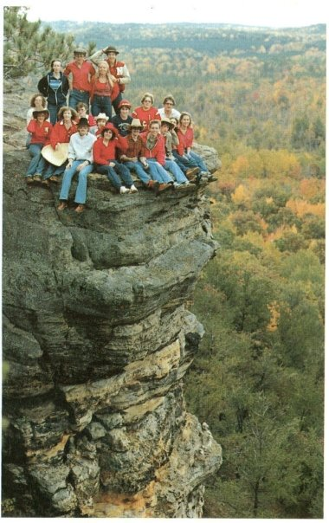
The class yearbook staff posed for this photo at Wild Cat Mound, a 20 minute drive west of Neillsville.

4.9 Leaving Neillsville
West coast colleges, including Stanford, run on the quarter system, with three periods per year instead of the two semester system of most midwest schools. That pushes the first day of classes almost a month past the start dates for all of my college-bound Neillsville friends, who by August were already beginning to pack their bags and say their goodbyes.
I found myself officially invited, for the first time, to honest-to-god parties organized by my high school classmates. Many of us had already turned 18, the legal drinking age in Wisconsin at the time, so the invitations came with the implicit assumptions that beer would be served, along with whatever potential debauchery might ensue.
Fish supposedly are unaware of the existence of water, living so immerse in it that anything else is incomprehensible. Neillsville was my water, and I was that fish, but I was eager to leave and learn all about the world beyond.
My parents insisted on taking me to California. The expense of three plane tickets, not to mention the hassles of getting to the airport and back, made it obvious that they would drive me there. Our family was used to long journeys west, but this would be the first time any of us made it all the way to California. Connie had school, and Gary was working full time so it was just Mom, Dad, and me packing into the car for the long journey to my future.
As we began our five-day drive to California, I asked my parents to stop at the sign outside of town so I could pose for one last photo and say goodbye.
The silly, rebellious teenage me, despite holding no malice toward the city that raised me, stood under the Neillsville sign and recited the Book of Mark:
And whosoever shall not receive you, nor hear you, when ye depart thence, shake off the dust under your feet for a testimony against them. (Mark 6:11)
Although I would return, briefly, for Christmas and then again the following summer, my Neillsville life was over. It would be decades before I returned with eyes that were mature enough to understand what I left behind.

5. My Family

5.1 Sprague Family History
Upwey is a small town in the south of England, a few miles from the coast. Sometime in October of 1609, our ancestor William was born the youngest son in a family that thought the Church of England didn’t go far enough in its separation from the Roman Catholics. Upwey was hundreds of miles from the real center of people who believed like they did, a group we now call Puritans. William was only six when his father died, and with few prospects of making a living under the religious persecution that his family saw coming, in 1629 he joined his brothers Ralph and Richard on a ship called The Lion’s Whelp, for the two-month journey across the Atlantic. Soon after their arrival in Salem Massachusetts, the governor asked the Sprague boys to explore the area between two nearby rivers. After quickly making peace with the local Indians, they formed a new settlement called Charlestown, in what is now the oldest neighborhood in Boston.
William was 26 when he married Millicent Eames, the daughter of a ship’s captain, who bore him 10 children, including Jonathan, who was born in 1648. Jonathan named his son after his grandfather William, born in 1690 when the family moved to Rhode Island. William Jr in turn had a son, Joshua (1729), who moved northward to Novia Scotia and had a son Nehemiah (1770) who had a son Thomas (1804). By then the family was living in Ohio and had a son Fellman (1849), who moved to Wisconsin and had a son named Howard (1887). Incidentally, Howard had an uncle named Lafayette, who died in 1862 at Antietam fighting against slavery.
Howard lived well into the 1970s, and I was about 10 years old when I met him and his wonderful wife (and my great-grandmother) Delia. They had a son, Donald, who married Ruth Faerber, and had a son they named Donald Eugene Junior (1940) – my grandfather.

A family like ours has zillions of stories, most of which seem too mundane to bother repeating, but which somehow end up in our collective memories. Oh, not quite memories – more like feelings and intuitions, attitudes about life that seem natural to us because that’s how we were raised, but might seem unfamiliar or strange to others. Most of these are too boring to notice, like how much we slouch in a chair; some are more important, like how (or whether?) you feel guilty when you’re late or how much you trust others – and whether you think there’s a difference between lying and fibbing. We Spragues didn’t learn those things from a book or school; we got them from our parents, who got them from their parents and on and on, all the way back to William.

5.2 My Parents
Although technically the Baby Boom lasted for a few years after I was born, I never felt like a boomer. The “in-between” demographics of my family might explain why.
Both of my parents were born just before World War II, barely. When Pearl Harbor was attacked in December 1941, my mother was not yet a year old. The war was over by the time my father, born in March 1940, started school. Neither of them remembers the war, except in the inevitable first-hand stories they heard from returning veterans. My grandmother kept wartime ration coupons in an old box she would show us sometimes, like museum pieces.
If the “Baby Boom” is a mindset of children born into a time of a rapidly growing young population, then my parents belong to that generation more than I do. Although their own parents and relatives weren’t themselves returning from WWII, they directly benefited from the American optimism and economic expansion that followed.
Both grew up on dairy farms in north central Wisconsin. As teenagers in the 1950s, they were old enough that they could tease friends who had only recently installed their first telephones, indoor plumbing, or electricity. Although they never flew on an airplane themselves, they knew people who had. They can remember their first TV sets.

Donald Eugene Sprague, Jr.
My father was an only child, in a rural community in northwestern Wisconsin full of big families. He had many aunts and uncles who bred dozens of cousins, many of them living close enough to play with regularly. Despite that, he remembered his childhood as a lonely time, of a constant struggle to overcome his natural shyness.
The first of his family to attend college, he entered the nearby Eau Claire state college, intending to collect enough units to transfer to the University of Wisconsin at Madison, majoring in engineering. It was at a basketball game during the fall of his sophomore year that he met my mother for the first time.
The two of them saw each other throughout the school year until he left for Madison in the Fall of 1960. But the much bigger campus was a lonely place, and he missed my mother. When he found the engineering classes more challenging than he expected, he dropped out, working part time in a photography studio until the end of the semester.
By winter (early 1961), he was back at his hometown of Sheldon, continuing to see Patsy Pulokas until they were married in July 1961. “After I was married, I never got less than an A in a class”, he recalls.
Although his mother raised him as an upright Lutheran, he didn’t take his religious upbringing very seriously. He was close to his evangelical grandparents, but his own father (my grandfather) rarely attended church. It may have been partly due to his lonely time in Madison, partly due to the regular talks with his favorite uncle Art, and partly the result of a young man beginning to take seriously his obligations as an adult, but sometime around then he joined his grandparents and uncle to become a “Born Again Christian”.
He remained an enthusiastic believer for the rest of his life. To this day I have not met a more sincere, devoted Christian than my father. His religious conviction was the absolute center of everything he did, and in all my years of knowing him, I never once saw him waiver. A devoted student of the Bible, he read, memorized, and prayed over the Scriptures every single day.
In his younger days – though this was before I was old enough to pay attention – he might have lived up to the caricature of an in-your-face evangelizer whose enthusiasm goes too far. He genuinely believed the Gospel was the solution to all problems, so naturally he wanted to spread the word. Raised by his mother to be a staid Lutheran, I can imagine he might have over-corrected after converting to become an evangelical early in his 20s.
The man I knew was always polite about his Christianity. Even if at some level he sympathized with those “The End is Nigh” placard-carrying demonstrators you’ll see in urban crowds, he would have thought their approach was counter-productive. My father lived his beliefs, as best he could, through his actions. Living the Christian life wasn’t difficult for him, because at every level, through and through, he believed it.

Patricia Ann Pulokas
My mother shared many of the same experiences growing up in dairy farm Wisconsin, but as the oldest daughter of Lithuanian immigrants, her family values and expectations were even more traditional than the Spragues.
She attended a one-room school house in elementary school, until middle and high school when her parents enrolled her in St. Hedwig’s Catholic School in nearby Thorp, Wisconsin. Her childhood was typical for farm girls of her time: she assisted her mother with household chores, helped with other farm duties like milking the cows or gathering eggs from the henhouse. She was also expected to be responsible for her younger brother, Paul.
She and her best friend left high school hoping to become flight attendants (called “stewardesses” back then). She failed the height test – at 5’8” she was too tall – but a career was the last thing on her mind when her parents enrolled her at the Eau Claire State Teachers College. In theory this would qualify her to become a schoolteacher – a reasonable and respectable job for a woman – but like all of her friends, her real goal was to find a suitable husband (an “M.R.S. degree”, they quipped).

Marriage
And so it was that, just after her 20th birthday, my mother was engaged. Married that July, they set out on a life together that by all accounts was perfectly normal.
And it was. That fall they moved into a small apartment off campus, where Mom took care of the cooking and cleaning while Dad finished his degree. Within a few months she was pregnant with my brother – who was born the following Spring.
By today’s standards, they were married at an eyebrow-raising early age, but it wasn’t unusual at the time. My mother had attended as many of her friend’s weddings before she was married as after. Many of her high school friends were already mothers by the time she had her first baby.
In fact, if anything the norm was to want to be an adult: to own a car, buy a house, have children. The concept of living as an unmarried single during your 20s would have seemed, well, lonely.
And very quickly, by the time my mother was 25 she already had three children. Nobody was lonely in our family.
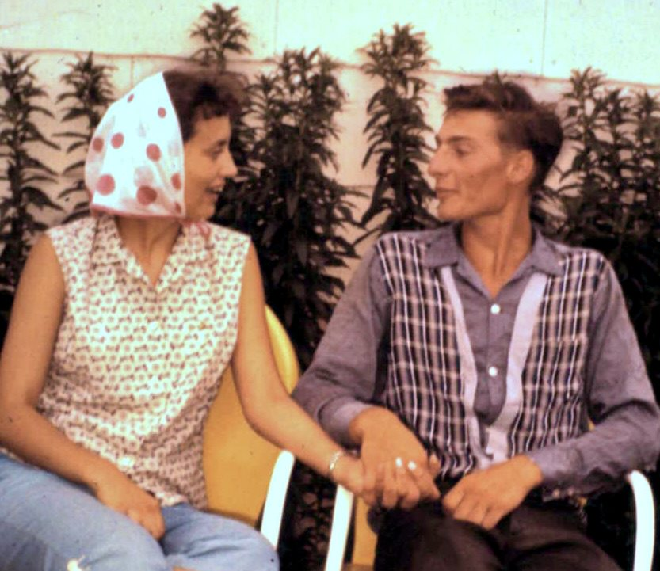
Mom and Dad, shortly after their marriage

5.3 Grandparents
I was lucky to know my grandparents and great-grandparents well.
My mother’s parents, the Pulokases, lived a half-hour’s drive north, on a small farm in Reseburg Township near Thorp, Wisconsin. My father’s lived about an hour away, just outside the tiny community of Sheldon, Wisconsin. Both sides of the family were active dairy farmers until I was a teenager, so cows, tractors, and hay fields were a natural part of our lives.

5.3.1 Pulokas Grandparents
The Pulokas relatives of my mother’s side were among the 350,000 immigrants who left Lithuania in the last half of the 19th century. Descended from a man named Matthew Pulokas who arrived in Franklin Vermont in 1900, settling in the Chicago area along with his brother Carl.
Matthew moved to America as the result of what appears to have been an arranged marriage, to Domecella Winskunas a year after his arrival. Like most immigrant farming families, they had many children—ten or more—but only three survived to adulthood, all boys, including my grandfather Anton. The family worked a small diary farm, purchased in 1904, on the south fork of the Eau Claire River in northern Clark County.
The farm was small, and by the time the brothers were in their teens it was no longer necessary to have the entire family work the place, so Anton instead found work as a truck driver, hauling cargo from northern Wisconsin to Chicago every day for a dozen years, until he was able to buy a farm of his own. His property, conveniently located adjacent to the rest of the family, became the home of my grandmother, Martha, the birthplace of my mother and her younger brother, and a wonderful place to play for me and my siblings.
Meanwhile, Carl had a daughter who married a Shainauskas man who died in the 1940s, widowing his Pulokas wife who raised her son Frank in the Chicago area. Frank was much younger than his two older sisters, who both joined a Lithuanian Catholic convent in Chicago. Frank visited the Pulokas farm during his childhood summers and the family remained in contact for the rest of their lives.
My mother’s two uncles, Walter (1902) and Joe (1904) never married but remained at their birthplace, working the farm for their mother while she was alive, and continuing to run the place, hunting and fishing until they themselves were too old to work anymore. Lifelong bachelors, they apparently had no interest in the basics of housecleaning after their mother died. The inside of the house was a mess, with a 1936 calendar posted above the kitchen table, untouched over the years that I visited.
I remember occasional visits to their home as we listened to them talk about the weather. The brothers had uncanny memories about anything weather-related. We could pick a random day anytime in the past half-century and the two would instantly tell us what the weather had been like that day or week.
You could pick any specific date, like “February 2nd, 1944”. Joe would answer “That was cold”. “Ten below”, his brother Walter would add. “A couple days before that big snow storm”, Joe might clarify. They could offer similarly detailed recollections about weather for any week, any decade.
The three brothers left school after the third grade to work full time on the farm, a common – and expected – fate for farm boys of their day. But if their educations were incomplete, it certainly didn’t show in their daily lives.
On our visits to his farm, Grandpa Pulokas would often sit in his rocking chair, head buried in a newspaper. He kept careful records of which cows he raised, how much profit per cow, and many other calculations that today we’d assume require a high school education. I still wonder how, statistically, it can be true that in America so many people graduate without the ability to read and write, when my country grandfather seemed to have no trouble, though he was only in a classroom for a few years.
About Grandma Pulokas
From Ancestry.com:
When Mathilda Martha G Petruzates was born on April 26, 1905, on the Petruzates farm in Eagle River, Wisconsin. Family legend says that her uncle was charged with the task of registering her name with the town but was drunk and gave the wrong name. For that reason, she always went by her middle name, Martha. Her father, Anton, was 43, and her mother, Anna, was 34. Martha was 35 when she married Anton J Pulokas on May 1, 1940, in Thorp, Wisconsin. They had three children during their marriage. She died on December 17, 1979, in Neillsville, Wisconsin, at the age of 74.
How Martha ended up in Thorp, uprooted from her roots in Eagle River Wisconsin, is a story long lost to history. Well into her late 20s and maybe even past 30, supposedly she had come to the Thorp area to meet my great-uncle, Joe – Anton’s older brother. Nobody knows what happened that might have precipitated the switch.
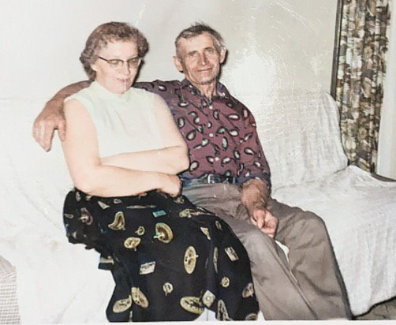
Martha and Anton Pulokas (colorized photo)
The Pulokas farm was much smaller than the farms of my father’s side of the family, but to us that made it more personal and friendly. It may have been just that my grandmother Martha was an incredibly sweet and loving woman who greeted us with presents on each visit: her back room was always set up with new toys and was our first destination each time we came over, which was at least once a month.
My mother and grandmother were emotionally close as well, speaking on the phone nearly every day – in spite of the fact that in those days such long-distance calls were charged by the minute. The trip to Grandma’s farm seemed long to us – perhaps the lack of traffic in Neillsville made any trip seem far – through the rolling hills, across the many streams, and past the endless cornfields and pastures of central Wisconsin. Surrounded as we were by so much nature, I guess we didn’t appreciate the countryside as much as I do now and I regret not taking it more seriously and treating it more like the precious experience that it was.
There was never a shortage of things to do at Grandma’s farm. During the summers, with the good weather, we played non-stop outdoors, mostly in the front lawn but sometimes in the cow pastures extending to the woods. The only area we were afraid to venture toward was the back yard, where Grandpa kept a large and scary-looking bull, chained through his nose to a heavy concrete block. We imagined that the bull was dangerous, and we especially avoided venturing near it while wearing red colors, but I never saw it to more than lazily munch the grass and hay that Grandpa had set out for it.
Of course there were plenty of farm chores to do as well, and Grandma let us help: fetching eggs from the chicken coop, pumping water for the bulk tank to cool the milk, harvesting radishes and onions from her vegetable garden.
There were pets too. Grandma kept a house dog, a small mutt she named Buttons. Well-fed from her kitchen scraps, Buttons was the fattest, most obese dog I’ve ever known. He died at some point in my childhood, soon replaced by another half-breed, a chihuahua-like puppy she named “Pepsi”.
Although there were no house cats, like all dairy farms they had plenty of barnyard cats, fed on leftover cow milk and whatever mice or rats that attempted to live on the grain kept over the winter. The cats had many kittens, including one litter of three that Grandma gifted to each of us children. The kittens were to be kept at Grandma’s house, which provided yet another excuse for us to enjoy our visits there. Sadly, like many barnyard cats, these didn’t make it to adulthood, dying one by one of distemper.
Grandma had a green thumb, and her house and yard bulged with pots bearing all manner of flowers and greens. My mother would sometimes consult with her about various planting problems, and somehow anything Grandma touched would end up growing again.
Partly because Grandma was so enthusiastically interested in us, and partly because Grandpa was less loquacious, I didn’t interact much with my grandfather. I suppose he would have been busy with farm chores, less able to spend time with us, and maybe my brother and I would have had more interaction if we had been older and more useful on the farm. Still, I know Grandpa cared about us in his own way.
One birthday he announced that he was taking me to a store to buy me a football. Despite not being much of a sports-minded person, I accepted his gift gratefully, not wanting to explain that I’d probably not get much use out of it.

Death of Grandma Pulokas
In late Fall of my junior year in high school, my grandmother Pulokas came down with what seemed at first to be a sore throat. By the time we saw her at Thanksgiving, it was bad enough that her voice was scratchy, an odd symptom that continued through Christmas until, finally, sometime in the new year she visited a doctor.
I know little about the medical details – my teenage self wasn’t tuned to such things – but eventually we learned that the “sore throat” was a symptom of late-stage lung cancer. Grandma never smoked, lived an exemplary life of rural organic eating with plenty of exercise, so it’s hard to “blame” the cancer on anything in particular except bad luck.
She was in and out of the hospital that year for various tests, and although I’m sure the adults were very concerned, none of the seriousness trickled down to me. She was just Grandma. Always Grandma. Always there.
Something happened that resulted in her admission to the big hospital in Marshfield, and I remember visiting her down the same long corridors that had been familiar to me during my own bouts of illness there: the ever-present statues and crucifixes that adorned St. Joseph’s Catholic hospital, symbols of reassurance to lifelong believers like her.
Somehow I was left alone in the room with her when suddenly she blurted to me: “Well, just know that I’m ready.”
To my evangelical mind trained that salvation only comes through direct faith in Jesus, I found this oddly reassuring and concerning at the same time. I knew on the one hand that she was a serious, practicing Catholic; but on the other hand my evangelical upbringing taught me to be suspicious of hope in heaven based on anything but faith and grace alone. Catholics pray to Mary, not God, and think you get to heaven by listening to the Pope, right? Now I can chuckle at my ignorance, but Grandma’s earnest faith made an impression on me.

5.3.2 Sprague Grandparents
The other side of the family – the Spragues – seemed less approachable, a bit more stand-offish than the loving embraces we received from Grandma Pulokas. Part of the reason may have been geographical: The Pulokas farm was much closer, just over a thirty minute drive. My mother brought us there several times a month, even more when there was no school. But I can’t help thinking that some of the reason we saw the Sprague side as less friendly was that it simply wasn’t possible to be a nicer, kinder, woman than my Grandmother Martha Pulokas.
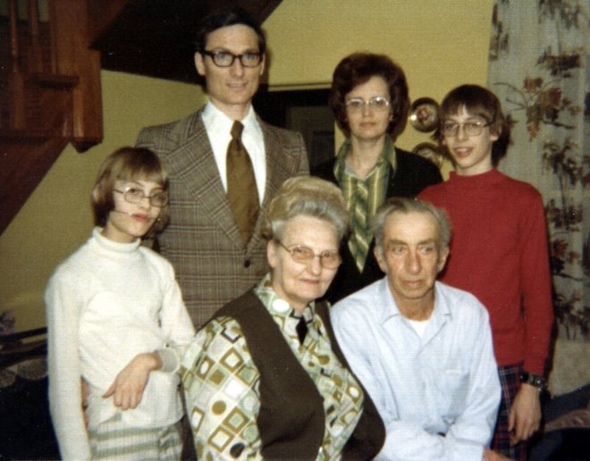
With my grandparents, Ruth and Don Sprague. My sister Connie was recovering from a broken arm.
My grandmother Ruth Sprague was a faithful matriarch who broke every mold of the typical Wisconsin farmer’s wife. Besides the normal work of milking cows each morning, for decades she was a full-time bookkeeper for the local farmer’s co-op, long before it was “normal” for a woman to have a job.
As the only of her siblings to graduate high school, she was proud of her literary tastes. The bookcase in her living room was packed with National Geographic, Readers Digest and various bound books of literature. I remember that she had a copy of The Koran up there someplace, which was exceptionally odd for a farm house back in those days, but that’s the type of person she was. She subscribed to the Wall Street Journal, delivered by mail a couple of days late to their rural farmhouse. The news may not have been fresh, but it revealed her admirable curiosity about the bigger world.
Her husband, my grandfather Donald Eugene Sprague, Sr., had no interest in reading as far as I could tell. Unlike my other grandparents, Grandpa Anton Pulokas, who always seemed to be reading a newspaper when we visited, I’m not even sure I could prove that Grandpa Sprague was literate. Well, that’s not completely true: to run a farm all those years I’m sure he was reasonably good at writing and math, but he showed none of his wife’s interest in life beyond his day-to-day country living.
Their farm was much bigger than the Pulokas farm, with many more cows, and hired hands whose names seemed to change regularly enough that we didn’t bother to get to know many of them. I remember Ted, who Gary and I found to be hilariously funny during our dinners together; and the Menchaka brothers, with their mysterious past – part Indian? Part something? Abandoned by their father?
In a farm community where most families were large, the Spragues were odd in that my father was an only child. Perhaps for that reason, after he left home my grandparents became foster parents, often for kids from troubled homes. I suppose the authorities thought that farm work would teach discipline and skills to struggling boys.
One of these foster kids, a teenaged boy named Robbie, loved to play rough with my brother and me, wrestling us on the ground much more seriously than seemed appropriate. We enjoyed rough-housing as much as any Wisconsin boy, but this kid seemed genuinely interested in hurting us.
We later learned that he had been placed in foster care at a very young age, after accidentally murdering another kid with a baseball bat. Robbie had a thing with baseballs: he broke one of Grandma’s windows with one. She demanded that he pay for the replacement out of his allowance money, but discovering that the cost would be higher than his allowance could pay, she promptly gave him a raise. This was how she thought about life.

Don (Sr) (my grandmother always called him “Don”) developed health problems as he aged into his 50s and 60s, probably due to his life-long cigarette habit. A relatively short man (maybe 5’8” or so), he had a slim build that gradually diverged as his wife became heavier. Sometime in the 1970s, he was diagnosed with kidney disease and had to go on dialysis.
They retired from farming to a life of regular long-distance travel, always by car, and generally to the west and south. My grandfather’s need for regular dialysis made no difference to their plans. Grandma simply looked up dialysis centers along the route, making regular stops as necessary.
Blood Types
Both of my Sprague Grandparents, like my father, had Type O-positive blood.

5.3.3 My Great-Grandparents
My grandparents were the last Sprague holdouts in an area that had once apparently been home to many of their relatives. Howard Sprague (1889-1975), my great-grandfather, had settled there in the 1920s or 30s and raised seven children, all of whom had their own farms at one point or another. After Howard left, the others left too, one by one, moving to cities out west in California or to the south, where they took part in the great American migration away from the farms, building lives in the cities that were much different from the agriculture-oriented world they left behind.
My great-grandfather Howard Sprague and his wife Delia were quite old, well into their 80s, by the time I met them, but they were both spry and full of energy, eager to meet us and spend time together. I feel very lucky that I had those several days to get to know them.
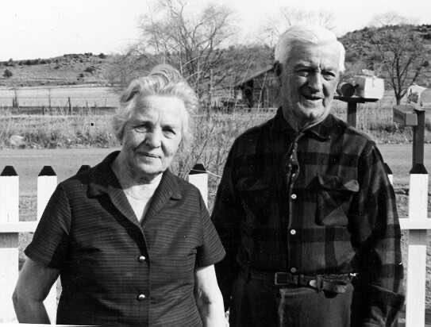
Delia and Howard Sprague
Howard Sprague was a perpetual optimist who enjoyed a life full of regular attempts at reinventing himself. Born in North Dakota, he lived as a farmer for many years while raising his family, ultimately settling in Sheldon, where my grandfather grew up and raised my father. Unlike many of his farmer peers, Howard seemed to do farming out of an interest in business: he saw it as a simple way to earn a living, buy seed for cheap, grow it until harvest and sell at a profit. But there were other ways to earn a living too, including home construction, which he did as a side occupation until, long before I was born, he decided to move near Monterrey California to start a commercial building business. He tried that for a few years, apparently successfully, before moving again, until he ultimately retired to Grand Junction, Colorado, where he lived until his death.
But back in Sheldon, somehow my grandparents held on, lone holdouts against the urbanization that called the rest of the family. As a result they gradually accumulated additional farms, left to them by departing relatives. This, too, made Grandma Sprague’s place seem so much bigger, and a bit more formal, since now the various additional farms were inhabited not by relatives but by renters.
Still, a farm is a farm and there is always plenty to do. Grandma Sprague had planted apple trees in her front yard decades before, and now during the late summer and fall the trees bulged with fruit begging to be picked. She too had a vegetable garden – far larger than the Pulokas one – with rows and rows of pumpkins, squash, sweet corn and much more. Of course, both grandparents’ farms were surrounded by thickets of corn plants, fields that by late summer grew into unnavigable mazes that we kids never grew tired of exploring. The Sprague farm had a separate, large hay barn, full of straw bundles that we turned into non-stop amusement, building our own caves and hideaways, like full-size lego bricks.
And always, the smell of cows, everywhere. “Fresh air”, my mother called it.

5.4 More Relatives
My father was blessed with dozens of cousins thanks to the prolific mating habits of his grandfather and uncles. But we knew few if any of them, and fewer of whatever children were my age. Partly this was a consequence of distance – they were scattered in California, Colorado, Oklahoma – but honestly a bigger reason was a lack of cohesion on that side of the family. “We’re the white sheep of the Sprague family”, we joked.
My great-grandfather, Howard and his wife Delia had seven children: Buren, Don, Art, Lyle, Avanell, Loretta, and Dewey.
Although I probably met each of them at some long-forgotten family gathering, I don’t remember much. Mostly they were just names to me, old people who were somehow connected with the Sprague side.
Art was an exception. He and his wife Doris lived a mile down the road from Grandma’s house – at least when I was very young – a place I remember full of stories of the practical jokes that the couple liked to play on others – and each other.
Their son Kenny, who was several years older than me, might have become a cousin friend but sometime in the early 1970s they moved to Kenosha, in southern Wisconsin, when Doris got a job at a car manufacturing plant.
Other sons of Howard were scattered across the country, and I know little of them except for family stories.
Howard objected when his daughter Loretta wanted to marry her teenage boyfriend, Harold. But somehow they married anyway, a relationship that lasted a lifetime. They lived in Lansing Michigan.
Most of these people carried the Sprague name, and I don’t doubt that if I ever spent time in Eureka California I would bump into descendants, legitimate and otherwise, of Howard’s son Dewey, who married multiple times and had many children and then grandchildren.

Paul and Pat Pulokas
We knew the Pulokas side of the family much better. My mother’s only sibling, Paul, was three years younger than she was, and having moved away from home while he was just beginning high school, she might be expected to not know him very well. But sometime after college, he met and then married Pat Henschel, a part-time registered nurse and family powerhouse.
She met Paul at a bar in November 1966, when she bumped into him on purpose as a way to strike up a conversation. They were college seniors at the time – she in her last year of nursing school, he in his final (fifth) year in agricultural engineering. They dated a lot after that, and by graduation in the summer of 1968, they were essentially engaged. He started a new job at International Harvester, but within six months he received his draft notice and soon was headed to Fort Dietrich Maryland for the next two years.
They corresponded by mail nearly every day and the following year he got her a ring and brought her to the farm to meet his parents. Her mother was strongly opposed to her marrying a Catholic, so it took another many months to work that out. Finally in 1969, she moved to Maryland, got a job at a hospital and an apartment there so they could see each other every weekend. They married in 1969.
It never seemed odd to us that Paul wasn’t much of a talker. Like his father (my grandfather), he was married to somebody who was far more conversational, so perhaps these Pulokas men simply never bothered to speak much to us. What would be the point, since their wives knew everything and kept everyone in touch anyway?
My earliest memory of Paul is from a hotel room near Madison Wisconsin, where we stayed while attending his wedding. I vaguely remember a long reception, with loud music and dancing that I thought overly boring. A much more exciting event at the time was the cartoon “Underdog” playing on our hotel room TV set. I also vaguely remember my brother being ill, perhaps from the abundant food.
Sometime a few years later, we visited Pat and Paul at their home in Bloomington Illinois to meet their first child, Tony Pulokas, my first cousin. It was a six hour drive that we could afford to undertake only on special occasions, like summer vacations. For Christmas or Thanksgiving, they would drive up north to meet us.
More children, and more cousins, arrived throughout the 1970s, eventually giving me four first cousins: Tony, Mark, Jim, and finally Katie (born in 1980). Because of the distance, we saw them at most once or twice a year. The boys were several years younger than we were – a difference that matters more at that age – so although I have pleasant memories of our yearly visits, we didn’t know each other as well as many families.
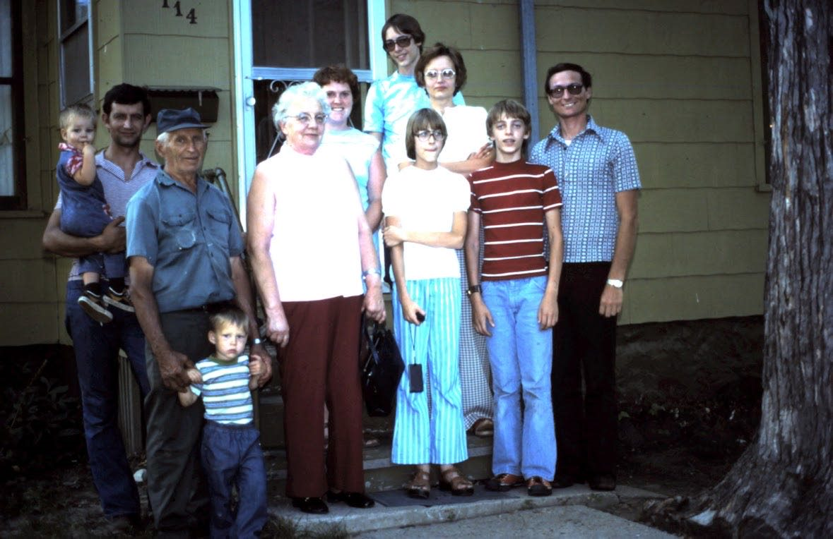
Me on the right, with my family. Pat Pulokas, Martha Pulokas, Anton and his grandson Mark, Paul with his son Jimmy. It’s possible that my cousin Tony took the photo, though he would have been quite young at the time.

Uncle Raymond
Raymond Lyle Herman Faerber
Raymond was born to Herman and Mary Faerber in McKinley Wisconsin. He was baptized into the Christian faith on January 7, 1921 by the Rev. A. F. Hemer at Jump River, Wisconsin. His sponsors were Ella Beutler, Reinhold Luedke and Frank Beutler. On July 2, 1933, he was confirmed into the Christian faith at Trinity Lutheran Church, Sheldon Wisconsin by the Rev. O.H. Marten.
On October 27, 1942, Raymond entered into active military service with the United States Army. He took part in battle and campaigns in the vicinity of Rome – arno, the Northern Appennines and Po Valley. He was awarded the Good Conduct Medal, the American Theater Service Medal, the European-African-Middle Easter Theater Service Medal and Two Overseas Service Bars. His rank was Private First Class.
Raymond passed away at Rusk County Memorial Nursing Home on Monday January 27, 1998 at the age of 79 years, 11 months and 1 day.
He was preceded in death by one brother, Reuben.
February 25, 1918 - January 26, 1998
Buried in Mt. Nebo Cemetery in Jump River, Wisconsin
My grandmother’s brother, Raymond, fought in Italy during World War II, and that seemed to be his favorite topic conversation ever since. Not the war, per se, but his observations about sinfulness and how small temptations could grow into bigger ones.
His sister, my grandmother Ruth, was only daughter in a family rocked by devastating tragedy. Their father (my great-grandfather Herman Faerber) had lost his left arm in an accident (sawing wood?) early in his life — I’m not clear whether it happened before or after his marriage.
Maybe it’s understandable that everyone in that family spent time in mental institutions (including my grandmother, of which I’ll discuss later). The eldest brother, Buren, had already been long institutionalized by the time my parents married, apparently coming to believe that he was God himself — on the only time he was introduced to my mother, he refused to shake with his right hand because “I’m holding the world in it”.
Their mother, Marie, died when Ruth was only 18 years old, of breast cancer, after what was no doubt a long bout of unspeakable pain and suffering. The mother and daughter were apparently quite close, so I’m sure it made a devastating impression on my grandmother, though it never occurred to us to ask the details.
Marie was, we were told, from a “rich” family in North Dakota and looked down on her husband Herman, who dragged her away from her happy family to live in an unsettled part of northern Wisconsin, near the Jump River, where somehow they had secured some land for farming. The family arrived in an ox cart (or so I’m told), amid forests so thick they had to secure permission from the county to graze their cow in a public park while they cleared their own property.
They spent their first Wisconsin winter on a dirt floor in a shelter barely worthy to be called a shack. The “real” house they built in the Spring became Raymond home for the rest of his life, except that brief period during the war. The property was situated near a river, but for daily use they dug an artisan well in the winter: one foot per day until they struck water at something like 30 feet.
I knew Raymond as a regular guest at Thanksgivings and Christmases, when you could reliably assume he would repeat his many stories of military service in Italy. As with many WW2 veterans in my experience, if he had seen action he didn’t discuss it. Rather, he regaled us with anecdotes of the depravity of his fellow soldiers, some of whom — the horror! — played blackjack.
Still, he was always friendly enough that it was easy to forgive his orneriness as a symptom of being a lifelong bachelor. Grandma would later chide him for “not marrying that Mennonite girl” when he had the chance, a woman who, I heard, remained unmarried herself.
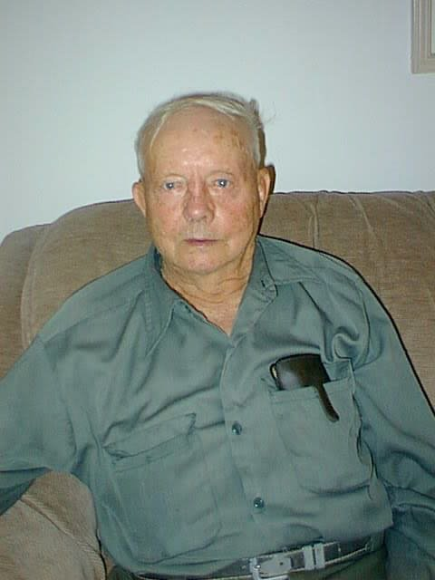
Raymond Farber (photo from the 1990s)
My new wife and I visited Raymond in the mid-1990s, not too long before he passed away. His house was spartan, though I remember it being much cleaner than the bachelor home of my other great-uncles — the Pulokas brothers Joe and Walter, who had never learned to clean up after their mother died. Raymond kept himself busy growing a large garden, and tending to his main prize: an elaborate grove of maple syrup trees, carefully rigged with tap lines that carried the sap automatically to an endpoint where he would boil it into dozens, maybe hundreds of jars of maple syrup each spring.
Although — perhaps because — he lived alone for so long, Raymond was a fiercely religious Lutheran who read the Bible regularly. Few things brought out a livelier side of him than a discussion about non-King James Version translations. I remember a lengthy lecture once about how the modern translators have deliberately inserted some heresy into various verses, the details of which I no longer recall, but which to him seemed of urgent importance.
He wrote notes on what he read, written in the smallest possible handwriting, edge to edge on whatever scraps of paper he could procure. After his death, the family found hundreds and hundreds of these scrupulously-written page of commentary scattered throughout the house.

Raymond and my grandmother had an older brother, Buren, who I never met. Well that’s not quite true. I was a few weeks old when, in April 1963, my mother carried me to the funeral of their remaining parent, Herman Faerber, my great-grandfather. When my mother met Buren there, he apologized that he could not shake her hand. “I’m God”, he explained, “and I need to hold the world in that hand”.
I know very little else about Buren. I dimly remember sitting in a car outside a mental institution in Owen Wisconsin, waiting on my father who had stopped in to visit. Buren was apparently quite intelligent, able to recall details of a newspaper after a brief skim. It was never explained to us how he was institutionalized. It’s one of those family mysteries that was probably so traumatic that at the time nobody wanted to discuss it further. Eventually, enough years passed that it became permissible to talk, gently, about the details, but by then, most of those who knew the facts were gone.

6. Meaning

6.1 Religion
You cannot understand my childhood without fully appreciating the role of Christianity, not just in the life of my family and surrounding friends (and non-friends) but in my own personal life. Other than school, no other activity consumed more of our time than our church.
Like everyone who hopes their life can be a long arc of improvement, rather than a static boring maintenance of some status quo, I have learned a lot since childhood, about everything, so of course there are some changes. But in the most important senses, on the most fundamental issues, I haven’t changed. As my perspective broadened in a life full of new experiences, of course I gained a deeper understanding of issues that I once thought were simple.
But first, let me describe my life then and the inseparable relationship I had with my religion.
Important Reminder
Please note that I use the past tense in this discussion only to emphasize the fact that these events happened in the past. While in many or most cases, I still believe what I did then, I say “believed” to reflect precisely the times cited. Also, while I think I fairly express what most of us agreed at the time, I don’t want to pretend that I speak for them today.
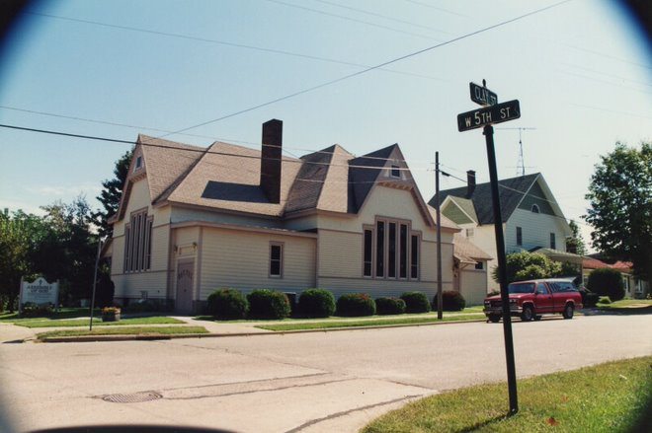
Neillsville Assembly of God: the church where I spent most of my childhood free time
Sundays of course were almost entirely devoted to the church. As the pastor’s family, we arrived at least half an hour earlier than everyone, and stayed later. This was true for Sunday morning as well as Sunday evening, when we had another service.
Before church, we helped with setting up for the service. Depending on the situation or time of year, this could mean anything from setting up folding chairs for a class or service in the basement, or shoveling snow on the sidewalks outside, vacuuming the carpets, preparing implements for a Communion service, or any number of miscellaneous tasks.
There was also time for socialization before church, first with my brother and sister and then with some of the children of the more enthusiastic churchgoers who arrived early.
In the back of our church was a large map that often provided an interesting focus to our attention. Pins in various countries showed where our missionaries were working, but to me it also showed the wonderful variety of places on earth. We played games where my sister or brother would pick a location at random – a river, a city, a mountain range – and the rest of us would have to guess where it was. Sometimes I would look at the map and imagine myself as an explorer trying to reach some exotic place without passing through some other forbidden territory. In those days, the majority of the world was covered with hostile – and inaccessible – countries like the Soviet Union and China. It was easy to think of our country as the last bastion of freedom in an oppressive world, and that map was for years a focus of how I thought about the larger world.
My closest friends were the children of other regular church-goers, and they would begin to arrive shortly before Sunday School began, offering the first socialization of the day. During the winter months we would cluster inside, or in the basement, chatting or playing games in the indoor warmth. During the Summer, we might be outside, sometimes congregating near the back of the church or on the next door lawn where we could talk or run around.
The hour before the main church service was Sunday School, and although this wasn’t as rigorous as our regular school – no grades, no tests – there was a curriculum to go through, and each Sunday was structured around a lesson covering some aspect of Christianity presented in a way relevant to our age group. Our Sunday school teachers knew us well – many of them had been teaching us for years – so the tone was always informal and interactive.
It would be an exaggeration to say that this was a thorough religious education – a reasonable smart kid would soon learn enough that you could get by without paying much attention to the content of each lesson – but for all of us these lessons became over time something that was just there. Each week, fifty-two weeks per year without fail, year after year, we heard another verse, another story from the Bible, another explanation or detail of our religion. Although I can’t say that we covered every part of the Bible through the years, the key stories and teachings were repeated often enough that even the least attentive kid could soon recite them from memory.
After the hour-long Sunday School lesson, we proceeded upstairs to join the adults in the main “worship” service. Here we had more roles to play: we kids were members of the church orchestra, so we began the service at the front of the church; depending on the time of year and availability of other attendees one of us might also be called upon to be an usher.
The worship service in an Assemblies of God church is far less structured than the Catholic services that my children know, but typically it has three parts: a song service, an offertory, and a homily, which ends in a benediction.
The first part, the song service begins with some introductory remarks followed by a ten or fifteen minute interval of congregational singing. Usually this meant three hymns, sung in a row, and led by a musically-oriented member of the congregation, often my father at times when nobody else was available. My friends and I were at the front of the church during this period. The core group consisted of my brother on saxophone, my sister on trumpet, me on flute, and Jimbo on clarinet, plus a few others: I remember sometimes an extra flute player or another wind instrument. Once the music service was finished, there would be an offertory with additional music, often performed solo by one of us. After this was finished, we returned to our seats near the front.
The homily (we didn’t call it that –we called it the “sermon”) was the longest part of the service, typically twenty to thirty minutes. Usually this was my father speaking, though perhaps once every month or two we might have a guest speaker. It always began with prayer, followed by a Bible reading.
Unlike Catholic or the “mainline” Protestant churches, the specific reading each week was entirely at the discretion of the speaker, so it could range from a short verse, or an oblique reference to one, to a long reading that took up much of the sermon. The congregation was encouraged to bring their own Bibles to the service (I always brought mine) to follow along in the text. It was assumed that the members of the congregation knew how to look up the scriptures themselves. If the preacher referred to “John 3:16”, for example, any Bible-carrying churchgoer could easily find the specific passage without assistance. People unfamiliar with how to look up Bible verses would be welcome to follow along with someone in their surroundings or just listen to the preacher.
The sermon itself was usually based on the scriptural reading, although this would vary considerably depending on the circumstances. During Church religious holidays – Christmas and Easter—the contents were determined by those specific Bible stories and readings. During the rest of the year, the sermon could range from a detailed theological discussion of something or other, to a discussion of current events. Because the sermon was so central to the service, and because so much was at the discretion of the preacher, the speaking talents of the preacher was a major factor in the size and vitality of the church. People were always free to go elsewhere if they didn’t like the sermons.
When the sermon ended, there would be a prayer and perhaps a final song, after which the congregation was dismissed. For my friends and me, this also marked the beginning of the most social part of the day, as we gathered in the back of the church to catch up. We knew everyone – the hundred or so attendees each Sunday – so there was plenty of conversation and I never felt awkward or alone.
For my entire time in Neillsville, this church and this rhythm was as much the backbone of my life as my family – it was my family, literally, since my father was the pastor, and we were there at every service. Conversations before and after church were with people I felt I knew deeply, nearly as well as I knew my brother and sister, and certainly better than I knew even my best friends from school.
Once the rest of the congregants dispersed, my family left for home too. Sometimes Mom would leave a bit early to get started on lunch (which we called “dinner”). When the weather was good, or if Dad looked like he would be staying longer, we might walk home. Occasionally, we might be invited to join some other family for lunch, or on special days like Easter there might be a church-related meal (a “pot luck”), either downstairs in the church basement, or if the weather was nice, at a nearby public park.
Sunday afternoons were always family time, and if it wasn’t just with my immediate family, my family was with me. Sometimes my brother or sister (or I) might spend the afternoon with a friend, but our friends always had parents who were friends of my parents. Our best friends all had brothers and sisters who mapped to my brother and sister, so it rarely made sense to take the trouble to visit somebody’s house without the whole family.
The other, more practical reason our family generally stayed together on Sunday afternoons was that Sunday evenings always included another church service.
The evening services were more informal than Sunday mornings, but the same pattern prevailed. We Spragues arrived earliest, to set up if necessary and to greet everyone else. There was no orchestra, so my siblings and I were a little more free to participate in the rest of the service, but I don’t remember ever using this as a reason to sit near anyone other than the rest of my family.
As you would expect, the evening service was less well-attended, and the congregants were generally more die-hard than the morning attendees. Many of them – the farmers – travelled a reasonable distance, sometimes through inclement Wisconsin weather, to get there, so it was no small sacrifice to come to town twice a day, every week, to attend. We took it all very seriously.
The service could go fairly late, past the bedtime of younger children, and I remember often my mother would (encourage?) let me sleep, laid down flat on the pew. This didn’t seem particularly unusual to me and I probably would have continued it to an older age but for the way that teenagers tend stay up later and need less sleep in the evenings.
Another reason I didn’t sleep was that because the Sunday evening service was attended by only the most enthusiastic parishioners, the sermons were usually more informal, more technical about the nuts-and-bolts of our religion, and often more interesting to somebody like me. I enjoyed the deep theological debates, and the fascinating mysteries I felt were being uncovered for me.
What did I give up? Sunday evenings in those days was also prime television time, and I missed some great TV shows (“The Six Million Dollar Man”, and many great movies on “Walt Disney Presents”). More than the shows themselves, I also missed the cultural references, which were familiar to my non-Sunday night church-going friends.
If Sunday evenings weren’t enough, there was also Wednesday Bible Study, another church night, and we were always there too. Again, since my best friends were also regular church-goers – the causality of friendship goes both ways – it was part of my social life too.
For much of high school, there was a separate youth service on Monday nights. The purpose was mostly social, usually involving an interesting activity, and we didn’t think of it as “church”. For many years, this was my church answer to Boy Scouts – a boys-only group, with our own uniforms, merit badges, campouts, and much more – and again it is hard to separate these activities from the rest of my social life.
In short, my social life and my church were the same thing. Among the more fundamentalist Christian denominations, my experience is not unusual. It seems unusual to many of my friends today – those who I met through college, grad school, and beyond – but that’s more because our lives are so self-contained. With such an emphasis on our religion, and the church-going that accompanies it, there isn’t much time to participate in the rest of the world’s activities.
The same is true, I’m convinced, for anyone or any family caught up in a passion about something, whether it’s sports leagues or Shakespeare Festivals or organic farming. To us, our church was focus of our entire social life. It’s impossible to understand my childhood without understanding this.
Besides these church services, my years were full of other church-related special events. Several times a year, my family attended meetings sponsored by other churches in the area.
Usually the event featured a charismatic speaker, often somebody well-known even outside our church community, such as a successful businessman or a former POW, or occasionally a very famous name like Billy Graham or Oral Roberts. Many of the speakers worked full time at speaking to Christian groups like ours, “Evangelists” who made a living traveling throughout the U.S. (and often, to other countries) preaching about God, always in an engaging and interesting way, full of stories and uplifting examples of how Jesus had helped them, and could help us too.
Many of these were music concerts, sometimes with “famous” musicians like the Lundstroms, an evangelist family who travelled throughout the United States and once even came as close as Marshfield – so of course we were there – giving me my one brush with greatness: after the Lundstrom concert, held at the Marshfield High School auditorium, several of us kids were enlisted to put away the folding chairs. I dutifully complied, taking down chairs and putting them onto rollers for transport into the auditorium storage areas, when suddenly Lowell Lundstrom himself approached me.
“Hey, can you be more quiet? I appreciate your help, but it sounds like shotguns going off out there.”
All of the events had a familiar pattern. There was plenty of music, always well-produced and performed live, with an interesting mixture of familiar hymns and newer, more contemporary songs. There was an inspirational speaker, who talked from the Bible of course, but usually while relating a personal story, always well-told and interesting.
These events were open to the public. In fact, we were encouraged to bring our non-church friends with us, though that was harder to do than it seems given that my social life consisted entirely of church-related activities. More often than not, my friends were already planning to attend.
Unless it was an exceptionally popular event (perhaps featuring a famous musician), there was no admission fee. Instead, sometime in the middle, just after the music and before the speaker began, ushers would come and pass offering plates throughout the audience to ask for donations.
Always, the event ended with a stirring and sometimes unsettling reminder of the shortness of life, the importance of a focus on things of lasting value, and an “altar call”, an opportunity for each individual in the audience to come forward and publicly agree to dedicate themselves to Jesus. For those of us who were already very devoted to Jesus, the altar calls were optional, although occasionally the speaker’s message would be so powerful (or unsettling) that I would be reminded again how perhaps I wasn’t really on the right track after all, and that it wouldn’t hurt to focus just a little more on the main messages of the Gospel.

6.2 The Minister’s Son
My father was pastor of our church for all of my Neillsville memories. It started as a “missions church”, meaning that the statewide district for the Assemblies of God had determined that our area needed a church, and they supplied a small amount of money and a pastor to get things started. Dad was the perfect candidate: sincere, enthusiastic, a college graduate who had grown up as a farmer, like most of the parishioners. The only thing he lacked was a degree from a seminary, but the church could supply that through an extensive correspondence course, which he devoured eagerly. With a certificate of completion in hand, and some assistance from the church statewide leadership, he jumped into the Neillsville pastorship with a passion that I’m sure was rare and appreciated.
His otherwise perfect background had only one flaw: his youth. By the time he celebrated his 30th birthday, we had been living there for several years. Although I was too young to notice at the time, I’m sure he was officiating at weddings and funerals where he was the youngest and least experienced person in the room.
In the late 1960s, though, youth was often an advantage, particularly to the expanding Baby Boom generation. To make ends meet until the church was better established, he worked as a high school teacher, where his youth probably made him easier to relate to the other students. When a “Jesus People Revival” hit the area in the early 1970s, he was a perfect leader, with dozens of young people eager to look to him as a role model and teacher, far more knowledgeable and experienced than they were, but young enough to be “hip” and approachable.
I learned later that “Preachers Kids” are supposed to have problems, especially when they reach their teenage rebellious years, but that was never the case for us. We loved our dad and respected his job and position in the community, although mostly to us it was just a natural and normal part of life. I never felt different – in either a good or a bad way – for being the preacher’s kid. When later people told me that children like us are held to a higher standard, that we would be expected to be perfectly well-behaved compared to other kids, it didn’t make sense to me. I thought we were well-behaved and obedient because the Bible commanded that of everyone. We attended church so much that obviously we knew right from wrong, as would anyone else who took our religion as seriously as we did. This wasn’t about our family, I thought, it was about being a good Christian.
Looking back, and understanding more about the attitudes of mainstream Americans toward minority Christian groups like ours, I assume that many or perhaps most of our schoolmates were taught to look at us with some caution, like an odd cult-like organization full of people a bit too extreme in our beliefs. The Assemblies of God denomination, as well as the evangelical movement of which it was a part, was growing rapidly in those decades, but was far more obscure than it is now. In those days, the idea of a “religious right” was inconceivable either to us or to the political world at large. Mostly we were perceived as a small, perhaps slightly strange, but harmless religious sect which America proudly tolerated.
In fact, we were self-segregating as we were segregated by anyone else. Although we were eager missionaries to others, so much of our time went directly to church-oriented activities that there wasn’t much left over to associate with the rest of our community. We didn’t drink alcohol, for example, so it would have been unthinkable to appear at any of the local Neillsville taverns or nightclubs. We were against going to movie theaters or listening to much popular music. Many of our church members frowned on TV viewing too, so there really was precious little exposure to the wider world, and frankly, that was fine by us.
From time to time, Dad was invited to community-wide gatherings, a city-sponsored Memorial Day event for example, and he might be asked to speak. In a small town like ours, everyone knew the mayor and other city leaders, but they all seemed unapproachable, like people from a far-off world who rarely if ever mattered for our day-to-day lives. I’m sure my parents had more exposure than we kids did, but never to the point where it affected us.
More recently I’ve discovered a generation of ex-Assemblies of God kids who call themselves emergent, who take pride in their openness to alternative theologies. The church of my youth would have dismissed them as simple “backsliders” or heretics, people who had been exposed to the absolute truth and then rejected it. Many of them, in fact, began as rebels from the church, falling into drugs and other behavior, often simply because it had been prohibited. But like me, I think people in the emergent church recognize that within the deeply religious life that we lived as children and teenagers, there was a core, a valuable center that really did make us better people.
There is much to be said for a church-centered evangelical life. The all-consuming aspect of our theology forced us to confront many deep, philosophical issues that are lost on too many adults who never had to confront issues of mortality or morality, topics that we discussed regularly at length. I understand how many of my peers ultimately found the deep, on-going commitment to be too exhausting, or perhaps, too limiting in a world of so much more to discover. But anyone who experienced it and who now reflects honestly will find, like me, that there was much value there, and much to lose for those who leave.

6.3 What We Believed
Christianity to us was not just a part of our lives – it was central to everything we did, the way we acted, the way we thought about other people, the future, the past. It’s hard to overstate this. Our Christianity was not simply a belief system, and certainly not just a set of rituals performed out of respect to family traditions. To believers like us, nothing – absolutely nothing—is more important that your relationship with God: not family, not friends, and definitely not other forms of “earthly” authority like schoolteachers or bosses.
We were warned that, like the original Apostles, many of whom were killed for their beliefs, we too would be persecuted. Our persecution might not be direct and physical – though we heard stories of children taunted on the playground by non-believing bullies – but it would happen all the same.

God is personal and real
We believed in a personal God, all-knowing, all-powerful, involved in every detail of every life, but still ultimately an individual with whom you could have a conversation. God was interactive too; prayer was two-way communication, with we humans speaking to Him, and God speaking back. Not in an audible voice, of course (although we believed that, rarely, this could literally happen) but if you listen carefully, He does speak. He speaks through a subtle, barely conscious voice within, a nagging thought in the back of your mind sometimes, or sometimes something more direct, like a strong feeling that you should act in a certain way.
This personal God is also directly accessible and makes no distinction among people. Anyone can understand God’s message. Through effort, one person might reach a better understanding of the finer details than another, but ultimately the relationship between you and God is direct and individual. There are no “priests”, to intermediate between us and God, and we are all “saints”, equally born in sin but deserving of the same grace granted to everyone who believes.

A sin is a sin no matter how small
We believed that all people are fundamentally sinful. We are born bad, and it is in our nature, our instinct, to do evil. Sin was all around us, a constant temptation. Not just the Big Sins, like murder or bank robbery – no, those were just distractions from the real and in God’s eyes equally serious daily sins we faced like anger or selfishness.
This sense of the ubiquity of sin was very real to me. When I was very young, first or second grade, I heard the Bible passage in the Gospel of Matthew reminded us that we were guilty of adultery simply by thinking lustily after a woman. I became convinced that, since occasionally I showed interest in girls, I was guilty of adultery and was therefore in immediate risk of permanent damnation in Hell. Naturally, this bothered me a great deal until eventually my father intervened to explain that I had nothing to worry about. He filled in more details, and this is how I learned about the birds and the bees.
Sin wasn’t divided into “big” and “small”, mortal and venial. All sins are equally bad in God’s eyes, and all humans are equally guilty. There was no such thing as one person – a saint – who was “better” than another – a criminal. Every single human who ever lived had committed some sin, and was therefore entirely worthy of eternal damnation, and equally in need of humility and submission before God.

Only a few will be saved
But, for whatever reason, God decided to care about our pitiful state of sin, sending his only son Jesus to rescue us. Through Jesus’ death on the cross, and subsequent resurrection, we had a way out of our terrible sinful nature. This was the essential extra step of our belief system: we are bad, but God is a personal being who cares about us, and Jesus is the way out of our sinful nature.
Non-believers, or those who consider themselves “mainstream” Christians yet reject a strict emphasis on Sin often miss this part of the Gospel. I never saw my Christianity as something that was just about sin and all the bad things that happen if you stray from God. Equally, it was about salvation and God’s love, and the wonderful peace and satisfaction that comes from following His will.
Importantly, our Christianity was equal opportunity and open to absolutely anyone who accepted the message. There was literally no distinction among people, rich or poor, educated or not, young or old, male or female, of any race. Every one of us, we believed, is fundamentally a foul, wretched sinner who can only be saved by belief in Christ. Humility, too, was essential, because often it was precisely those who think they are good who are the most deceived of all. True salvation is always a gift of God, and not something we earn by our social status or even our own efforts in the faith. Only God could save you, nobody else.

We are the chosen elect
There is no greater theological gulf than the one separating different denominations among evangelical, fundamentalist Christianity. When the stakes are so high – eternal salvation or damnation – the serious believers will explore every nuance of the faith, uncovering entire revelations of truth in seemingly tiny passages of Scripture. The Assemblies of God was front and center of that tradition, and we believed we had uncovered the greatest truths of all, the source of God’s power delivered in practical terms to humankind: the Gifts of the Spirit.
The most straightforward was the gift of “speaking in tongues”, glossolalia. Under intense and sincere focus on the Holy Spirit, we believed you could spontaneously begin speaking in languages you hadn’t learned. Based on a literal interpretation of the Biblical Book of Acts, where the early Apostles described themselves praising God and preaching to the unconverted in foreign tongues, we believed that normal Christians today could do the same thing, and it was common in our church. My father, of course, and most of the leadership of our church routinely acted on this gift during our church services, especially during the Sunday or Wednesday night services that were attended by the most faithful.
I received the gift of speaking in tongues by around age twelve or so, and during our prayer services nothing felt more natural than to spontaneously begin speaking aloud in what to outsiders sounded like gibberish, but to us was a melodic proof of God’s power, of a direct and real communication with the Creator of the Universe.
There were many Gifts beyond speaking in tongues. The Gift of interpretation enabled a believer to understand and then translate into English the otherwise incomprehensible speech of somebody speaking in tongues. Many of our church members also had the Gift of Prophecy, through which they had a direct channel into some new spiritual insights they could relay to the congregation.
Often these insights were general and broadly applicable admonitions to keep up the faith, but sometimes – when we were really lucky – the prophecies carried a specific prediction about the future. Although it was exciting to hear these predictions, they were usually rather generic, such as a warning to be on the lookout for a stranger who seemed to be of God but actually wasn’t. The most common type of prophecy was conditional: if we did something (e.g. pray more fervently), we would see more of something else (e.g. more converts).
The Gift of Healing was especially relevant to me with my history of surgeries, but for some reason the Gift wasn’t as common, at least among regular church-goers. Most of the Healers I met were visiting preachers – evangelists – who made this a special ministry. People with serious, acute afflictions like diabetes, cancer, or those who were wheelchair-bound might travel long distances to seek help through a well-known healer, and there were many success stories of people who claimed to be healed of incurable diseases.
All of these Gifts made us feel special, like we had a unique and powerful channel to God, a window on a spiritual world that was real and relevant but hidden from our unbelieving neighbors outside the church. It was also a powerful incentive to stay in the church, to study our doctrines more fervently, to learn as much as we could about this fantastic new world.

The altar call: focus on what’s important
With constant reminders of our sinful nature came an undercurrent of belief in the precariousness of life and our situation here on earth, a point that was brought to us forcefully and regularly during the last part of many of our church services, in what we called the “altar call”. It’s easy to be so caught up in the daily cares of our existence that we forget the true meaning of life and that each of us is on earth for a special purpose, and the altar call was a time to humbly acknowledge the ways in which we have veered off the path that we should be taking.
Much later, in the business world when a project came to a point of desperation, we sometimes called a meeting that we called a “come to Jesus”, which somebody with my background could understand intuitively. The altar call is like that: a chance to return to your roots – in religion or in business – and to focus on the fundamentals.
These were the central, core messages which I grew up in, and if I learned nothing else, I knew that this was the way to live: a focus on my fundamentally sinful nature, the existence of a personal God who cares about my wretched condition, the saving grace of His son Jesus, and the overriding priority that we think of life in its eternal context, never losing sight of what is truly important.
Belief in these fundamentals was enough to get me through the rest of my life, the bedrock of my moral system and the lens through which I was taught to see everything else.

Original Sin, Creationism, and more
The world outside my church influenced me more in theory than in reality. I attended a public school, where it was obvious that most of my peers believed differently than me. Although if asked, nearly everyone would have claimed to be Christian, our definition of salvation required a more active and fundamentalist interpretation than most students and teachers thought necessary. In fact, for us the term “Christian” referred exclusively to people with our exact beliefs. Other denominations might call themselves “Christians” but we knew they were abusing the term.
Some people might have interpreted our beliefs as judgmental or even haughty – ha ha, we’re saved, you’re not! – but that concept literally wouldn’t have crossed our minds. After all we are sinners too – and all sins are equal. Instead, we looked at others with a mixture of compassion and fear. We wanted them to convert, but we were wary too that they were likely to persecute us.
I was afraid of the non-Church world, full as it was of people deceived by the Devil and no doubt ready to deceive me too if I gave them a chance. Usually that was not an issue, but occasionally we would have interaction with people who were also enthusiastic Christians, but who disagreed with us on some – to us – major issues.
The Bible Baptist denomination split from the more populous (and mainstream) Southern Baptist denomination over what to outsiders might appear to be picayune and trivial details of faith, but to insiders was a life and death struggle for souls. Satan, after all, fools best when he can tell marginal lies because by getting people to believe a small lie, he grabs a foothold that can lead to who knows what over time.
One serious matter was a question of whether a true Christian – one who has been “saved” – can end up in Hell. It was obvious to us that all sins are equal, and that a single error is all it takes to be eternally damned. But shouldn’t a person’s faith in Jesus have been sufficient to overcome this? Surely a true lifelong believer would be protected somehow in the event of a last-minute sin just before death? At the risk of inviting tomes of criticism for what I write, let me oversimplify by saying that some Christians used this example to argue that true believers would never commit such a sin in the first place. In my church we didn’t believe in this idea of “eternal security”, but as a practical matter it wasn’t relevant. In our day-to-day lives, salvation was something we had to accept by faith – the same faith that we looked to for help in avoiding sin in the first place.
Again, I’m oversimplifying terribly, but this is exactly the type of subject that could provoke hours and days of heated argument between apparently similar believers. It was an impetus for both sides to apply themselves ever dutifully to additional, concentrated study of the Scriptures, many hours or prayer, and always more back-and-forth discussion. To outsiders, or even to insiders who are content to live and let live, this can seem pointless and tedious; but I thrived on this, and learned to this day to enjoy the thrill of understanding that comes from a thorough questioning of seemingly minor challenges to your beliefs.

6.4 Evolution
Nothing in my life posed a greater challenge to my curious and science-oriented mind than the theory of evolution. It would not do, we insisted, to think science is wrong. Almost by definition, we believed science – the objective study of God’s creation – is infallible. What happens when scientists and our religion collide?
To even ask that question shows a naiveté about our religion that annoys me to this day. Science means truth, and truth-seeking. The same is true of Christianity. It would not be possible – indeed, it doesn’t even make sense – for science and Christianity to be at odds with one another. It’s like saying “what would you do if it turned out that people are not human?”
We could point to great scientists throughout history who looked to the Creator – our God – and to Christ and Christianity as the source of their passion and interest in science. After all, to know God requires that we study Him, both through his revealed words in the Bible, and through his Creation. The study of nature is just another aspect of our study of God. We looked with inspiration to many great historical figures from Isaac Newton, who wrote more about theology than he did about physics, to Descartes, who invented much of mathematics as a way to prove more about God’s existence.
Many Christians are content to simply leave it at this: great scientists of the past believed and drew inspiration from their Christianity, so any scientist of today who rejects this is simply wrong. How and why is a subject that requires more deep thinking than many of my Christian friends thought worthwhile.
But not me. I relished the debate, just as I loved the other deep inquiries into the rest of our theological questions. Fortunately, my father, who had been trained as a science and math teacher, was up for the debate and had many books about the subject that I quickly devoured.
The first big challenge in studying why evolution is wrong involves the timeline of creation. If you believe, like we did, that the Bible is literally correct, then the Biblical story of Adam and Eve’s creation seems at odds with everything else we see from the fossil record, for example, which does not seem consistent with the idea that the earth was the product of seven days’ work a few thousand years ago.
Some creationists will argue that there is no conflict: the existence of, say, dinosaur fossils can be easily explained by another Biblical truth, the story of Noah’s flood, which resulted in a mass extinction and burial of ancient creatures under the earth. When confronted with the apparent great age of mountains or other geographical features, we can simply reply that God created them old. When He formed the earth a few thousand years ago, wouldn’t He create fully-formed trees, with tree rings, or mountains with layers of sediment? In other words, there simply is no reason to question the scientific availability of evidence that appears to show age; God made it that way.
In the literal reading of the Bible we practiced in my church, though, we saw many more details. It turns out, we discovered, that the Book of Genesis offers an intriguing additional piece of information when it points out, right after “God created the Heavens and the Earth”, that “the earth was without form and void.” The ancient Hebrew word “was” in this passage, we learned, could be re-translated as “became”. In other words, immediately after God created the Universe, something happened that destroyed everything. That something was an entirely separate creation that included dinosaurs as well as any other evidence of the earth’s age that might seem inconvenient to the stories of the Garden of Eden. Adam and Eve were indeed created a few thousand years ago, but this was eons after the creation of the rest of the earth. And the seven days of creation could have been literal twenty-four hour days, but it all occurred in the distant past, easily within whatever timeline that mainstream science may claim.
Animals and plants were created around the time of Adam and Eve, but we weren’t concerned with the specific dates. The Bible left enough ambiguity between the time of Adam and Noah that it could easily have been many more thousands of years – perhaps hundreds of thousands of years – than a more simplistic reading of the scriptures implied. Although the Bible specifies genealogies in great detail – who begat whom, from Adam all the way to Jesus—we knew that these genealogies often skipped generations. The important thing was that so-and-so was the “ancestor” of so-and-so, and not strictly the immediate parent.
Noah’s flood wreaked far more havoc on the earth than might be apparent from a simple reading of history. The world of Adam and Eve was marked by a mysterious “firmament”, some sort of non-rain atmospheric phenomenon that ended with the Great Flood. Since scientific dating methods like Carbon-14 assume that processes of life and decay are constant through time, the major changes that happened with the Flood are enough to easily explain away any apparently contradictory evidence.
We could go on and on. We knew the arguments for evolution at least as well as my science teachers. If asked, I’m sure I could have written a defense of the science of evolution that would have been prize-winning quality in Neillsville. We had books that explained in detail, then refuted, the scientific evidence of evolution in well-written clarity that all but the most careful reader of science could have understood.
It’s important to point out that although our viewpoint on Evolution was more well-articulated than the others around us in Neillsville, our general beliefs were common enough that this alone would not have ostracized us. Like people everywhere, most of our community simply didn’t prioritize knowledge about biology or science enough to be bothered one way or another.
It wasn’t until later, when I arrived in college, that I finally met my match in an excellent book by the science philosopher Philip Kitcher (who, it turns out, was John Svetlik’s graduate school advisor) that carefully looked over all the evidence that I had been studying in these creationist books. Kitcher’s style appealed to me because he took me and my beliefs seriously and rather than simply laugh my ideas away, he engaged me and then showed the difficulties of my approach, and why ultimately it didn’t really matter to my faith after all.
People who have never been exposed to the die-hard, well-read, and well-meaning creationists (like I was), find it easy to dismiss the entire discussion as “anti-science”, a threat to modernity in general and more specifically a hindrance to the advancement of our technological way of life. I disagree. I think creationists’ interest and passion for science is greatly underestimated, and perhaps even should be embraced. In what other field of intellectual inquiry would such devoted, and vigorous debate of facts be discouraged?
I now believe that serious creationists are anything but close-minded. It is far, far easier scientifically to simply accept whatever is taught in the “mainstream” media and school systems, parroting back whatever answers are considered “appropriate”. I’m fortunate that I was encouraged to spend so much time getting to the bottom of what evolution really means, how “evidence” can be manipulated in any direction to serve a cause, and why really understanding the truth is difficult. There are no shortcuts, and I now think of myself as fortunate to have grown up in a world where I was forced to learn science the hard way, for myself, and that I came to my current beliefs with much more confidence and self-awareness than if I had simply taken what I was learned as an unquestioned fact.

6.5 Philosophy
My religious training made me sensitive to issues of meaning and the wider world generally, but my interest became super-charged when I discovered a set of books in the high school library: the Encyclopedia Britannica Great Works. A shelf full of classics of philosophy, I saw for the first time names like Plato, Descartes, Hume, Marx, with the first volume an introduction that described eloquently the point of it all: how the books here were part of a “conversation” through the ages, from one great mind to another, and how I the dear reader could participate in that conversation. I was hooked.
Around that time, my father was working with other clergy in Neillsville to sponsor a community-based program to show a series of short documentary films by a Swiss-based philosopher named Francis Schaeffer. The well-made films attempted to explain the roots of Western culture from a Christian point of view, discussing key philosophers and their contributions, but then making the claim that the modern world has drifted away from the key insights of these great philosophers, forgetting what has made the West so great.
This documentary was co-produced by Dr. C. Everett Coop, the man who would later become much more well-known as the United States Surgeon General in the Reagan Administration. One of its more vivid scenes – a segment including a large pile of dolls with heads removed, to depict abortions – became a source of controversy for Dr. Coop later and he downplayed his role in the film, but at the time it struck all of us as an unusually sharp and vivid portrayal of our core, small town, Christian values. To me it was also a fascinating introduction to ideas, to ways of thinking about history, ethics, metaphysics, in much more depth than I had seen before. I also realized that these subjects had been much-studied by the larger world around me, not just the Christians I had been exposed to so far, and I learned that such subjects could be learned in a way that was entirely consistent with my Christian education. Indeed, the film and accompanying study guides suggested that our approach to philosophy was the real one, the one most consistent with the original intent of these great heroes throughout history.
My brother attended the same events, of course, but showed little interest. It just wasn’t practical, he thought. But I drank it all up.
Soon I was looking for the original sources of the works mentioned by Schaeffer, which led me back to the Britannica Great Works. I started with John Locke and his Essay Concerning Human Understanding, which I read after hearing that this was one of the key Enlightenment books that influenced the American Revolution. Although I won’t claim that my teenage, Neillsville-trained mind was up to the powerful ideas contained in that book, I certainly wanted to understand. On a nearby library shelf, I also found Bertrand Russell’s History of Philosophy, which I devoured even more intensely, including the chapters on modern philosophy, which had been referenced negatively by Schaeffer, but which I felt inspired to tackle head-on. My faith was strong enough, I felt, to withstand some of the deceptive ideas that Satan had put into these philosophers, and I saw my reading as a way to improve my faith.
Similarly, my father had come into possession of a book about the history of America, The Light and the Glory, by a Christian minister/historian named Peter Marshall. Published in 1977, its ideas had become popular after the American Bicentennial celebrations because, to us Christians, Marshall presented a view of history that placed American religious tradition at the center of what made our country great. Although I’ve since studied far more history, and would today probably find that book not very satisfying, at the time it was illuminating to me because, first, with all its footnotes and careful reading of history became an example to me of the importance of first-rate research, and second, the contrast it struck with what I learned in my high school history texts helped me see – and seek out – variants of history that are not today considered “mainstream”. Like the philosophy books I was reading, I felt like this was opening to me a new world, a secret and hidden set of truths that were unknown and special.

6.6 Politics
During the Nixon presidential campaign of 1972, my fourth grade friends and I worried anxiously about who would win. After all, so much – our future, and the fate of the world – was at stake! One friend concluded, based on what her dad’s comments, that the outcome was obvious. “Everyone we know is voting for McGovern”.
Although at the time her conclusion left me disappointed, I took this as another sign that my family and I were different, a tiny minority of Christians in a hostile world. My father talked about politics regularly within our family, and though I was too young to understand the details, I knew that we were mostly cheering for the Republicans. Our reasons were not economic, or even social, as the “religious right” would later contend. Dad was, simply, anti-communist, because communism was atheist. Our world was painted in stark black and white terms, as Jesus said “whoever is not for me is against me.” I think Dad could have supported any political movement, as long as it was anti-communist. When the George Wallace ran for president in 1968 and 1972, the segregationist part of his platform was beside the point as far as we were concerned. At least he understand the clear threat of communism.
In rural America, though, to be a Republican was hardly a minority position. My McGovern-loving friend was wrong, as we soon learned in a classroom “election”, where Nixon won by even more of a landslide than he did in real life. Among my relatives, everyone was Republican, including my Catholic grandparents.
The one exception was my outspoken grandmother, but we thought of her generally as a crank about such things. And anyway it wasn’t clear she thought much about it, because her main reason seemed to be her gratitude to FDR for getting us out of the depression. Democrats, she believed, fought for the poor; communism, to her, was a sideshow.
To us, it was not a sideshow. To be anti-Communist was to be pro-America, pro-Christian. You couldn’t possibly think anything else. Protesting the Vietnam War, a clear case of good versus evil, was from this perspective an act of treachery. Evil communism was on the rise everywhere, and we Christians were the only significant force that would hold it back. We had to remain firm about this; America’s future was on the line.
We were encouraged, but not deceived, when Jimmy Carter’s election brought the idea of being a “Born Again” Christian as a topic of conversation in American politics. Despite his regular references to the Bible and fundamentalist Christianity, our support for him was out of the question given his – to us – obvious tolerance of communism. If anything, Carter’s religious positions became to us a warning of how deceptive the Devil could be, using the same language we used in order to trick us into supporting evil.
During the Bicentennial period, interest in American history was natural, and my father introduced me to a popular book among Christians at the time, a history of America called The Light and the Glory, by Presbyterian minister and one-time Senate chaplain Peter Marshall. It presented the history of America since Columbus as one of direct intervention by God, to create a special nation and culture built on Christian principles. Marshall’s book was full of wonderful details about American history that I saw for the first time, and it impressed me not just for its message but for the excitement of seeing how a whole new way of viewing history could be exposed by a careful researcher.
The Seventies were years of significant economic and political turmoil, with rising inflation, the shock of Watergate, American defeat in Vietnam, and a seemingly non-stop rise of Communism. As I became more aware and interested in the politics of the wider world, I also saw the Democratic Party as the clear overseer of all of this mayhem. After all, they controlled both houses of Congress (and the Presidency, after 1976). This was no coincidence, I concluded, and began to think of Republicans as the last defense American had against, not just godless communism, but also everything that went against American values.
What did I know about the world? I watched the nightly news, usually NBC, whenever we had a TV set. At various times throughout the 70’s, my father subscribed to US News & World Report, which I read too, though I don’t remember spending too much time on it. The biggest source of news was probably the Milwaukee Journal, which as the paper boy I had the opportunity to read regularly.
Our high school forensics club, a group focused on learning to speak in public, was a natural fit for me. Forensics was divided into different sections, some of them based on length, some based on style of speaking. I chose extemporaneous speaking, appealing to me because it required the least amount of actual preparation. While others (like Jimbo) had to spend weeks preparing a specific speech, working carefully on the content and delivery, I would be given a topic an hour before the speech, and was expected to speak for about five minutes, intelligently and with good delivery.
I enjoyed the chance to speak off the cuff, but doing well meant a different sort of preparation: I had to read the news generally, and absorb facts and ideas in a way that could be useful later. You never knew what the topic of your speech would be, only that it would have something to do with current events. So I read as much as I could about the headlines, and tried to develop opinions – and if possible, a framework for making opinions – to keep all of my speeches interesting and on-topic.
My brother, on the other hand, never showed interest one way or another. If you had asked him at the time, I’m sure he would nodded in general agreement if a conversation concluded the Democratic Party was godless and evil. But he wouldn’t have been interested in the details and certainly not in any debate about it.
He read the comic section in the newspapers he delivered, but the rest of the paper he found tedious and irrelevant. He had a practical bent. If you showed him how a policy proposal had a direct impact on his life, he might have had an interest. Otherwise, what was the point?
He was fiercely independent by nature, instinctively opposed to anyone who might try to limit his ability to do something. At the same time, he abhorred the idea of being dependent on others. He was viscerally opposed to the idea of ever receiving a government “handout”, for example, or somehow being given something without working for it. When my grandmother expressed support for government proposals like those of FDR or LBJ, Gary was skeptical. “If they’re that poor, they should just get a job”, he’d respond. After all, that’s what he did.

6.7 Race and Sex
Neillsville’s racial makeup might be worth noting to demographers of the early 21st century, who seem obsessed about such things. But it literally never occurred to us to think of ourselves as “white” or any other race. We were just normal Americans.
We knew, theoretically, about the existence of black people – we studied the horrors of slavery in school, like everybody else in America. We felt some pride at learning how Northerners had fought against slavery in the Civil War, and about the bravery of those Northerners who helped with the Underground Railroad.
The only exposure we had to black people was via the media, which always portrayed them as heroes and celebrities. Black athletes and movie stars didn’t dominate the way they do now, but we certainly knew of them and cheered for them, like everyone else.
Still, underneath our experience with the positive examples we saw in popular culture, we knew that some black people were stigmatized, for crime especially but also for other vices. We couldn’t point to any personal examples, but when traveling to other places it was natural to see them as “other”. We treated them like we treated all outsiders: be polite and helpful, give them the benefit of the doubt, but be a little careful.
We were aware that others, particularly those in the South, had different experiences with black people. My family was sympathetic with George Wallace despite his racial views, because he was so articulate in expressing his anti-communism. I was too young to have an opinion about the Civil Rights Act of 1964, but none of its consequences mattered much to us at the time. Nobody in Neillsville would have imagined separate drinking fountains, or any rules that treated races differently.
Not everyone in our small community was white. We knew many Chippewa Indians, of course, and it wasn’t uncommon for people to boast of partial Indian ancestry. One of our church friends had a Filipina mother. My doctor was Japanese-American. The Gungors mother was Puerto Rican – which some people today would classify as non-white – but nobody would have thought that back then.
These many examples of interracial marriage prove that we were generally accepting of such things. That said, a black-white marriage would have strained our tolerance, though not because we would have objected per se. We had no animosity toward any race, but we recognized that not everyone felt the same way, and that marriage – being permanent – included children and grandchildren, whose own lives would naturally be affected by such a union. We knew that “half breed” could be a pejorative, and that parents bore some responsibility for bringing such a child into the world. Most of our community would have opposed laws that forbid interracial marriage, but we would have wanted the parents to think long and hard before bringing a child into it.

Homosexuality, on the other hand, was completely worthy of ridicule. We knew of no openly gay people, and to the extent we heard of them, they were targets of scorn deserving of our ridicule. It’s important to remember, of course, that we didn’t think of homosexuality as a trait, like skin color, that some people are born with and can do nothing about. Rather, it was an activity, like pedophilia, adultery, or prostitution. Sure, there may be people who do it, but it’s always bad.
I remember being told of the existence of a tall building in Minneapolis that was a popular gathering place for gay men. And of course we knew of San Francisco’s reputation as a haven for such people. But this was presented as a joke. It was completely acceptable to make fun of such people, in the same way you could make fun of somebody who chose to wear different clothing. We wouldn’t tolerate physical violence against such people, of course; peer pressure was enough disincentive to keep away any thoughts of something we considered so unnatural.
Once, during my summer job at the foundry, I remember one of my friends asking the serious question about how such a thing as homosexuality could even exist. “Where do they put it?”, he asked in all innocent sincerity.
Years later, as homosexuality became acceptable – and even praiseworthy – in mainstream American society, we learned of several Neillsville classmates who “came out”. After same-sex marriages were legally recognized, at least one of our classmates married. It’s difficult to describe how hard it would have been back in high school to understand – let alone condone or even celebrate – such an idea.
Along with the mainstream acceptance and then celebration of race and sexuality as a “core parts of who we are”, there is the opposite strain where it has become popular to criticize our “small town values” as bigotry, “hatred”, and even “un-American”. I think such a characterization overshoots, and misunderstands our real thoughts.
Our fundamental, core value, was the acceptance that “all men are created equal”, that we are all God’s children. We also believed that none of us is without sin and that any criticism of our fellow humans must be accompanied by a health dose of humility.
That said, we also believed that Satan is real, and that there are evil forces hoping to undermine the basis on which we built our society. If we called out people who did something immoral or dangerous, we weren’t attacking the people, but rather their actions. Once they repented, they would be fully accepted.

7. How They Turned Out
One of the many blessings of such a stable childhood is that I’m able now, after a lifetime, to look at how these people turned out. Neillsville was especially interesting because many – perhaps most – of the kids I knew remained in the area, mostly to work full-time after graduation, or otherwise to attend college or trade school, often in Eau Claire (the most popular destination) or another University of Wisconsin school such as Madison or Stevens Point. A few kids joined the military.
At graduation, I observed that something like 10% of the students were married or pregnant – a figure that counts the boys, which by biological implication means closer to 20% of the girls. Even of the girls who weren’t yet pregnant, most would be within a few years. Those children are themselves now all grown up and many with children of their own, easily making many grandparents (and a few great-grandparents) today out of my classmates.

7.1 Jimbo
Jimbo’s choice surprised me: he signed up for college at Illinois Wesleyan, the same school he’d attended the previous summer. But he also signed up for the Army Reserve, curiously, as a way to pay for college, in spite of his parents’ obvious ability to pay. By that point, he was closer to Tracy Thompson than he was to me, so perhaps it was partly from some influence from Tracy, who also signed up for the Reserves. Maybe Jimbo felt he wanted to be in better shape? Or to prove his independence from his parents? To challenge himself generally? I’m not sure, but anyway the two shipped out together early in the summer and I wouldn’t see either of them again for years.
We were in touch, to be sure – he wrote me letters from the army, and I responded diligently. There were occasional letters exchanged during college as well, where I learned that he had become a history major. He spent time in Washington DC on an internship where he enjoyed regular sightings of and introductions to various famous political people. His best friend in college was a guy named Rick Linneman, from whom he picked up some bad youthful habits: drinking, marijuana, but all in a socially-acceptable way, of course. Ultimately Jimbo found a nice Catholic girl who he married soon after graduation. They moved to Chicago for work near her family.
I met Jimbo and his wife at their house in the Chicago suburbs a few years later. She was, of course, very attractive, but something about the relationship didn’t seem right; she was just a little colder than I would have expected, just a bit less interested in his past life than, I guess, I would be in my own spouse. Or maybe she was just being polite, to let Jimbo catch up in private with an old friend.
Tracy lived not far away, and for a while it was just the three of us guys from Neillsville, exchanging old memories and filling in the blanks. I learned for the first time how much of the Neillsville world I had missed: the sexual exploits of Jimbo with a girl from our church, of Tracy with a popular girl from class, and many others. There were stories, too, of the lawyer who lived down the street from us, by all accounts a pillar of the community and very respectable, who after an ugly divorce took a shotgun into one of the historic homes – the Todd Mansion in a nice downtown part of Neillsville – and shot the place up.
Sadly, within a year or two Jimbo and his wife were divorced. He told me later that their marriage was always on pins and needles. She constantly accused him of adultery, despite – he confided honestly – that he had absolutely never considered the slightest fling outside marriage. Apparently her accusations were self-projections because later he learned that she had an affair. The marriage blew up soon after, and she was gone.
Jimbo moved to downtown Chicago, in a very nice apartment at the heart of the city, and later married again, to a Moroccan woman, but that marriage didn’t last either. Sometime after that he found another wife yet again, in middle age, a friend’s friend, but again, they split up after a year or two.
We stayed in touch over the years, talking by phone occasionally, often when he was especially excited about something. I remember early in the 2000s he called regularly with investment advice, having discovered day trading. He moved in with his parents as they got older, and he proudly told me about how well he cooked for them.
One time he called me in a panic, begging me to help him escape from somebody at college who was trying to kill him. It sounded ridiculous to me, but he insisted that these people held long grudges and they were not going to forget. Jimbo smoked marijuana a lot — it was an uncomfortable part of him whenever I saw him in person — so I assumed that these paranoid calls were caused somehow by some psychoactive substance and I just ignored him.
It took a couple of decades for the truth to emerge that he was suffering from paranoid schizophrenia. Sometimes the attacks were serious enough that he would be involuntarily confined under the State of Wisconsin rules for handling people with serious mental problems. This typically only angered him further, until the mid-2010s when he ended up homeless and on the streets. The last time I saw him in person was at a homeless shelter in Eau Claire where between his happy reminiscences of our childhood, he would break in and out of angry paranoid outbursts that left me shaken and wondering where my old friend had gone.
We had a brief Facebook exchange in the late summer of 2016, when he explained he was at a public library preparing to write me a long email. It never arrived.
Much later, out of the blue in early 2023 he messaged me again and at last we were able to speak. He lives alone in a comfortable private apartment in Thief River Falls, in northwest Minnesota. Having been diagnosed with severe bipolar disorder, he now lives on on SSDI (disability) and medicaid, so his basic needs are provided for. Surviving on a regimen of miscellaneous anti-psychotic drugs, his personality – and life – is much more stable and he’s able to enjoy a modicum of normalcy after more than five years on the streets.

Jimbo’s older brothers did better. Ed ran a wildly successful evangelical church in Marshfield for many years, building it from nothing to something like over 1,000 attendees each Sunday. It came crashing down when Ed ran off with the babysitter, throwing it all away for I guess a week or so of passion. He eventually came back to the wife (and kids) and settled into a sales type job someplace for a while, or so I heard, until he got back into the ministry, carefully re-building his career until he joined an offshoot of the Episcopal Church, where he is now a Bishop. His son, Michael, became a Grammy-nominated Gospel musician famous enough to have his own Wikipedia page only to renounce his evangelical faith and become one of the “emergents”, one of those ultra-moderns to whom every form of spirituality is equal.
Jimbo’s other brother, Mark, remained true to his wife, Debbie, for decades and decades, building a successful marriage counseling ministry that included a popular Youtube channel that garnered millions of views. When after a long battle with cancer Debbie passed away, Mark remarried and by all accounts appears to be a successful, well-adjusted Evangelical Christian.

7.2 Gary
(May 16, 1962 - Sept 20, 2016)
All night I heard the moans that Gary made with each breath and at 6am, my mother came into my room to warn me that it was time, so I quickly put on my clothes and rushed out.
Maritza hadn’t slept much, probably not at all, and in the final moments she was reaching over on his bed, her arms around him. He seemed to be choking on something, probably the liquid that had built up in his throat through the night, so she lifted his head slightly, then took an eyedropper to place a few drops of water on his tongue. He moaned one last time, exhaled, and it was over, Maritza still holding him, and his mother sitting in the chair next to his bed.
The rest of the family came in quickly and everyone cried and hugged for the longest time. Cameron too — I’ve never been hugged so tightly. Amid more tears, we held hands and prayed, reciting Psalm 23, and my mother, sobbing heavily, held me as she pleaded, “Don’t you leave me!”
It’s hard to distill this moment into words because, despite the years of forewarning, the final reality comes with sudden force. Just two days ago, he was in this same bed, talking to his parents; earlier in the month I was driving him to Gulfport for work. It’s hard to realize that those moments with him are now so permanently over.
Gary was always a fighter, for the right causes, but he also had a strong aversion to being dependent on others. During these past few weeks as he recognized his condition was hopeless and deteriorating, I think he was filled with a resolve to not to be a burden to others. No longer able to get out of bed, he didn’t want his family to suffer longer, and I think deep down it was that drive that gave him the strength to embrace the inevitable quickly and efficiently. Even as we gathered around him, crying, I could imagine his voice there with us: “Whatcha all standing around for? Don’t y’all have something to do?”
Maritza dialed the nurse, then Katelynn, then her own mother and a few others. And we waited. Gary’s body, now lifeless, gaunt unshaven face still twisted slightly in the bed, his eyes shut, mouth wide open and expressionless.
The nurse arrived within an hour and with her stethoscope confirmed there was no heartbeat, marking the legal time of death: 7:34. She retreated to the kitchen to fill out the paperwork. The coroner’s office needs to know about every scratch and bruise, a formality to rule out foul play, so she asked me to help move the body so she could see any marks on the back. A few weeks ago, while walking through the new house with Connie, he tripped and fell, and we explained which bruises resulted. Difficult conversations, but necessary she says, because the funeral home will later describe everything to the coroner. She then asked for his medications, carefully counting each narcotic pill for disposal.
The people from the hospice were on the phone and asked if we want to keep the body there longer or if they should call the funeral home. “No you can take the body away now,” Maritza said and they were on their way.
Connie’s plane would be arriving soon, so we decided that Mom would stay here and Dad and I would drive to the airport, an hour or so away. We left at 9:30 and by the time we returned, with Connie, the bed had been cleared and new people had gathered: Maritza’s sister, their mom, and now a string of others throughout the day.
It’s one of the tragedies of a day like this that there is so little you or anyone can do, and for me at least it’s hard to know what to say, or whether to talk at all. Cameron retreated to his room. Katelynn, who had been driven here by a cousin immediately after a college exam, arrived in early afternoon. She was talkative, eager to explain all of her classes and what she thinks of each teacher and her fellow students. I know she was devastated — she and Gary were very close — and I worried that, by holding in her emotions, she might be hiding something deeper. But I don’t know what to do either.
The long line of relatives and well-wishers continued throughout the day, until by dinner time Maritza was looking overwhelmed and in need of her own peace and quiet. But how do you tell that to the good people gathered here, many of whom have left jobs and driven here for hours to see her?
We asked if she’d like to get away for an hour or two, maybe go to dinner with just the close family, but she said no, and besides Cameron didn’t want to leave. So my mom and dad, plus Connie and me — now, forever, just four of us — left for dinner at a quiet restaurant.
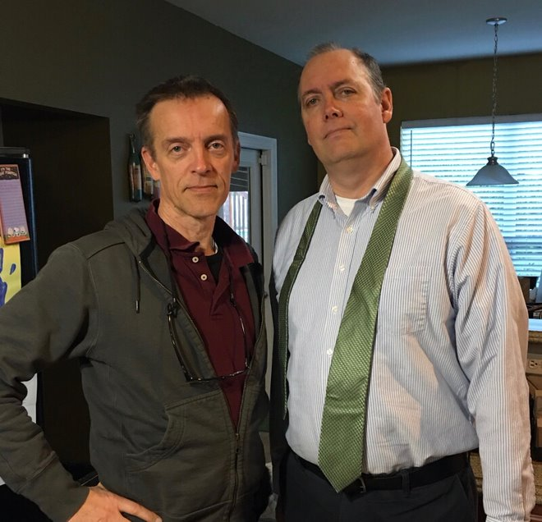
Me and my brother
Perhaps the only, tragic comfort of a life lost too young is that there are plenty of friends and family alive to share the grief. Gary’s funeral service was packed with relatives, work colleagues, and many friends and neighbors.
This is the eulogy I gave at his funeral.
My brother was taller than me. I didn’t think about it much when I was young because, well, he was older and I was growing too. It’s just not something that ever occurred to me.
Many of you who are seeing me for the first time could be forgiven for wondering if we’re really brothers. We don’t look the same. We live in different parts of the country. We’ve had very different careers. We don’t talk the same. But for the first 18 years of our lives, we were inseparable. Same small town of Neillsville in Central Wisconsin, same parents, same sister, same school, same teachers, same church, same church orchestra, same vacations. We even shared the same room. The only difference between us is that he was a year older. And he was taller, so he got the top bunk.
He was first to Kindergarten, and our family has an interesting story that tells you what kind of person he was, even back then. When the big day arrived, his mother dropped him at the school and told him to wait at this spot for class to end, and she’d pick him up. When the day ended, Gary dutifully went to the appointed location and waited for his mother. And he waited. He waited while all the other kids left with their parents, one by one, and he waited while, finally, even the teacher left and he was alone. I don’t know what happened that day. Probably Mom was caught up dealing with something caused by my sister or me. When she realized the time, she rushed back to school in a panic, thinking Gary would be all upset, probably balling his head off. But instead, she saw him waiting patiently, just as she had told him. “Mommy says she’ll be here, so I just have to wait.”
He was Momma’s boy.
Now that I’m a parent, I understand why my first day of kindergarten went so much more smoothly than his did. The second kid benefits from the mistakes you make on the older one. And that happened all throughout our childhood. Gary did something first, and by the time my turn came around, everything seemed so much easier.
I don’t think Gary liked having a little brother. But I liked — needed — him as a big brother.
He had a rough time in high school, and in some ways I owe my own success there to his example. We were both scrawny and awkward, “city kids” among big, tough farm boys. You can’t blame the ugly glasses or the mismatched clothing all on the 70’s. Face it, we were dorky. Perfect targets for any bully.
But he had to face all that awkwardness first. By the time they got done picking on him, they were bored with Spragues and ready to try some other kid. I was lucky to be younger.
He had better success outside school. His first job was delivering papers. Up every morning before dark, before school, in the Wisconsin cold. Fifty houses to visit on bike before school. If that bike broke down on the route, he had to fix it himself. In the summers, Dad put us to work too: cutting trees out in the woods.
Later, he found a job at a grocery store and saved his money. He bought his own car (and paid the insurance and gas), then a boat. All before he was 18. How many kids today can say that?
Then I left for college. Our parents moved to New Orleans, and Gary found himself alone in our home town. He was doing well — that grocery store owner told me recently that Gary was “one of the one or two best employees” he had in his entire 50+ year career at that store. I believe it. Nobody was more diligent than Gary.
But I think he missed his family, because after about a year he moved to Louisiana too, never looking back. For his entire life he was proud that he’d had enough initiative to leave his home town. It’s the advice he gave his children: follow the opportunity and don’t be afraid to move, far away if necessary.
After moving to New Orleans, he did okay for a while, but he had a hard time figuring out what sort of life he wanted. He didn’t want to keep working at an hourly job; he wanted a salary, a career, maybe in something like banking, a difficult choice for a young man with no experience or college degree. But he persevered, submitting applications throughout the south shore until he landed an entry job as a teller at the Whitney Bank in Kenner. It was a pay cut for him, but it’s something he really wanted to do, so on the side — nights and weekends — he did one more thing that ended up leading to the biggest and most important thing in his life.
He took a part-time job at Walmart, where he caught the attention of a girl named Maritza Feinstein. And everyone who knew Gary before and after will tell you that’s when his life really began. She saw something in him that until that moment he hadn’t seen in himself. He told me, “She makes me feel like I can do anything!” and it was true. For the first time in his life, he felt tall!
His life after that just clicked. They bought a house, fixed it up, bought another one, fixed it up. The kids arrived. He wasn’t afraid to work hard, and for many years he continued to work multiple jobs to provide for his family. Nobody worked more hours, or slept fewer than Gary in those years.
A diligent and honest worker, he served in a wide variety of positions at the bank, a breadth of experiences that, during the chaos of Hurricane Katrina, proved his invaluable operations abilities, earning a promotion to VP. After the recovery, he moved his family to Covington, where he bought a big home, surrounded by close family and friends.
And he watched his family grow. He was so proud of his kids. His daughter Kateylnn: a straight-A student, so smart, so confident. And Cameron, so far beyond anything Gary could have done. Gary played in the high school band, but nothing like Cameron. And Cameron: so good-looking, so many friends. Gary was so proud.
When we first heard the diagnosis, it was out of the blue. My brother had never been sick a day in his life, not a broken bone.
In fact, one of my earliest memories was of me in the hospital, looking down the corridor at my sister and brother. The doctors told us that I was unlikely to live, and that this could be the last time I see my brother. But now, here almost 50 years later, I was in the corridor again, only this time Gary was on the wrong side of the hallway!
But he fought it. He did every treatment he could find, changed whatever he had to to beat that thing. And all the while he insisted on continuing to do what he thought was important: work and most of all family.
A few weeks ago, I was with him on what looking back was probably his last really good day. He was full of energy and wanted me to drive with him to Gulfport for a business meeting.
And that’s how I will remember him: walking into that big glass headquarters building wearing his white shirt and banker tie, briefcase in hand. Confident. Dependable. Independent. A proud father. Devoted husband. Sincere and believing Christian. A loyal son. Great friend. My Big Brother.
He’s still taller than me.

8. After Neillsville
Neillsville was a forgettable footnote to my life, I said to myself for many years after I had left. A birthplace is accidental, I thought, but we can choose where to spend our lives. And I chose California.
College was everything I’d hoped: packed with interesting people and experiences I couldn’t have imagined in Neillsville. The California weather reminded me each winter why I had left, and why I had no desire to return.
In fact I didn’t return. The year after I left, my parents left too, with my sister to Dad’s new job in New Orleans. Gary stayed for a while, but in time he grew lonely for family and he joined them there. During college I found interesting and well-paid computer work that kept me in California over the summers. I visited my parents, now in New Orleans, no more than once or twice a year.
My dream of learning a foreign language came true upon graduation, when somehow I landed a job in Tokyo Japan. I lived there for three years, and returned to the US for graduate school in Philadelphia. By then my parents and sister had returned to the midwest, this time to Michigan. My Sprague grandparents, who still had their farm, were my only connection to Wisconsin. It had been almost ten years before my grandfather’s funeral brought me back to Neillsville. And then I was off to Japan again after I had my masters degree.
I worked in Japan for Apple Computer, which though it was not yet nearly the giant tech company that it later became, gave me a front row seat to the birth of the computing products we now take for granted. Eventually they brought me back to California where I married a woman I’d met at business school.
Soon we were raising a family in Silicon Valley. A new job with Microsoft brought us to Seattle, to the suburban community of Mercer Island. My kids grew up there, with technological amenities that would have been inconceivable to me when I was their age.
When the kids hit middle school, we moved to Beijing China for three years, exposing them to a whole different set of experiences that, to them, were as normal as anything I witnessed in Neillsville.
They grew up in a community where every classmate was the child of a professional – doctors, lawyers, engineers. Virtually everyone they know is the child of two college graduates; most of them are the grandchildren of professionals as well. They don’t know anyone who is associated with the military, or for that matter with any occupation that doesn’t require a college degree.

Sometimes I think about those iconic photos of a lone camel herder riding in front of the Great Pyramids in Egypt. I wonder if, while going about his daily chores, does the camel rider ever think about how those giant stone monuments came to be? Is he curious about who could have built such a massive structure? Does he consider the thousands and thousands of laborers, architects, engineers, and managers it must have required to do such a project? And then does he reflect on how all those skills came to be lost, to the point that now in their wildest imaginations his community couldn’t possibly repeat a feat that his distant ancestors took for granted.
I grew up in a community run by people who had personally experienced the horrors – and victory – of World War II. Against what at the time had been improbable odds, they were integral participants of a country that defeated the Nazis, and the Imperial Japanese. The farmers, teachers, and businessmen of Neillsville were part of a culture that, within living memory, had invented electrification, the telephone, automobiles, the airplane, antibiotics – and on and on.
On my infrequent trips back to Neillsville I marvel at the many huge, well-built houses, many of them constructed in the late 1800s during its heyday as a logging center. Somebody built those houses with manual tools, laid the foundations with horse-drawn labor, calculated the materials and costs using pencil and paper. They did this in the cruel Wisconsin winters, long before electricity and outdoor plumbing. And of course they had to feed and clothe themselves and their families.
I left Neillsville as soon as I could, for what seemed at the time like obviously better opportunities. No doubt I made the right decision. On any measure, my children’s lives are vastly better than anything my childhood self could have imagined.
But sometimes, like that Egyptian camel rider, I wonder at the monuments of this urban world. Could we build them again, from scratch? If faced with a mortal enemy, like my grandparents faced in the last World War, would we rise to the challenge?

Now that I’m much older, having seen a world of other cultures, I realize that much of America’s success was embedded in the unspoken values we took for granted in the many small towns like Neillsville. Although we couldn’t always articulate – or in my case at the time, appreciate – the wisdom that surrounded us, there is much to remember. I don’t want us to forget.
That’s what I learned in Neillsville.

Technically, it was the village of Elk Mound, a 15-minute drive from the college – now University of Wisconsin Eau Claire – where my parents met
Who, I believe is the author of this history of our church for the Wisconsin Historical Society
Tragically, Tommy’s father died in drowning accident a few years later, and Tommy moved away when his mother remarried a few years after that
Interestingly, one of my children was born with and quickly got over a similar condition, so it may be hereditary.

